CAREER NEWS Friday 24 April

 Dates to Diarise in Term 2
- Law Week – 18 to 24 May 2020, various forms of delivery

 Applying to the US Webinar
Students considering studying in the US are encouraged to participate in a free webinar which will cover changes to the SAT/ACT, a list of universities going test optional and more.
The webinar will take place on Sunday 26 April at 1.00pm. Register at Applying to the US Webinar

 Community Achiever Program (CAP)
As a Year 12 student, do you demonstrate leadership in your school or workplace, coordinate a community initiative, volunteer in a local cultural, sporting or religious group or provide care to someone in need? ACU's Community Achiever Program is designed to acknowledge commitment to our local communities.
The Community Achiever Program (CAP) recognises a students’ potential to achieve great things. A successful CAP application means a student could receive a provisional university offer as early as August to study at ACU. Being part of this CAP group also offers successful students’ unique opportunities to enhance their leadership and volunteering skills, while they study at ACU.

CAP applications to study in 2021
  - Open – Wednesday 1 May 2020
  - Close – Wednesday 12 August 2020 (Melbourne courses)
Wednesday 2 September 2020 (Ballarat courses)
  - Offers released early September to mid-September 2020
Students are encouraged to begin gathering their required documentation now to submit with along their application. Failure to meet all the requirements for the CAP will result in not being considered for the program. Students are encouraged to browse how the CAP is assessed and offered so they can make sure their submission is well-written, and also provides guideline minimum ATARs required.
Find out more at Community Achiever Program (CAP)

 Applications for 2021 Entry
Current domestic Year 12 students who intend applying directly to ANU for undergraduate study in 2021 are advised that ANU will now make offers based on Year 11 results on 10 August 2020, and these will be honoured for study in 2021 as long as students have completed Year 12.
Should the Year 11 results not meet entry requirements, selection officers will automatically consider your Year 12 results in the December offer round.

Students considering applying are encouraged to browse Frequently Asked Questions. Applications are open and will close on 25 May 2020. Students are advised to read through Application Information before applying at ANU Applications for 2021

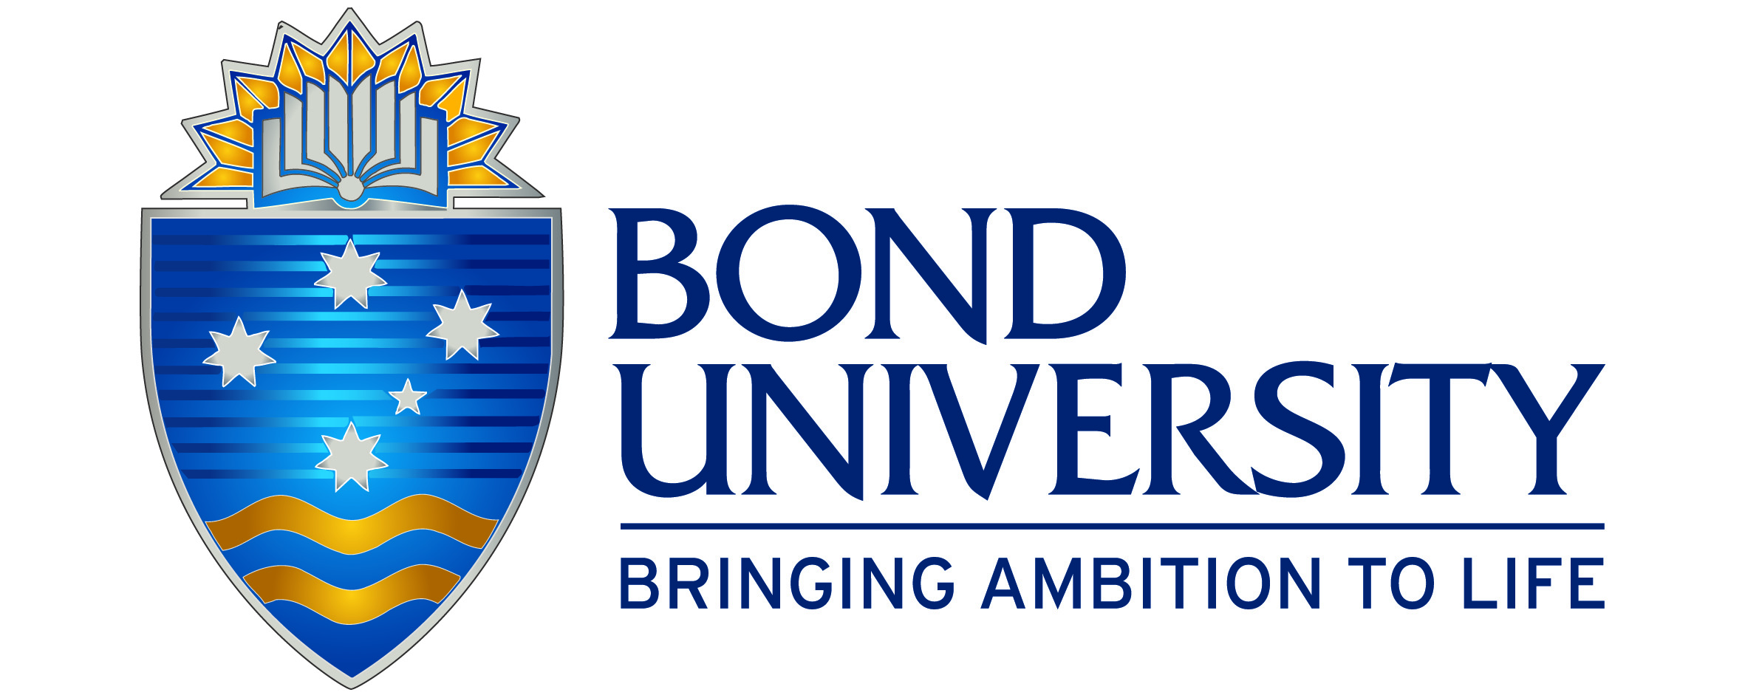 Scholarships at Bond University
Bond University offers an extensive scholarship program to both domestic and international students, with values ranging from 25% scholarships to 100%. It is important to note that applications for the 2021 Scholarship Program for Australian Year 12 students open on 1 May 2020. Students applying for the Vice-Chancellor’s Scholarship must submit their application by 9 August 2020. The closing date for all other scholarships is 6 September 2020.
Scholarship applications should be submitted online; students should note that only one application needs to be made, and students can apply for as many scholarships they are eligible for.
Visit Bond University Scholarships for a comprehensive list of scholarships, including other sport scholarships, and/or to apply. Also visit Bond Application Tips to read through useful tips on applying effectively. For further queries, email scholarships@bond.edu.au or phone 1800 074 074 toll-free (within Australia).

 Information Evenings by Webinars
Discover why Victoria University (VU) is the New Way To Do Uni at our online information evenings on ZOOM.
Find out all about the VU Block Model, our industry connections, undergraduate courses and the variety of pathways to education available.

Victoria University will be presenting a series of Information Evenings virtually from 6.00pm to 7.00pm over a number of nights.

Sessions will be held on:

- Sport & Outdoor Leadership
- Law, Criminology & Legal Services
- Business, Tourism, Hospitality & Event Management
- Engineering, Built Environments & IT
- Creative Arts, Humanities & Music
- Youth Work, Criminal Justice & Community Development
- Education & Early Childhood
- Psychology & Social Work
- Biomedical, Exercise, Environmental & Biotechnical Sciences
Register for one or more sessions at VU Information Evenings by Webinars

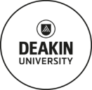 Communication Degrees at Deakin University
Deakin offers a suite of Bachelor of Communication degrees, and they are briefly profiled below. The VCE prerequisite for all four courses in an English.

- Bachelor of Communication (Advertising)
Do you have a way with words and consider yourself a confident problem-solver? Catch people's attention, understand the world of brand communication and tell the story that sells. Students get to explore the principles and practice of advertising with hands-on learning; they get to experiment with future-focused approaches to brand communication, and critically evaluate the role and impact of advertising on society.
Find out more at Bachelor of Communication (Advertising)

- Bachelor of Communication (Digital Media)
Do you want to carve a career in today’s rapidly evolving media climate? Combine your interests in communication technologies, social media and content production to discover a career in digital media. Through the Bachelor of Communication (Digital Media), students get to develop confidence in their creative, analytic and production skills to communicate professionally across traditional and digital platforms. They also learn how to engage audiences, build communities and help organisations and clients with digital content solutions.
Find out more at Bachelor of Communication (Digital Media)
- Bachelor of Communication (Journalism)
Do you want hands-on real-life newsroom experience while you study? In today’s fast-paced digital age, we’ve never been hungrier for news – sharing it with the masses in real time, as it happens. The Bachelor of Communication (Journalism) will give students the skills to unearth a great news story, engage with their audience and deliver the news across a range of media platforms - newspaper, radio station or television.
Find out more at Bachelor of Communication (Journalism)
- Bachelor of Communication (Public Relations)
Do you want to create, inspire and problem solve? Steer your way to a dynamic career in communication? In the Bachelor of Communication (Public Relations) students get to build the reputation of brands, people and organisations with skills and techniques they develop. They learn how innovative and ethical communication fosters meaningful relationships with stakeholders as they develop the capabilities to create inspiring campaigns and events, manage issues and becoming adaptive communications experts.
Find out more at Bachelor of Communication (Public Relations)
 Universities in Western Australia
There are five universities in Western Australia, one of which – the University of Western Australia – is a member of the Group of Eight universities.

- Curtin University
Curtin University is a large multi-cultural university. It has a strong commitment to international engagement with Australia's third largest international student population. It maintains campuses in Malaysia and Singapore while also conducting face-to-face teaching in a number of countries. This cultural diversity adds a rich and valuable dimension to its campus atmosphere and also prepares the graduates to live and work in an increasingly global environment.
Curtin is also fundamentally committed to providing regional education within Western Australia through a number of campuses and education centres spread across the state, but also has a campus in Sydney where it offers a range of business courses. Curtin University recently introduced undergraduate medicine.
Visit Curtin University to find out more.

- Edith Cowan University (ECU)
Established in 1991, Edith Cowan University (ECU) is a large multi-campus institution serving communities in Western Australia and a significant cohort of international students. ECU is considered a pioneer in the development of alternative entry pathways to higher education, helping Western Australians reach their potential.
Visit Edith Cowan University (ECU) to find out more.

- Murdoch University
Murdoch University has more than 18,000 students and 1,400 staff with a desire to discover, use their imaginations and ultimately make a difference. There are over 200 undergraduate degrees and postgraduate courses offered across a range of disciplines, including Veterinary Science, Law, Education, Psychology, Business, Security Terrorism and Counterterrorism and Nursing. The university is recognised for excellent teaching, ground-breaking research and high student satisfaction rating.
Find out more at Murdoch University.

- University of Western Australia (UWA)
The University of Western Australia (UWA) has very high quality undergraduates and this is underpinned by the fact that the proportion of UWA graduates accepted into full-time employment within five months of completing their course is the highest of all Western Australian universities and among the highest in Australia. UWA offers graduate Medicine. Visit University of Western Australia (UWA) to find out more.

- University of Notre Dame Australia (UNDA)
The University of Notre Dame Australia (UNDA) was founded through an Act of the Parliament of Western Australia in December 1989, and now has over 7000 students enrolled on its three campuses in Fremantle, Sydney and Broome. UNDA offers graduate medicine, and it is offered at both the Fremantle and Sydney campuses. Visit University of Notre Dame Australia (UNDA) to find out more.
 Psychology Degrees offered in Victoria in 2020
Psychology is a popular field of study in Australia and is taught at universities in every state and territory. With diverse workplace settings and areas of expertise, psychology can be a highly rewarding and satisfying career choice. Psychologists who complete postgraduate studies in specific areas of psychology may be eligible to receive area of practice endorsement from the Psychology Board of Australia. Find out more at Australian Psychological Society (APS) - Careers in Psychology
Students are reminded that, for the most part, the only VCE prerequisite subject for university entry is an English. Students should verify this at VTAC. Please note that after completion of an APAC accredited undergraduate degree, a further minimum of three years education and training in psychology are required to register as a psychologist in Australia.
Victorian universities that offer dedicated APAC - Accredited undergraduate psychology degrees include –
UNIVERSITY | COURSE | ATAR 2020
ACU | Psychology (Honours) | 85.50 (M)
ACU | Psychological Science | 58.50 (M)
Deakin University | Psychology (Honours) | 80.15 (M), 80.55 (G)
Deakin University | Psychological Science | 60.00 (M), 60.65 (G), n/a (W)
Deakin University | Arts (Psychology) | 60.45 (M), 57.80 (G)
Federation University | Psychological Science | 41.10 (Be), 41.05 (Gi), 53.70 (Ba)
La Trobe University | Psychology (Honours) | 85.15 (M), 92.05 (B), n/a (AW)
La Trobe University | Psychological Science | 55.00 (M), 57.50 (B), 57.90 (A)
Monash University | Psychological (Honours) | 88.65 (C)
RMIT University  *other prereq’s | Psychology (Applied Science) * | 60.05 (Ci), 63.30 (Bu)
RMIT University  *other prereq’s | Psychology (Social Science) | 80.95 (Ci)
RMIT University  *other prereq’s | Criminology & Psychology | 81.00 (Ci)
Swinburne University | Psychology (Honours) | 83.25 (H)
Swinburne University | Psychological Sciences | 60.40 (H)
Victoria University | Psychology (Honours) | 82.60 (FP)
Victoria University | Psychological Studies | n/a (FP)
Victoria University | Criminal Justice & Psych. Studies | n/a (FP)

For a comprehensive list of all courses offering psychology, including it being offered as a major in arts and science degrees, as well as the many double-degree options, visit VTAC

 Public Relations Courses in Victoria in 2020
Public relations officers plan, develop, put into place and evaluate information and communication strategies that present an organisation to the public, clients and other stakeholders. They also promote good information flow within their organisation - Good Universities Guide - Public Relations Officer.
Several universities in Victoria offer public relations degrees, or public relations as a major in other degrees - some of these are listed below.
For a comprehensive list of courses offering public relations (including the many double-degree options) on offer at universities, visit VTAC.
INSTITUTION | COURSE NAME | VCE PREREQs | MAJOR STUDIES IN 2020 | ATAR 2020
DEAKIN  M - Melbourne  G – Geelong Waurn Ponds | Communication (Public Relations) | Units 3 and 4: a study score of at least 30 in English (EAL) or at least 25 in English other than EAL. | Campaigns and event management, Ethical communication, Marketing communication, Media and communication, Media relations, Professional writing, Public affairs, Public relations, Public relations management, Social media, Strategic communication. | 60.50 (M)  56.40 (GW)
LA TROBE  M - Melbourne | Media and Communication (Public Relations) | Units 3 and 4: a study score of at least 25 in English (EAL) or at least 20 in English other than EAL. | Public relations, Strategic communication. | 56.60 (M)
MONASH  Ca – Caulfield | Media and Communication | Units 3 and 4: a study score of at least 30 in English (EAL) or at least 25 in English other than EAL. | Journalism, Media, Public relations, Screen. | 80.40 (Ca)
RMIT  C – City | Communication (Public Relations) | Units 3 and 4: a study score of at least 32 in any English. | Business practice, Communication management, Communication research, Leadership, Marketing communication, Professional practice, Public relations, Strategic planning, Writing. | 80.05 (C)
RMIT  C – City | Communication (Professional Communications) | Units 3 and 4: a study score of at least 30 in any English. | Advertising, Asian studies, Cinema studies, Communication, Journalism, Literature, Media production, Politics, Popular culture, Public relations. | 76.65 (C)
SWINBURNE  H – Hawthorn  * - Professional degree | Media and Communication (Professional) *  Media and Communication | Units 3 and 4: a study score of at least 30 in English (EAL) or at least 25 in English other than EAL. | Advertising, Cinema and screen studies, Creative writing and literature, Digital advertising technology, Games and interactivity, Journalism, Media industries, Professional Writing and Editing, Public relations, Social media. | 80.15 (H) *  60.95 (H)

