## For children’s service providers and families

# The Get Active Kids Voucher Program is now open!

The Get Active Kids Voucher Program is now open! Get in quick as applications

will remain open until the allocation is exhausted.

If your family or child has a Health Care Card or Pensioner Concession Card, you may be eligible for up to $200 to put towards the cost of your child’s participation in sport and active recreation activities.

Important Dates:

**Round 8 open to apply for a voucher or reimbursement:** 10:00 amWednesday, 9 October 2024 and will remain open until the allocation is exhausted.

**Reimbursement expenditure dates:** from **1 July 2024** until submission of application

**Vouchers expiry date:** Tuesday, 29 April 2025.

The *Get Active Kids Voucher Program* helps eligible families get their kids involved in organised sport and active recreation activities by providing financial support for the cost of membership and registration fees. Eligible children may be able to receive up to $200 each.

Special consideration also applies for children residing in care services, as well as temporary or provisional visa holders, undocumented migrants, or international students.

To find out if you are eligible, how to apply, what costs are covered and more, visit [www.getactive.vic.gov.au/vouchers](http://www.getactive.vic.gov.au/vouchers)

*Image:*

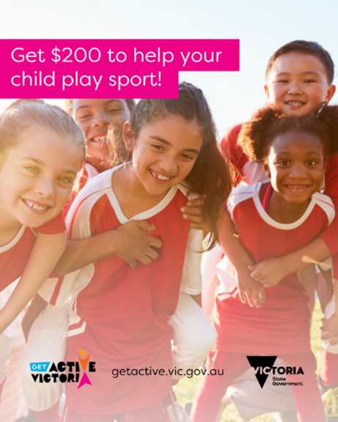

# Sample social media post

The Get Active Kids Voucher Program is open! Get in quick as applications for a voucher will remain open until the allocation is exhausted.

Victorian families with a Health Care Card or Pensioner Concession Card can apply for up to $200 to support their child’s sport and active recreation activities. Apply now at [www.getactive.vic.gov.au/vouchers](http://www.getactive.vic.gov.au/vouchers)

