Help Lenny Jansz get to the

2023 Ninja World Championships

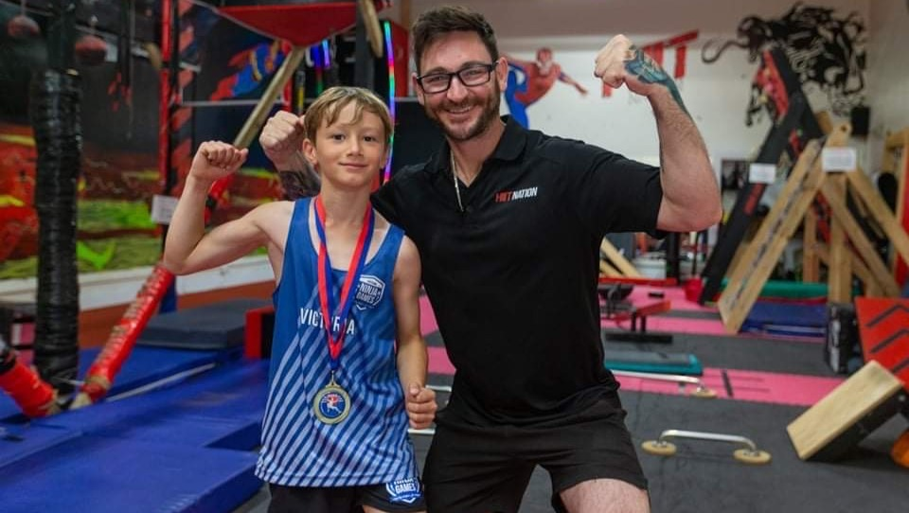
Lenny Jansz has recently qualified for the 2023 UNAA Ninja World Championships in Orlando, Florida, from the 26th to the 30th of July 2023. Lenny was recently crowned the 2023 7U Australian Ninja Games Champion to book his spot in Orlando, Florida, where he will represent Australia at the World Championships.
The World Championships are a self-funded event and without support, we wouldn't be able to make the trip. Lenny has worked hard to make this a reality and we would love to support him on his journey. If you would like to support Lenny in his quest to the UNAA Ninja World Championships, your donation would be greatly appreciated. Any extra money raised above what we need for the trip will go to HIIT Nation in Warrnambool to help improve facilities and purchase equipment to grow the sport locally and support the facility that has done so much for us to this point.

Thanks in advance,
Mark & Lenny Jansz

Scan below to donate or go to: https://gofund.me/b9636e3a

