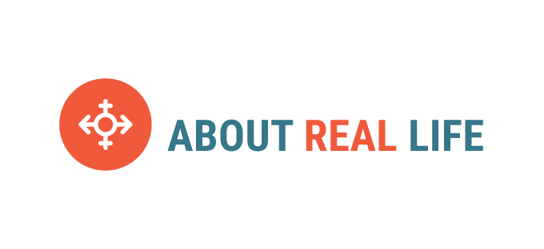

Sexuality education begins at home and can be supported by schools as part of a broader curriculum aimed at maximising children’s health and wellbeing.
The following family (parent/s and child/ren) presentations are facilitated to encourage conversation throughout the session and beyond. They include the following content -

Years 3 & 4, 50-60 mins

People Similarities and differences in our families & friends
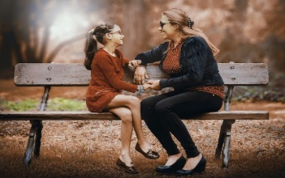
Bodies Similarities and differences
Privacy & Safety
Foetal development & birth

Years 5 & 6, 60-70 mins

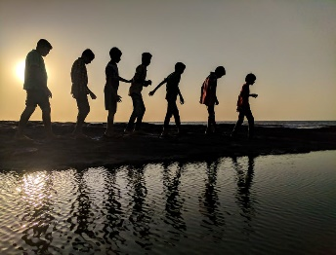
Puberty Hormones, general & gender specific physical changes, emotional & social changes
Privacy & safety in the real and online world
Reproduction

