
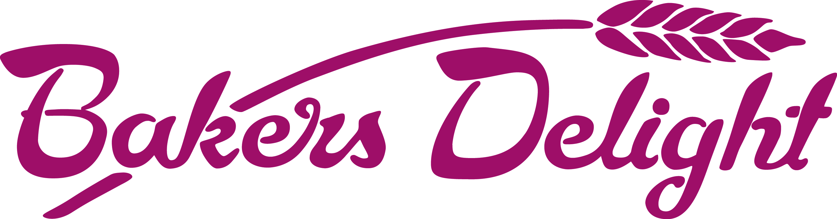

HOT CROSS BUN DRIVE ORDER FORM – BUNINYONG PRIMARY SCHOOL

BAKERS DELIGHT SEBASTOPOL would like to offer you the opportunity to purchase yummy Hot Cross Buns and make a profit for your Primary School.

For every 6 pack of Hot Cross Buns you order (Traditional Fruit, Chocolate Chip, Mocha, Fruitless or Apple & Cinnamon),
BAKERS DELIGHT SEBASTOPOL will donate $2.00 to Buninyong Primary School.

Simply fill in the details below and select which Hot Cross Buns you would like to order, ask your friends and family if they would like to order some too.
Once you know what you are after, pop onto QKR to place your order. Keep this form for your own reference.
Cut off is 11.30am Monday 31st of March, 2025. No late orders can be taken.
Your Hot Cross Buns will be baked fresh and ready to collect from Buninyong Primary School, on Thursday 3rd ^{of} April, 2025.
NOTE: Items must be ordered in packets of 6. Each 6 pack of Hot Cross Buns is $9.50.

Name: ___________________________ Contact Phone Number: ____________________

Full Name | Traditional FRUIT  Hot Cross Buns  6 Packs | CHOC CHIP  Hot Cross Buns  6 Packs | FRUITLESS  Hot Cross Buns  6 Packs | MOCHA  Hot Cross Buns  6 Packs | APPLE & CINNAMON  Hot Cross Buns  6 Packs | TOTAL 6 Packs Ordered | TOTAL $$$ @ $9.50 per packet | PAID  (Yes/No)

