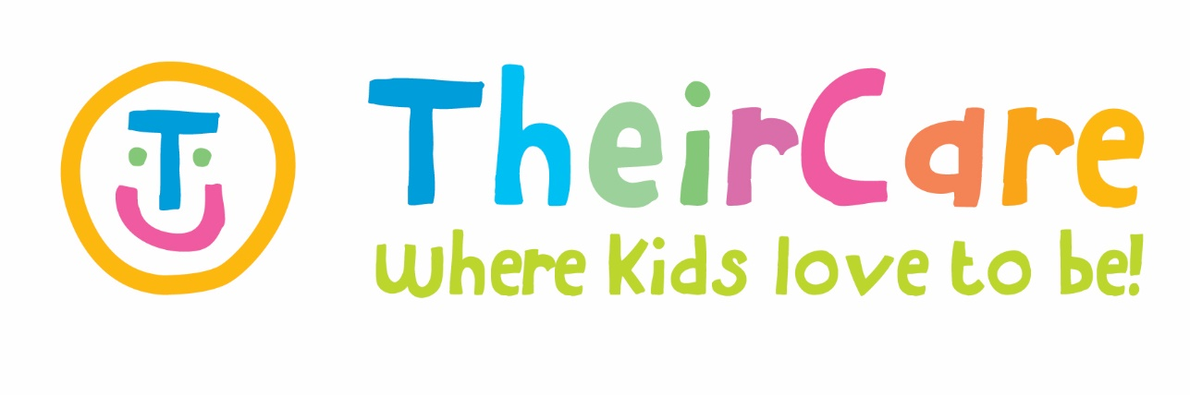

#### Newsletter Term 4 Week 8 2021

***St Marys Primary School St Kilda***

**Bookings are now open for Summer Holiday Program ‘The Greatest Show!’**

We would like to invite our children to join us in ‘The Greatest Show with amazing activities, special visitors and excursions, where our kids can show off their special skills and learn new ones, during this Summer Holiday Program.

Jump on TheirCare Website for more information [www.theircare.com.au](http://www.theircare.com.au). Bookings can be made online using the parent booking portal, or parents can call 1300 072 410 for support.

**Photo Gallery**

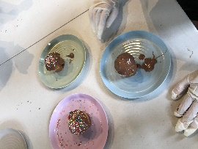

**Kindness Week 6**

The Kindness World Day was celebrated the 13th of November and it was the theme for week 6, with activities related to be kind to other, friendship, understand emotions, gifts making, and groups activities to keep us physical active. Also, we celebrate the Remembrance Day with Poppy Craft activities to involve our children in the memorial day.

In addition, this week we had accessed to the Toy Library with the Robotic Kits and our children loved them! We got Spheros controlled by tablets, Ozobots and Cubetto to learn about codding. It was a really good experiences and our children would like to introduce these kind of technologies to the service program.

**Road Safety Week**

The theme for week 7 was ‘Road Safety Week’ involving craft activities, construction games, group games and sport activities, following the child interest and with intentional learning of Road Safety. Monday was the last day of the Toy Library in the service, and our kids enjoyed playing with them. Road Safety Signs Craft was popular this week, the science experiment related to PH indicator and the cooking activity decorating muffins with chocolate and sprinkles. We had a variate of child initiative activities such as group games as octopus, what is the time Mr. Wolf? and tagging; construction games with Lego and Jenga blocks; sport activities as soccer and volleyball; board games as ‘The Game of Life’ and ‘Code breaker’; sensory activities as making stress balls.

|  |  |  |  |  |
| --- | --- | --- | --- | --- |
| Contact Service | Contact Head Office | Times |  |  |
| Phone: 0475 577 404 | Phone: 1300 072 410 | Before School: 7:00am – 8:45am |  |  |
| Email: stmarysstkilda@theircare.com.au | Email: info@theircare.com.au | After School: 3:30pm – 6:00pm |  |  |