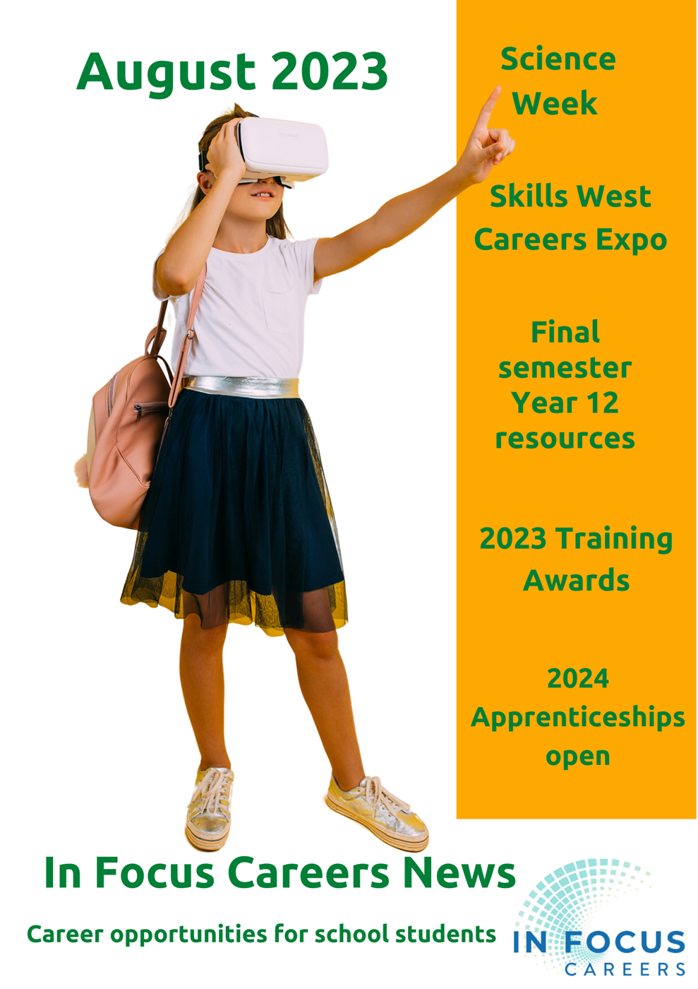

CONTENTS
Section 1: Students and Families
Section 2: Insanely Great Career Advisors
Section 3: Monthly Career Calendar

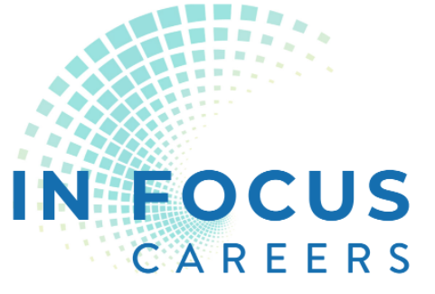

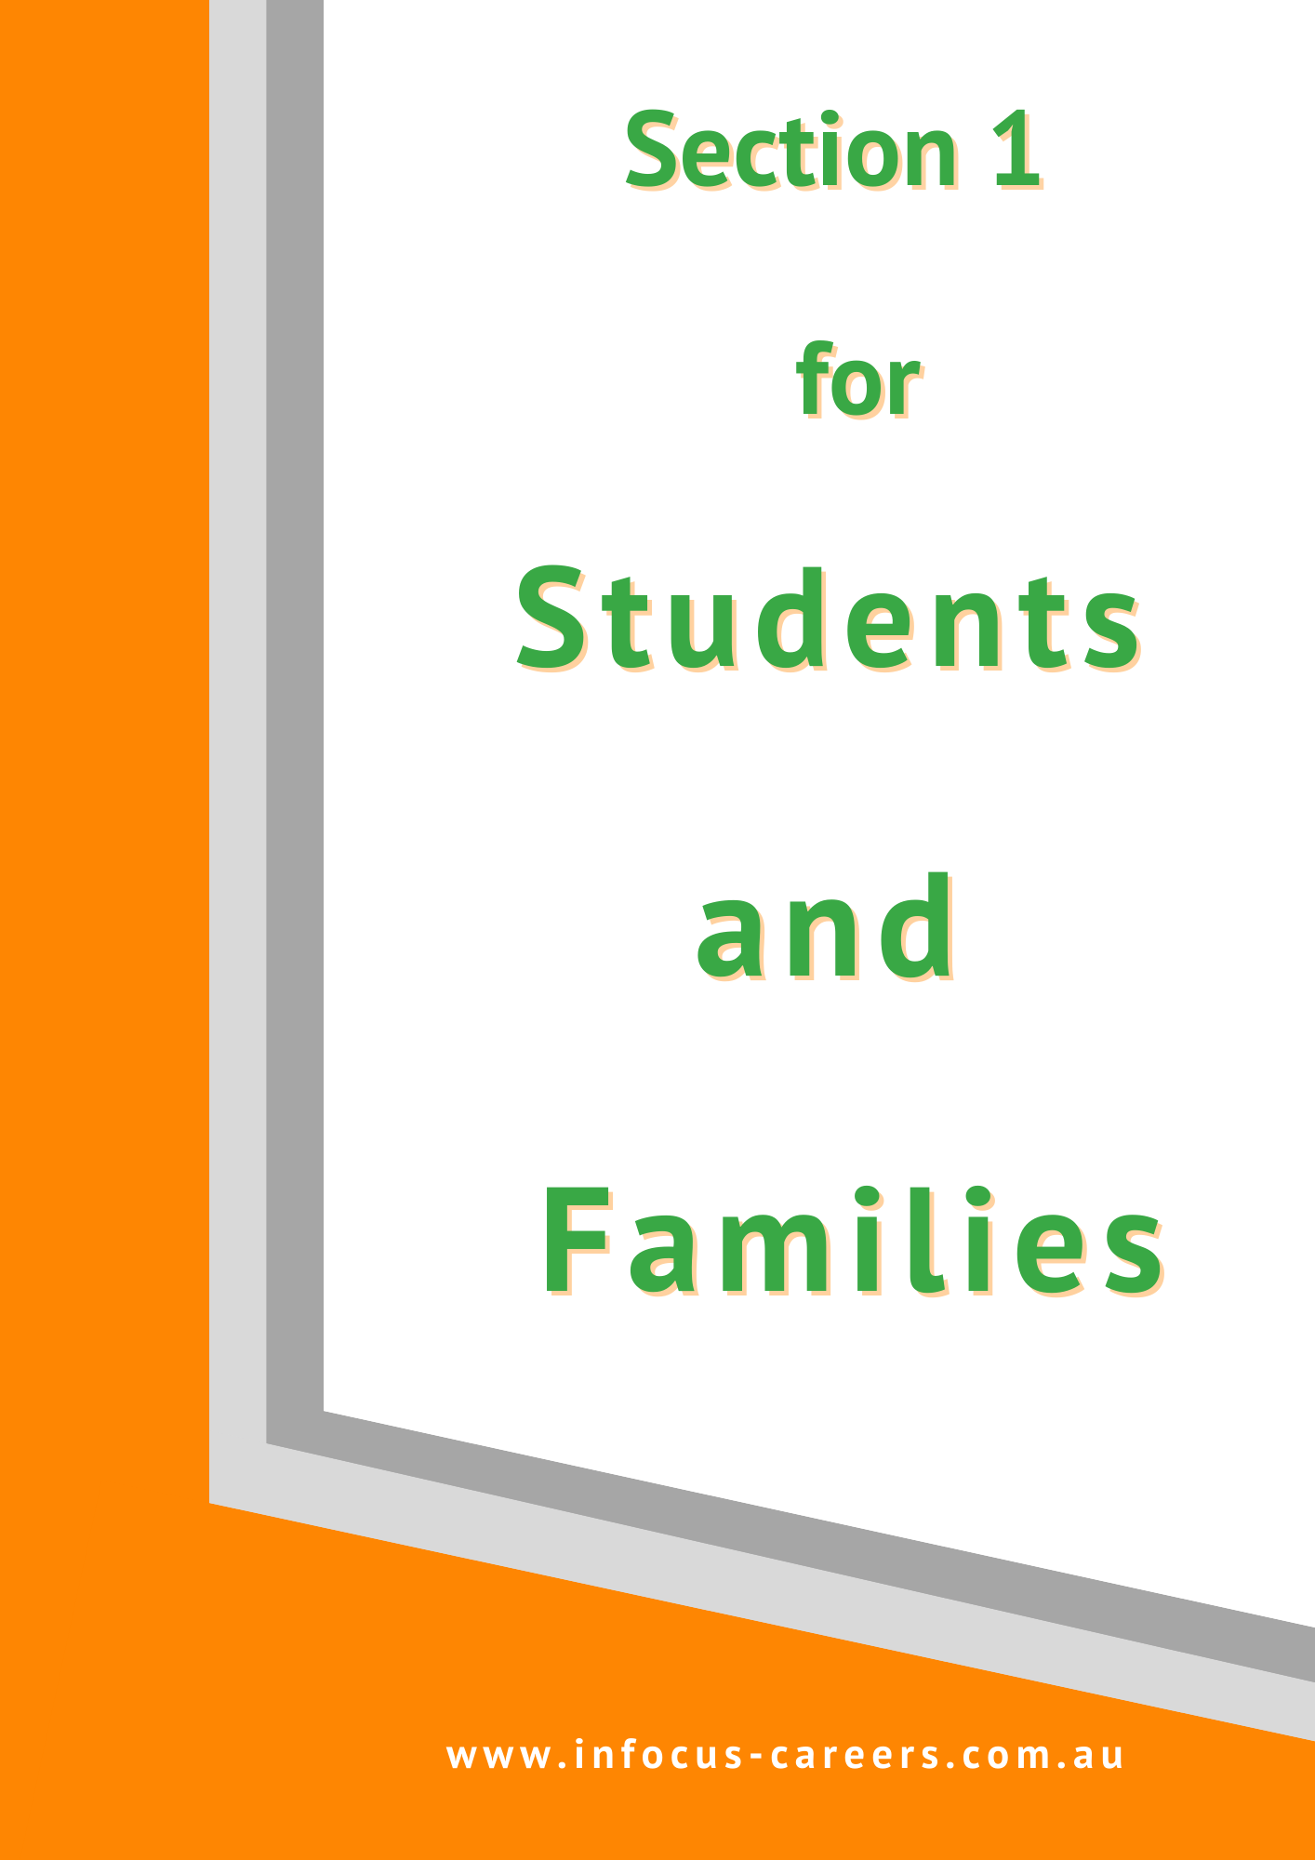
Section 1: for Students and Families

Out of school career opportunities
Finding your right career is about your soul.
It’s about connecting with where you belong.

1 August entries close for Festival of Perth Writing Competition for:

12 – 14 year olds

15 – 18 year olds
The Best Australian Yarn Short Story Competition is back for 2023 with a total prize pool of $75,000 in cash prizes, including a record $50,000 to be awarded to this year’s winner.
You can read more details on the website.
The story doesn’t have to be long – just 1,000 to 2,500 words and anyone over the age of 12 can enter.
To find out more, and to register now visit bestaustralianyarn.com.au
Entries close 1 August 2023. Find details HERE.

Career Conversations
These Conversations are a great initiative by the Education Department, designed to help families understand the opportunities that are open to school leavers.
You can attend one of these at:
- 1 August Morley (John Forrest High School)
- 15 August Piara Waters Senior High School
- 22 August Joondalup Resort
Register HERE.

11 – 12 August Great Southern Hackathon Mandurah
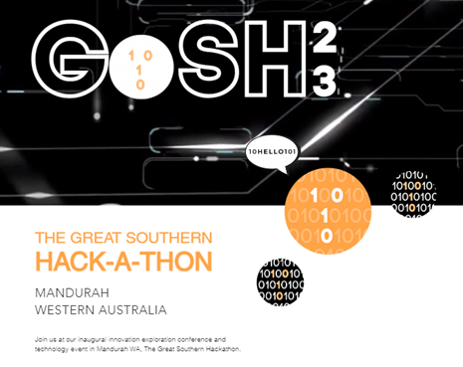
The Great Southern Hackathon is highlighting a multitude of potential future careers in technology through presentations and participation events.

The program looks fantastic. Events will take place across three venues in Mandurah. You can check out the details HERE.

12 – 20 August National Science Week Events Metro Area
Discover a world of STEM careers during National Science Week. These events are running across the metropolitan area from 12 August.
Event | When and Where
Online Girls Day Out in STEM: Future New Worlds Tour  Get ready futurist travelers as off we go to discover the new frontier in the modernization of jobs and of jobs that are not here yet but to come. All you need to do is take a few brave steps to register to get your ticket and join our New Future Worlds Tour. | 12 – 20 August  Online 7am  8 hours per day
Lake Joondalup Birdlife Walk  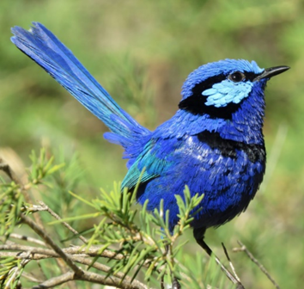  On the morning of the walk, you will be provided with a list of birds commonly sighted in this location and asked to see if you can spot them in their native habitat as you are guided on a short walk finishing at 10am | 5 August Saturday  9 – 10 am  Lake Joondalup

Birdlife WA: Talk and Bird I.D.  Brendan from Birdlife Australia will deliver a talk about all things birds. You will be surprised what you will learn about these fascinating creatures.  Find out about their names, diet, and habitat. Listen to different birdcalls through sound recordings |  | 5 August Saturday  11 – 11.45 am  - Wanneroo Library  12 August  11 – 11.45 am  - Yanchep/Two Rocks Library
National Science Week Launch  Hear from WA's Chief Scientist - Professor Peter Klinken, WA's 2022 Innovator of the Year - Kate Lewowski, and Lead Engineer from ULUU - Shawn Price - a company replacing plastic with a carbon negative ocean material.  Watch Telethon Kids Institute's 3D Food Printer in action or chat to our mixologist about whipping up the best 0% alcohol drinks around. |  | 7 August  5 – 7.30pm  Engineers Australia, St Georges Terrace.
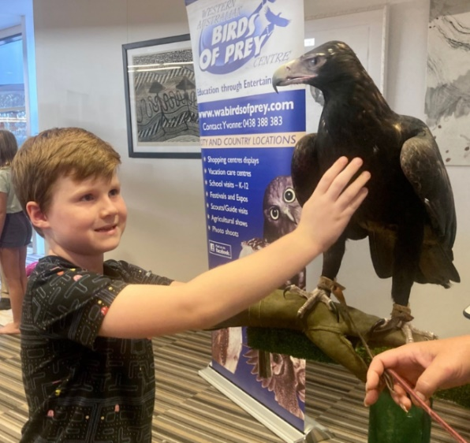  Birds of Prey  WA Birds of Prey will showcase 5 of their majestic creatures in an interactive presentation. There will be owls, a falcon, and a wedge-tailed eagle.  Learn about the science about bird behaviour, conservation and what individuals and group can do to preserve bird habitats. From exploring bird facts to making bird-nesting boxes, join us to learn about an assortment of scientific concepts. |  | 7 August  4 – 5pm  - Girrawheen Library  8 August  4 -5pm  - Yanchep/Two Rocks Library  14 August  4-5 pm  - Clarkson Library  - Wanneroo Library  Check this as both are scheduled at the same time.
 | Event |  | When and where
 | The Rise of AI  Explore the potential of AI with Professor Ajmal Mian as he examines its benefits and risks.  AI technology has the potential to revolutionize our world with its promised benefits of personalized medicine, workplace efficiency, and autonomous vehicles. However, it also poses significant concerns such as perpetuating biases, displacing human workers, and spreading misinformation. |  | 10 August  6.30 – 8.30  WA Museum
 | The Anti Conference: Innovation, Inspiration, Intelligence  Grab your friends and bring your best science facts to our first session, Intelligence. We're talking one big boozy science quiz at Perth Mess Hall.  On Saturday we're heading to the WA Museum Boola Bardip for two interactive sessions that are talking home grown innovation. Think debates on the best renewable energy source, human spectrograms, and more. |  | 11 August  5.30 – 8pm  - Perth Mess Hall  12 August  WA Museum Boola Bardip

Event | When and where
Re-Cyc-Ology  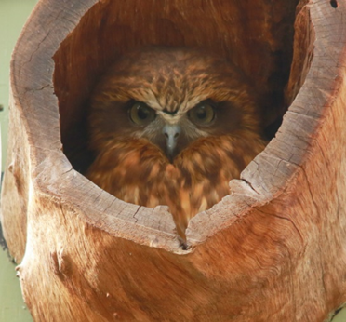  Creating habitat to help wildlife find refuge in your own backyard is an incredibly rewarding way to engage with nature. This can include planting a native garden, installing a water-bath, digging inn a frog bog or even building a nest-box an artificial tree-hollow for mammals and birds needing a home. | 11 August  3.45 – 5.00 pm  - Wanneroo Library  18 August  3.45 – 5.00 pm  Clarkson Library
Bird Brain  Join three scientists from the University of Western Australia and learn about their latest research findings, we are focusing on the study of cognition and communication in birds, using two main study species; the Western Australian magpie, and the southern pied babbler. | 12 August  10.30 – 11.30  - Clarkson Library  16 August  1 – 2 pm  - Girrawheen Library  19 August  10.30 – 11.30  Wanneroo Library

Event | When and where
National Quantum and Dark Matter Road Trip  As a part of National Science Week, a team of scientists and science communicators are traveling around Australia, delivering engaging presentations, hands-on activities, pub quizzes and more. | 17 August  7 – 8 pm  UWA
Hologram Printing with 3D Printing  Participants of all ages will have the opportunity to use desktop hologram printing kits and 3D printers to design and print their own unique holograms. But this competition is not just about having fun - it's also an excellent chance to learn about scientific concepts in a memorable and interesting way. | 19 August  9am start  UWA
Biggest Science Lab Ever  The Biggest Science Lab Ever is your ticket to a world of scientific discovery and innovation. Join us for a fun and educational weekend that will leave you inspired and informed.  Paleo Jam is on Saturday from 12 – 1.00pm. | 19 – 20 August  Museum Boola Bardip

Event | When and where
Kaarakin Black Cockatoo  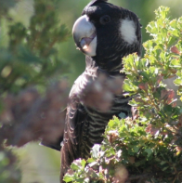  An educational and interactive talk about the latest research projects that cover bird cognition and behaviour and the impact of environmental changes in their habitat.  Kaarakin Black Cockatoo Conservation Centre is the only centre dedicated purely to the rescue, rehabilitation and release of the three threatened and endemic species of black cockatoos that inhabit southwest WA. | 22 August  3.30 – 4.30  - Girrawheen Library  24 August  - Clarkson Library
West Australian Robotics Playoffs  This is a robot building competition based on the global FIRST Robotics Competition. Teams are provided with a basic kit and the challenge instructions. Schools then have to build the best robot they can to compete in the challenge.  Innovation Competition  In this competition groups of students are able to select a challenge from four, real life, industry problems. The students need to research the problem and come up with potential solutions. They must then give a 10-minute presentation to a panel of judges detailing their research and conclusions. | 26 – 27 August  7am – 6pm  Curtin Uni Stadium

Event | When and where
MicroToons” Scab” Launch Event  MicroToons is an animated science cartoon on based on a short story written by Dr Rina Fu (Scientist-Author-Artist) and brought to life by artists with autism | 25 August  5.30 – 7.30  Medina Hall

15 August Innovation Powering Future Industries webinar
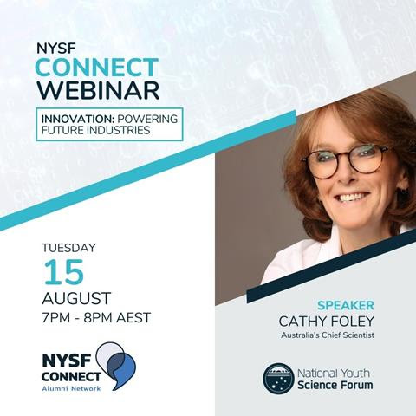
Australia's Chief Scientist, Dr Cathy Foley is presenting on innovation in this National Youth Science Forum webinar.
5pm 15 August
Find details HERE.

Labour Market Trends – Unemployment Down AGAIN!
The Australian Bureau of Statistics June figures show unemployment went down to 3.6%.
Trends, like horses, are easier to ride in the direction they are going.
John Naisbitt. Global Megatrends

The latest Labour Market update reports that over the past year,
- Post school qualification: around 92 per cent of total employment growth has been in occupations where some level of post-secondary school qualification is usually required,
- VET qualifications predominant: around two-thirds of total employment has been in occupations where VET qualifications are the primary pathway.
While skills shortages continue to remain, the report also shows that there was a strong increase in full-time employment and improvements for the long-term unemployed. To read the full update click HERE..

In June the number of job advertisements declined slightly. See details HERE.

Highest Paying Jobs in Australia 2023
- Legal: Equity Partner (Up to $850,000)

- CEO or Managing Director ($700,000)

- Retail: General Manager ($510,000)

- Accountancy & Finance: Head of Treasury ($410,000)

- Property: Development Director (up to $388,000)

- Energy: Project Delivery Director (up to $357,000)

- Construction Manager (up to $320,000)

- Head of sustainability ($310,000)

- Technology: CIO an dCTO ($306,000)

- Marketing and Digital Executive Director of Communications ($300,000)

Higest Paid Medical Jobs
- Surgeon $406.068
- Anaesthetist $ 388,814
- Internal medicine specialist $410,848 (specialist physicians, cardiologist, endocrinologists, neurologists and paediatricians).
- Psychiatrist $252,691
From Forbes Advisor June 2023

University Opportunities

25 July Notre Dame Young Achievers Early Offer Information Session
Find out everything you need to know about the program, including selection criteria, the application process, important dates, benefits and more.
You’ll also hear from current students about how receiving an Early Offer helped them finish Year 12 with added confidence and chat with academics about your undergraduate study options for 2023.
6 – 8 pm Register HERE.

27 July WAAPA Arts and Cultural Management and Production Information Evening
The Bachelor of Arts (Arts and Cultural Management) prepares students for exciting and challenging careers in the arts and entertainment industries. Whilst our Production and Design programs prepare students for a range of technical live production careers.
To find out more about these exciting courses, come along to our WAAPA Arts & Cultural Management and Live Production Information Evening.
Please note that this information session will not cover performance courses.
6pm Mt Lawley Campus. Find information and register HERE.

31 Juy Murdoch University Information Evening Mandurah
Attend our Public Information Session and find out everything you need to know about studying at Murdoch University.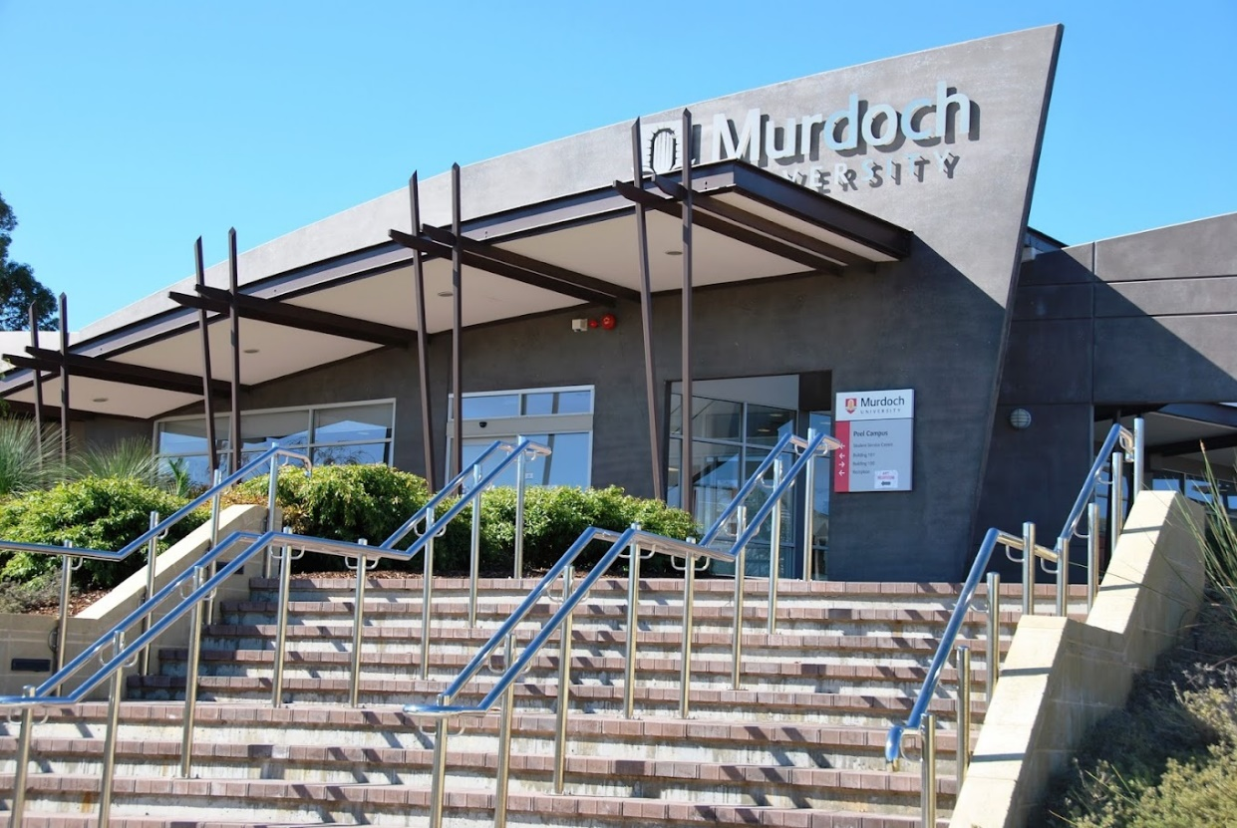
We welcome all parents, teachers, high school and mature age students to attend.
We will be sharing important information such as:
- Pathways into Murdoch University
- Our courses and study areas
- Understanding study commitments and timetables
- University study vs High School study
- Scholarships
- Dedicated support services for students
- Orientation and starting at Uni
Murdoch Mandurah Campus 6pm Register HERE.

1 August Many university scholarships open
Many university scholarship applications open on 1 August.
Start checking undergraduate scholarships under any category that applies to you like, financial hardship, educational disadvantage, women in STEM, First in Family to go to uni. There are so many different scholarships that each university lists pages of them:
- Curtin University
- Edith Cowan University
- Murdoch
- Notre Dame
- University of Western Australia
TIPS: Some scholarships and universities give advice and tips on how to write a successful application.
See the Curtin Scholarship Information Session on 8 August

2 August UWA Podiatric Medicine, Pharmacy and Optometry information session
Did you know healthcare and social assistance is Australia’s largest and fastest-growing industry?
If you’re passionate about helping people, join our online event to discover exciting pathways to Podiatric Medicine, Pharmacy and Optometry.
Online 5-6.30 pm Register HERE

3 August Murdoch University inforumation Evening Rockingham
Attend our Public Information Session and find out everything you need to know about studying at Murdoch University.
We welcome all parents, teachers, high school and mature age students to attend.
6pm Gary Holland Centre Rockingham. Register HERE

8 August Murdoch University FlexiTrack Information Session
FlexiTrack High is a direct entry pathway for Year 12 students who are unlikely to get a selection rank in 2024 but aspire to go to uni.
Fully funded scholarships are available to equity students.
Kim Beazley Lecture Theatre 6pm Find more information and register HERE.

8 August Curtin Scholarship Information Session
Scholarships offer you more than financial support, they connect you with opportunities to help you thrive at university.
Join us online for the Scholarships Information Session to discover our range of scholarships and get tips and advice from our experts on how to submit a compelling application. Register HERE 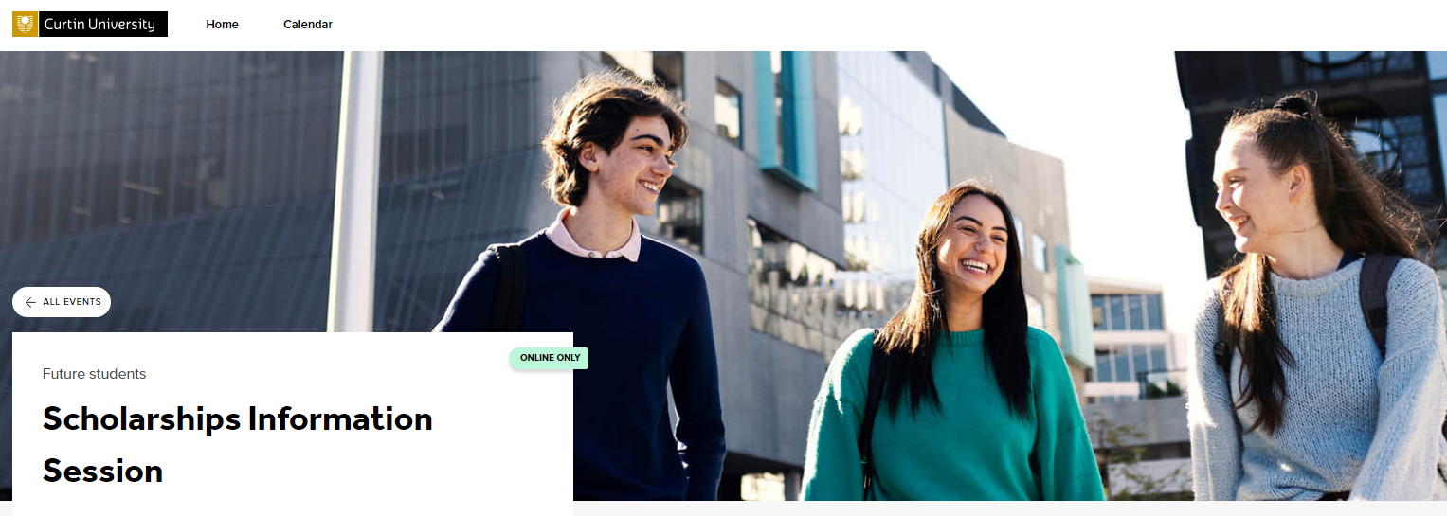

23 August UWA Social Work Information Evening
This information evening is available both in person and online.
Hear from our academic staff, current students and recent graduates about their experiences and the benefits of studying the Bachelor or Master of Social Work.
Event details
Location: Online and in-person at UWA
5:30pm - 6:30pm
Register HERE.

23 August Murdoch University Open Night: Nursing
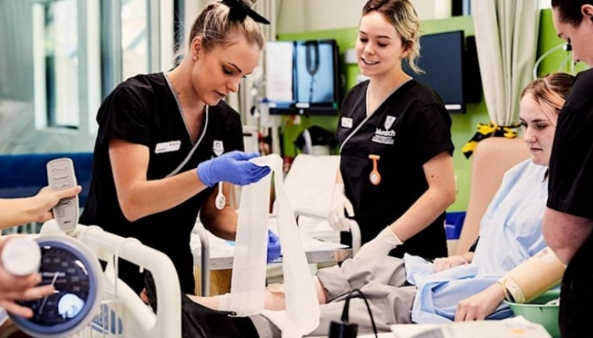
Gain hands-on experience as we take you on a tour though the state-of-the-art facilities including our Simulation Lab.
The Simulation lab is modelled off a real-life hospital ward and provides Nursing students with an immersive experience whilst gaining confidence in their nursing skills.
Take part in a vitals workshop, meet our High Fidelity Sim Man and learn about clinical care, under the guidance of experienced staff.
Start time 4.30pm
Find details and register HERE.

24 August Murdoch University Open Night: Sciences, Technology, Engineering and Maths
Join us for a night of innovation, as we explore how a Science, Technology, Engineering, or Mathematics degree from Murdoch University equips students with the skills and knowledge needed to solve complex problems, think critically, and adapt to new technologies. Specialist academics and industry partners design murdoch’s degrees to ensure that our students are prepared for emerging industry and global trends.
5.30 Murdoch Campus. Find details and register HERE.

29 August Murdoch University Business, Law, Humanities, Art and Social Sciences, Education
Join us to see how a degree from Murdoch University could inspire you to use the power of analysis, communication, creativity, and storytelling to challenge the way we think about, look at and understand the world. Specialist academics and industry partners design murdoch’s degrees to ensure that our students are prepared for emerging industry and global trends.
5.30 pm Murdoch University Campus Find details and register HERE

30 August Murdoch University Health and Education
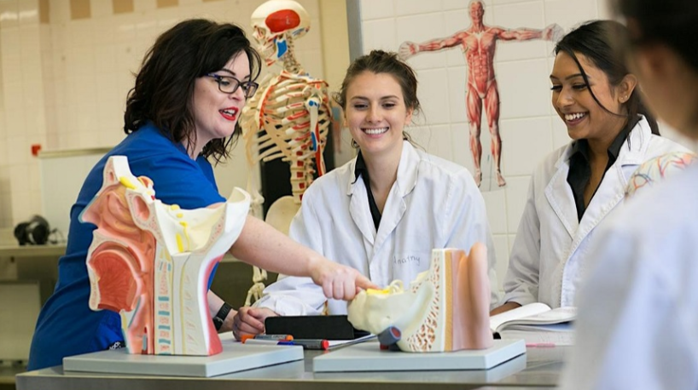
Join us to see how a degree from Murdoch University can prepare you for a career within health industries or teaching the next generation of thinkers. Learn how you can use your passion for sport, rehabilitation language, science, leadership and compassion to improve the lives of others. Murdoch's degrees are designed by specialist academics and industry partners to ensure that our students are prepared for emerging industry and global trends.
Find details and register HERE.

1 September ECU Nursing and Midwifery Showcase
At our Nursing and Midwifery Showcase Evening you will have the opportunity to explore our state-of-the-art facilities, learn about our courses and the excellent support services you can expect as a student. You can speak to our Future Student Engagements Team about admission pathways, how to apply, fees and scholarships and flexible study options like online or part-time.
Joondalup Campus 5.30 – 7.00pm Register HERE

Notre Dame – Tertiary Pathways
Notre Dame's Tertiary Pathway Program (TPP) is designed to prepare you for entry into the University’s undergraduate degree programs. The skills, knowledge and experience that you will develop during the semester are essential for successful transition to university.
The Tertiary Pathway Program is free. Find out more details HERE

Change of Preference Tips from Good Universities Guide
In Year 12 you may be focusing on getting the best possible ATAR score. You may have made a decision about what university course to enrol in but thinking about what units to take in that course may be a problem for the future.
The Good Universities Guide provides great tips on How to approach the change of preference period.

Tips from First in Family to go to uni
All students can learn from the First in Family site. It has information about:

- What I wish I’d known before starting.
- Study Hints for Undergraduate Students
- Study Hints for Online Students
- Top 5+ Hints for Family Survival

Training Opportunities

27 – 29 July SkillsWest Careers & Employment Expo
This event is one of the biggest held in Perth each year. Universities and training providers, industry representatives and providers of services to job seekers will all be there. Check out the exhibitors HERE.

Schools can register to attend HERE.

4 August Rio Apprenticeships Open

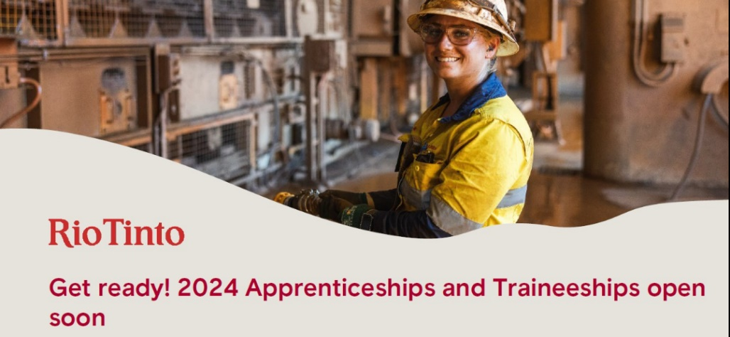
Discover what Rio apprenticeships are available for 2024 and to apply go HERE.

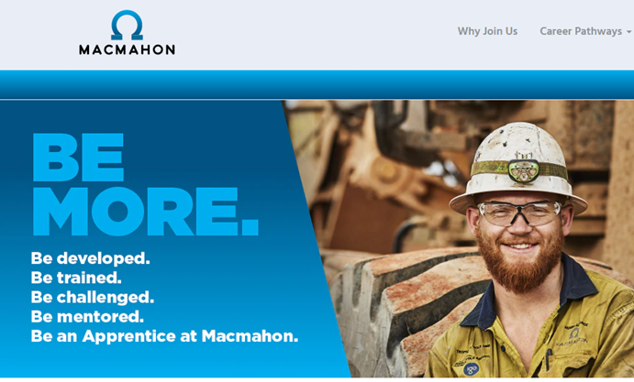
For Macmahon apprenticeships go HERE.

If you don’t have a career advisor or support at school, go to a Jobs and Skills Centre and ask for help with your application.
Check for more apprenticeships at Indeed
Contact
The Australian Apprenticeship Support Network is a network of organisations that have expertise in apprenticeship and traineeship employment, training and support.
In WA you can find Metropolitan support network providers HERE and outback service providers HERE.

Due to the skills shortage, there is a big push to attract females into trades. Ask your support network provider what they can do to help you.

9 – 10 August Plumbing Industry Expo
There will be workshops, displays and plumbing products at this expo at the Perth Convention Centre.
Check here for details www.waplumbingexpo.com.au

30 August WAAPA Production Tour
WAAPA is recognised nationally and internationally for the quality of its graduates and provides Production and Design students with ‘on-the-job’ theatrical experiences. You can find out more about WAAPA's exciting backstage Vocational Education and Training (VET) courses, admission pathways and application process during this event.
WAAPA's VET courses provide some of the most comprehensive and highest quality training for the theatre and events.
6 – 7.30pm Mt Lawley Campus. Find details and register HERE.

Construction Training Scholarship applications open
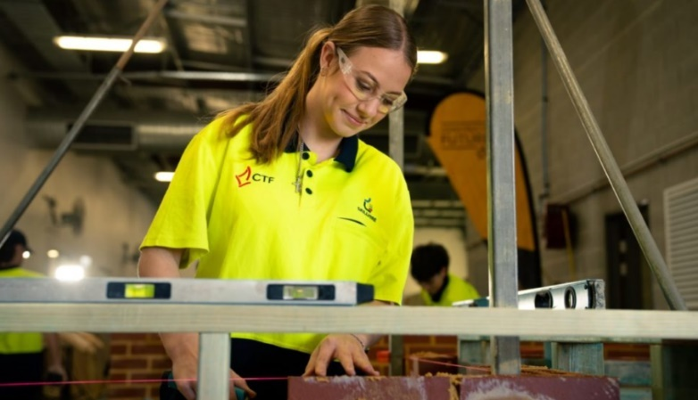
Each year, Construction Training Fund (CTF) awards scholarships to Western Australian students passionate about the building industry.
Students in Years 10 or 12 interested in completing a pre-apprenticeship at school during Year 11 and/or 12 can apply for a pre apprentice. Find more details HERE.
Register HERE.

See Training Award announcements on the Facebook page
Keep up to date with progress on the WA Training Awards at the Facebook page.
It is through the Facebook page that you will find the latest information. Last year’s winners were published on the Facebook page as they were announced.
WA Training Awards Facebook page

Get your drivers licence
At a recent career professionals breakfast career advisors were talking about how all employers of tradies demand that staff have a driver’s licence.

What’s going on?? VET student numbers down in 2022!
The latest Government-funded students and courses 2022 report from the National Centre for Vocational Education Research (NCVER) shows that student enrolments in government-funded vocational education and training (VET) have declined 4.3% in the 12 months to December 2022.
The number of students in traineeships and apprenticeships increased. Find the report HERE.

Senior School Opportunities
Meaninglessness… is the biggest problem facing youth growing up today.
Prof. Bill Damon, Stanford University

Open now: LGBTQIA+ Education (uni or VET) Scholarships
Scholarships are awarded by the Pinnacles Foundation for fulltime study at public institutions of higher education in Australia, for the purpose of gaining an educational or vocational qualification in any profession, trade or the arts.
Applications close 31 August. Check details HERE.

30 July Applications CLOSE for Defence Work Experience at Pearce RAAF Base

An Aerial View: Air Force Careers Day (12 September 2023) Job Ref - WEP/01108/23  - 12th September 2023  - RAAF Base Pearce, Bullsbrook, WA  - Air Force  Information Pack Word Document Information Pack PDF Document | - Start New Application  - Access Existing Application  - Preview Application Form
To find details of all Defence work experience opportunities HERE.

31 July applications close National Summer School Maths Camp
National Maths Summer Camp for top maths students
Seven West Australian students will be chosen:
- Two week residential camp.
- 7- 20 January 2024
- Australian National University Canberra
- Cost: $1300 + subsidised flight (Scholarships are available)
Applications Close 31 July. Appy HERE.

31 July West Australian Summer School Maths Camp – applications close
WA Maths Summer School for mathematically talented students
- 14 – 20 January
- University of Western Australia.
- Cost $1400
Applications close 31 July. Apply HERE.

27 August Applications Close Defence Navy Work Experience
Naval Gazing Navy Careers Experience - October Job Ref - WEP/09395/22  - 2 - 4 October  - HMAS Stirling  - Navy  Information Pack Word Document Information Pack PDF Document | - Start New Application  - Access Existing Application  - Preview Application Form
Find out more and apply HERE.

12 August Innovators Tea Party Mentoring
STEM Show and Tell is a speed-networking event introducing students to 8 different women in STEM via engaging activities specifically designed to link the science and maths curriculum to their jobs. From biomedical science, to aviation to agriculture and engineering - meet some of WA's technical experts and STEM leaders!
10 am – 12 noon Bentley Get tickets HERE.

10 August From Little Things Big Things Grow Webinar –
Getting Your Ideas Off the Ground: Powered by the Fogarty Foundation
This webinar is designed for high school students who are looking to bring an idea, initiative, or venture to life in their local community.
Students will hear from three young innovators and entrepreneurs who share their stories, experiences, and advice from their own journeys bringing ideas to life and accessing opportunities. From there, we'll be diving into a practical masterclass on how to develop, launch and test a minimum viable product (MVP) for an idea.
3.15 – 4.15pm Find details and register HERE.

Swan Active Education and Employment Opportunities
Students in Ballajura, Beechboro, Ellenbrook and Midland areas
Swan Active partners with training providers to support young people to gain qualifications in sport related careers which can lead to sport related jobs.
To find out more go HERE.

Year 12 Opportunities

25 July Army Reserve Information Evening
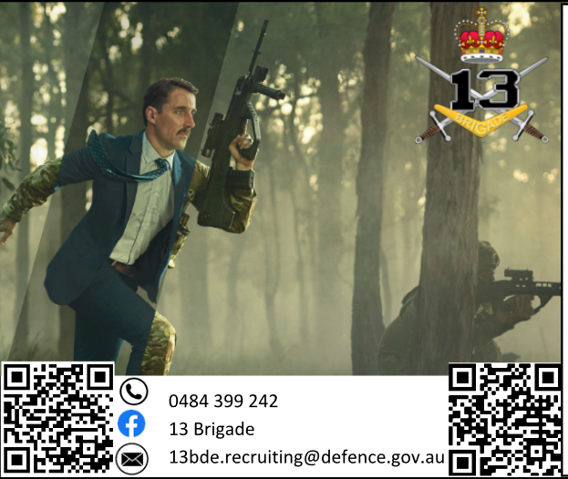
If you are 17 you can take up part-time work with the Army Reserves. You can apply now and continue to work there while you undertake your uni or VET studies.
- Flexible work arrangements
- No minimum period of service.
- Earn qualifications.
Information session 7pm 25 Jul at Irwin Barracks.
Contact at any time on 0484 399 242 13bde.recruiting@defence.gov.au

Open Now: ECU Women in STEM Scholarship Applications close 31 August
There are up to 500 scholarships to support more women in STEM. There lots of scholarships and a range of categories. You can find details HERE.

2 August Australian Government School Leaver Program
Get a job in the Australian Government.
With the Australian government’s commitment to restoring excellence in the Australian Public Service, the Australian Government School Leaver Program is a brilliant opportunity to get in on the ground floor. Find out about it HERE.

2 August and Australian Tax Office School Leaver Program
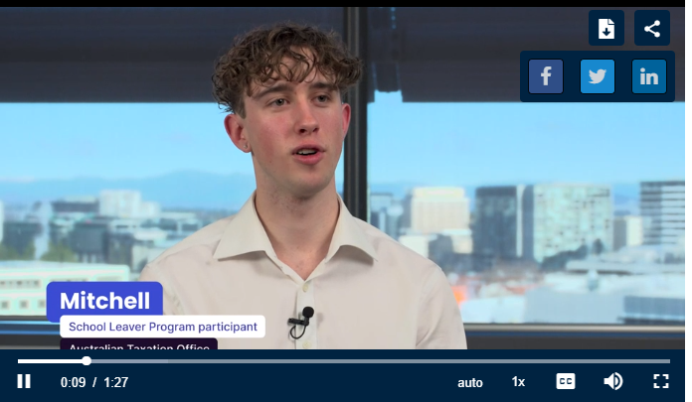
The Australian Taxation Office has its own customized program. Check it out HERE.

SCSA Year 12 ATAR Course Examination Timetable
The 2023 Year 12 ATAR course written, and practical examinations timetables are provided below.
- 2023 ATAR course written examinations timetable
- 2023 ATAR course practical examinations timetable

From Tuesday, 5 September 2023, students will be able to download their Personalised written examinations timetable and Personalised practical examinations timetable from the student portal HERE:
.

18 August Veterans Scholarships Open
These schoarships are for children and grandchildren of ex-service veterans.
If you are planning to enrol in TAFE or uni in 2024 you may be eligible for a Veterans Scholarship.
Check your eligibility HERE.

Police Cadet Opportunities Open
If you are nearly 17 and interested in a police cadetship, check out the details HERE.
Applicants must be 17 upon selection to the Cadet school.
Find details of the recruitment process HERE.

School Leavers Information Kit
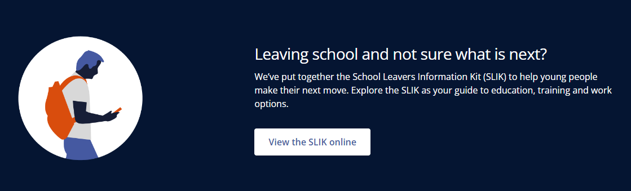
Whether you want to do more study, take a gap year or start work straight away, there are resources to support you in the School Leavers Information Kit. To find all the resources go HERE.
Thanks Penny Walmsley from Byford Secondary College for sending this through.

4 September Westpac Young Achievers Award
Applications for the Westpac Young Technologists Award open for this scholarship on 4 September. More details in the September issue.

Volunteer Opportunities for school leavers
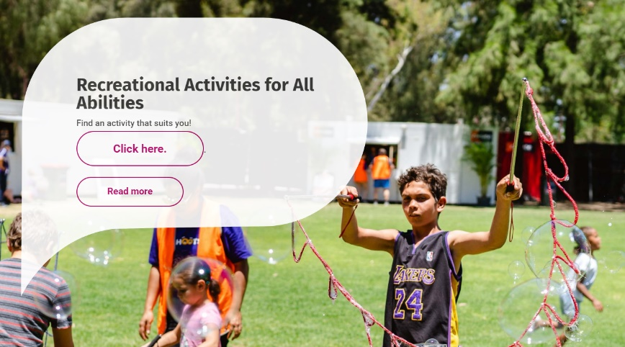
Cahoots provides camps and programs for young people with disabilities. They are looking for Year 12 school leaver volunteers who are willing to support young people to engage with recreational activities. Find out more HERE.

How Uni Fees Work – Rough Calculations
UWA Fee Calculator is good. You check the course you are interested in, and it will give you a rough idea of how much your course will cost each year.
It currently identifies most courses costing an Average Annual Fee of $9,134.
If you do 8 units in your first year you will be paying over $1100 per unit.
Check your course costs HERE.

Important TISC Dates to the end of the year
If you haven’t applied for university in 2024 it is time to do so now. Check key TISC dates HERE.
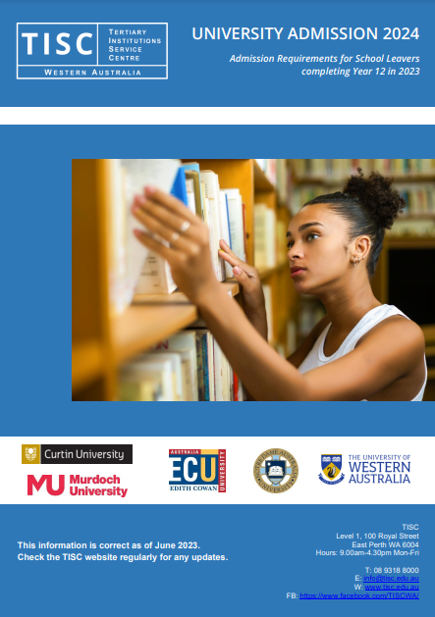
WA 2023 ATAR results and Universities Admission Advice Letters will be available online on 17 December.

TISC University Admissions 2024 Released
This has recently been published to help Year 12s with specific reference to each university and courses.
Get your copy HERE.

Interstate Admission Centre Contacts
For those who are thinking about applying for a place at a university outside Western Australia here is a list of admission centres around Australia.

- Open Universities Australia
- Victoria
- NSW
- Queensland
- South Australia
- Tasmania
- Northern Territory
- ACT

Health Industry Scholarships and Grants
Information about scholarships and grants for medical and allied industries is collated on this page.

CBH Summer Harvest Jobs
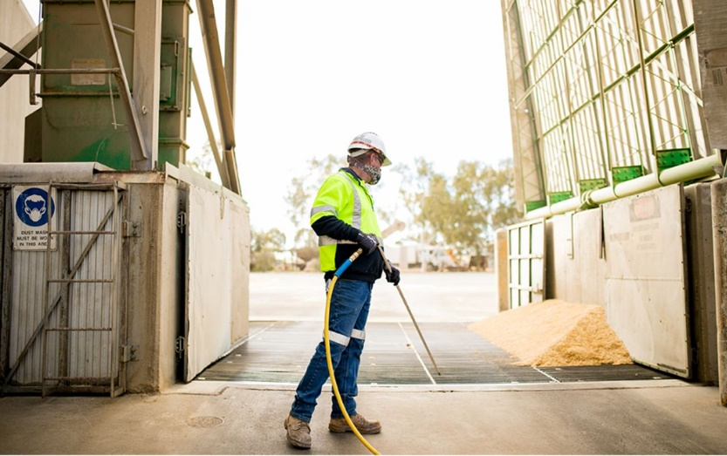
We have had so much rain that we are sure to have yet another bumper harvest and farmers will be scrambling for workers to help them bring in the crops.
They have started advertising already. The pay is $29/hour, there is training, free accommodation and a range of roles. Check details HERE.

Vacation Swimming Instructor Jobs
If you are 17 you can be a qualified swimming instructor.
Check the qualifications you need HERE.
Check Jora for Swimming Instructor jobs across Western Australia

Final Semester Year 12 is tough
These resources from In Focus Careers are designed to help:
- Year 12 Burnout Busters – Trying to maintain interest in Semester 2, Year 12 is tough. Help is available. This post provides links to support, strategies and tips to help you to get through.
- Do this to achieve ATAR success in December – This is a step by step pathway to ATAR success. Plan for success.
- Alternative Paths to uni in WA in 2024 – If you are not going to get the results that get you into your ideal course, there are lots of alternate paths you can take.

Year 11 Opportunities

31 July Applications close: National Youth Science Forum 2024
Current Year 11 student who are passionate about STEM can meet like-minded young people from across Australia at the National Youth Science Forum in January?
You not only meet people who could become future colleagues, you will meet leaders in various scientific fields who will teach you and chat with you about their work.
Find out more and apply HERE.

Register Now: Fogarty Futures Leadership Conference for Years 10 – 11, 29 September – 2 October
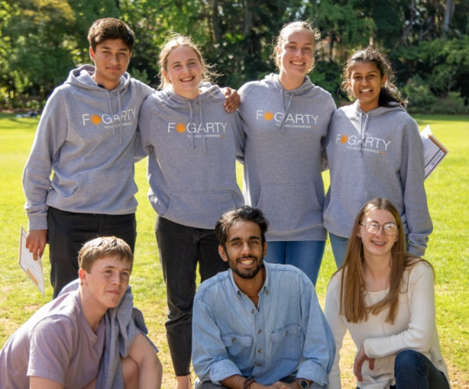
Fogarty Futures Leadership Conference empowers years 10 and 11 students with leadership skills for the future. Based in Western Australia, we seek to encourage students to develop a passion for social justice and benefit their local communities. Soft skills such as leadership, communication and interpersonal skills are not taught in schools, despite being vital to living in a modern globalised world; Futures aims to fix this gap. Find details and apply HERE.

Year 10 Opportunities

31 July School based Traineeships in the Public Sector 2024
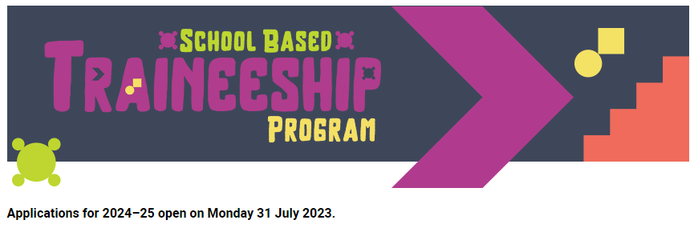
The School Based Traineeship Program provides students entering Year 11 a fantastic opportunity to gain on the job experience and build workplace skills while earning a part time salary.
Find details HERE.

Middle School Opportunities

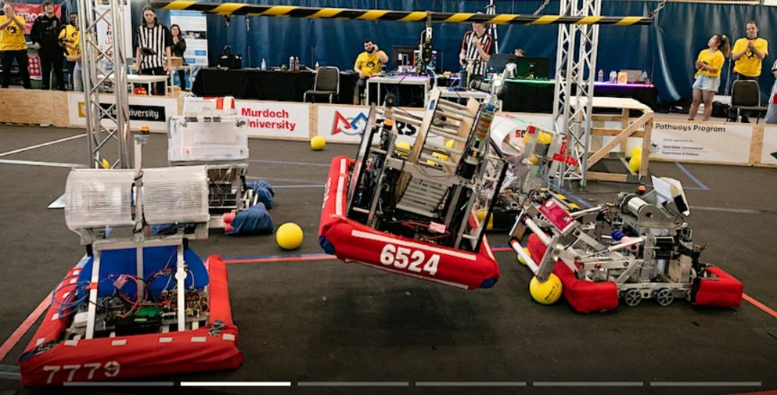
26 - 27 August WA Robotics Playoffs
Get along to the Curtin Uni Stadium (the big building off Kent St) to see the robots students have built to compete in this 3 on 3 basketball competition.
Watch a video about the competition HERE.
Reserve a spot HERE.

Year 8 Opportunities

Scholarship for Year 8 Girls going into Year 9
Smart girls in government schools who are experiencing economic hardship can apply for a Harding Millar scholarship.
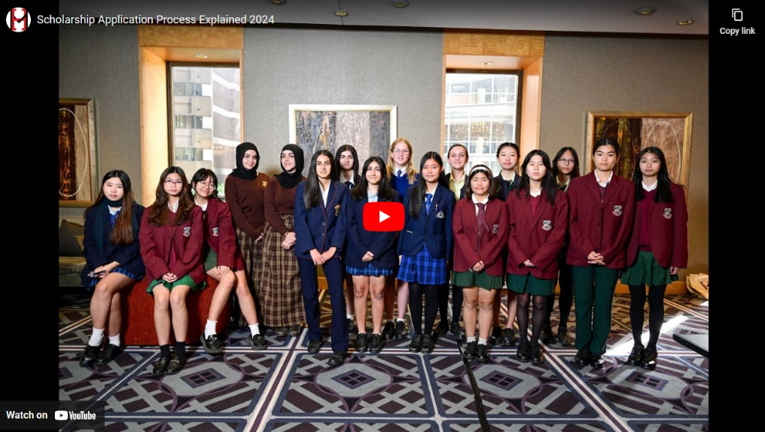
This scholarship is for 4 years and includes:
- A high-quality laptop
- Online IT support
- High-speed internet
- $2500 worth of online or face to face tutoring
- Online homework help
- Prepaid expense cards for essential school needs such as uniforms, textbooks, and school excursions
Applications close on 13 September.
Find details HERE. There are information sessions on 25 July and on 27 July.

RRR Opportunities

Department of Education Career Conversations
- 25 July Newman
- 27 July Carnarvon
- 8 August Kununurra
- 10 August Tom Price
These events are a great initiative by the Department of Education that is working to ensure parents and students have a better idea of career opportunities that are available. To register go HERE.

25 August Murdoch University RRR online information session
Attend our Online Regional & Remote Student Q & A Session and find out everything you need to know about making the transition to uni and studying as an undergraduate at Murdoch.
You’ll have the opportunity to explore the wide range of courses we offer and hear the real experiences and support from our staff and students.
You'll also have the opportunity to ask our staff and student advisers any questions you might have about studying, student experience, accommodation, support and much more.
To be reminded of the event please register now.

26 July VET DSS Open Night Geraldton
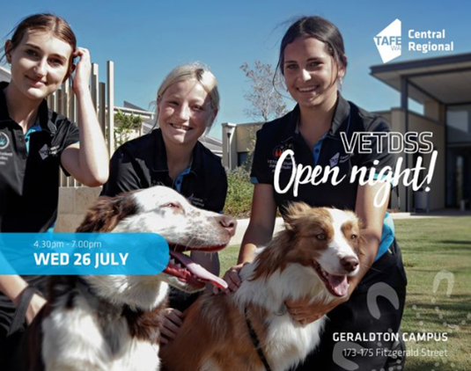
𝗔 𝗴𝗿𝗲𝗮𝘁 𝗼𝗽𝗽𝗼𝗿𝘁𝘂𝗻𝗶𝘁𝘆 𝘁𝗼:
- Meet our amazing Lecturers.
- Check out our facilities and State-of-the-Art equipment.
- Grab a bite and...
- Listen to some live music!
The event will start at 4.30pm and we invite you to meet up by the outdoor Canteen Area on Campus
𝗙𝗼𝗿 𝗺𝗼𝗿𝗲 𝗶𝗻𝗳𝗼𝗿𝗺𝗮𝘁𝗶𝗼𝗻, 𝗽𝗹𝗲𝗮𝘀𝗲 𝗰𝗼𝗻𝘁𝗮𝗰𝘁 𝗼𝘂𝗿 𝗚𝗲𝗿𝗮𝗹𝗱𝘁𝗼𝗻 𝗩𝗘𝗧𝗗𝗦𝗦 𝗰𝗼𝗼𝗿𝗱𝗶𝗻𝗮𝘁𝗼𝗿:
E: VETDSS@crtafe.wa.edu.au T: 0417 918 051

28 July Morawa College of Agriculture Open Day
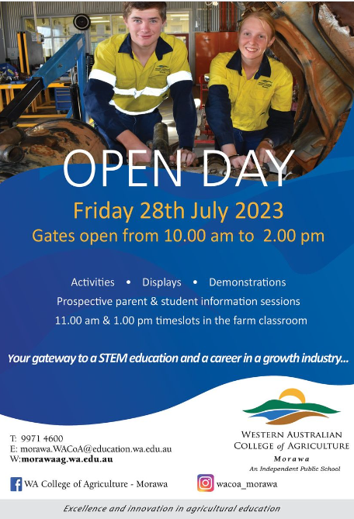
Staff and students take the opportunity to showcase the college. There will be teachers available to give information about courses and students will be able to tell prospective students what to expect.

Find details HERE.

Health Industry Scholarships and Grants
Information about scholarships and grants for medical and allied industries is collated on this page.

RRR School Leavers Information Kit
The Australian Government has provided this information kit for RRR school leavers:
- Are you moving away from home?
- Rural Inspire
- Resources
- Pathways
- Explore different journeys for school leavers
- Additional supporting resources

Science Week Grants Regional Projects
Jerramungup and Ravensthorpe  Living and Learning the Biosphere | The Fitzgerald Biosphere is internationally and nationally recognised for its high biodiversity richness. The Living and Learning the Biosphere events aims to connect people to foster an understanding and take ownership.
Kondinin  Super Sunday Science Funday  Community Resource Centre | This is a spectacular science stage show and interactive hands-on experiments that participants can rotate through.
Nannup  Birds of a Feather, Flower and Garden Festival  Nannup Garden Village | Experts from the Blackwood Valley Raptor Centre, will be talking about all things birds at this exciting session during the Nannup Flower and Garden Festival
Carnarvon | The Youth Team from the Shire of Carnarvon are delivering three events:  - a Young Rocketeers workshop at the Carnarvon Space Museum.  - an agriculture workshop, run in partnership with Central Regional TAFE and DPIRD,  - a Young Engineers Challenge
Geraldton  On the Road with STEM Kids  The Community Toy Library | Children aged 3 – 8 and their families will discover how to ask questions, problem solve, experiment, hypothesis and evaluate with 8 curated STEM play environments to investigate.
Harvey  Curious Minds  The Shire of Libraries | For children aged 4 – 14. Activities will include Lego Mindstorm, Turing tables, and challenge activities such as structure and bridge building, algorithm games, and marble runs
Toodyay  Robotics Day  Community Resource Centre | Participants will learn how to interact, service, program and build humanoid robots with advanced digital technology and artificial intelligence.
Broome Festival of STEM  3 – 4 August | There will be two parts to the festival with a school festival during the day and a community festival in the afternoon.  The festival will take place at the Broome Civic Centre. Find details HERE.
Gascoyne Rocks  Mt Augustus rocks, crystals and minerals | Participants will discover what links Mt Augustus rocks, crystals, and minerals to the rocks in space through a night with experts at Gascoyne Junction Town Pavilion.
York  STEM Embrace for All Community Resource Centre | This will include activities like Lego maze coding, building a hand crank winch, stop motion animation video creations, jellybean building and so much more. The Science Alive team will run two interactive shows for the community.
Hopetoun  Elemental Energies  Community Resource Centre | A series of hands-on workshops for children and adults will teach participants how to create energy from the earth’s elements.
Broome  Red Dirt Robotics | Five 3D design and printing sessions will be delivered at Broome Public Library. The local tech exploration group, Innovation Station, will work with the founder of Red Dirt Robotics to deliver these workshops to their community, inspiring teens to get involved in the local group.  Find details HERE.
Karratha  Makedo Maker Space Library  31 July | Join us at the City of Karratha Libraries for special sessions using the Makedo system in hands-on, large-scale cardboard construction activities.  Aimed at ages 4-12 years old. Find details HERE.

Aboriginal and Torres Strait Islander

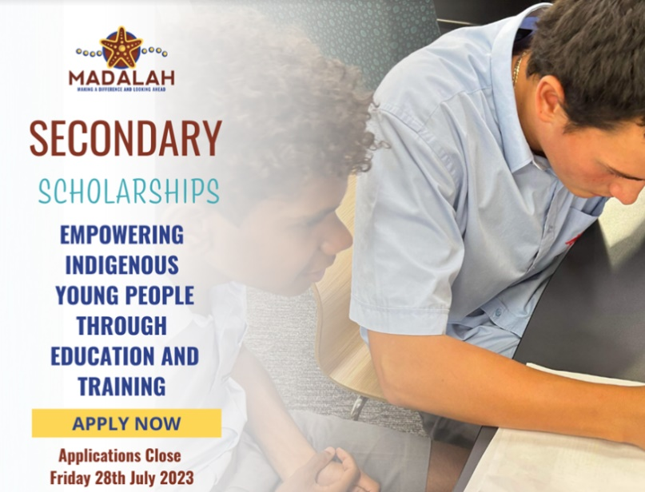
28 July Madalah Scholarship Applications Close
URGENT Applications close soon.
These scholarships are for Indigenous students to attend WA’s leading boarding schools and universities. For information go HERE.

Apply now for Army Work Experience - Applications Close 17 September
Indigenous Army Careers Day - WEP/02599/23 (26th October 2023) Job Ref - WEP/02599/23  - 26th October 2023  - Irwin Barracks  - Army  Information Pack Word Document Information Pack PDF Document | - Start New Application  - Access Existing Application  - Preview Application Form

Aboriginal Cadet Applications Open
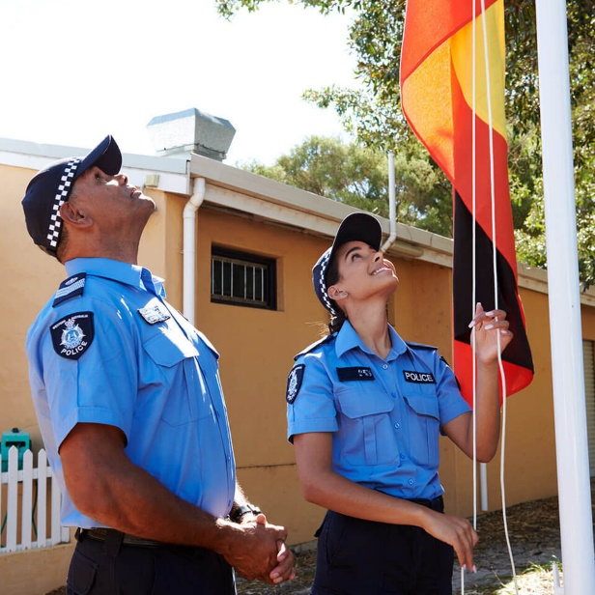
If you are 17 or over and an Aboriginal or Torres Strait Islander, you are eligible to apply for a Police Cadetship.
You can apply while 16 but must be 17 upon selection to a Cadet school.
Find out about the recruitment process HERE.

Stephen Michael Foundation
The Stephen Michael Foundation has grown from the world of Aussie Rules and a belief in the power sport in the development of leadership, cultural awareness, educational achievement and well-being.
It is not exclusively for Indigenous young people as one of its pillars is to build engaged and inclusive communities.
There are programs run across
- Perth Metro
- Upper Great Southern
- Gascoyne and
- Murchison.

To find how you can engage with the Foundation go HERE.

Scholarships for Aboriginal and Torres Strait Islander students to study health industry courses
The Aboriginal and Torres Strait Islander students will find lots of career opportunities at HealthInfoNet like these scholarships:

- Puggy Hunter Memorial Scholarship (for the Australian College of Nursing)
- Indigenous Health Scholarships.

Free University Places for Indigenous Students
From 2021, the Australian Government guaranteed Aboriginal and Torres Strait Islander students from regional and remote areas a Commonwealth supported place.
This measure has now been extended to all Aboriginal and Torres Strait Islander students regardless of location. From 2024, all Aboriginal and Torres Strait Islander students in Australia will be guaranteed a Commonwealth supported place at a university of their choice, when accepted into their chosen course of study.
Find details HERE.

New First Nations workforce analysis reports
Two significant reports have been released:
- First Nations Workforce Analysis
The First Nations Workforce Analysis finds a number of positive trends emerging.
- In the 5 years to 2022, the number of First Nations People working as Contract, Program and Project Administrators increased by 42% nationally. Other occupations which saw strong First Nations growth included Welfare Support Workers (33%), Aged and Disabled Carers (31%) and Child Carers (22%).
You can find the full report HERE.
- Employers Experience of First Nations job applicants
The survey found that First Nations applicants have a 70% success rate when applying for jobs and 93% of businesses who hired a First Nations applicant said the person had adjusted well in the workplace.
- Some 52% of businesses used strategies to assist First Nations applicants to transition into the job, with a buddy or mentoring system being most common.
- Ten per cent of businesses accessed programs and subsidies when employing a First Nations applicant.
- Even though the transitions of applicants into small business’ workplaces are good (92%), First Nations applicants are less likely to be successful in getting a job in small businesses (61% of applicants) compared to medium to large businesses (82% and 73% respectively).
You can read the report HERE.

Students with Disability

25 - 26 August Disability Connections Expo
More than 250 service providers under one roof, participants, their families and carers can exercise greater choice and control over their care.
Find details HERE.

Support for apprentices with disability
The Melbourne Apprenticeship Disability Network (MADN) in partnership with the Australian Apprenticeship and Traineeship Information Service (AATIS) have released a series of 5 blogs to support those living with disability to understand Australian Apprenticeships.
- Part 1. Getting the most out of an apprenticeship or traineeship
- Part 2. The benefits of doing an Australian Apprenticeship
- Part 3. The way that parents, carers and allies can support careers transitions
- Part 4. Support for Australian Apprentices with disability
- Part 5. Choosing the right employer
View the article

Curtin Portfolio Entry for Students with a Disability
Students who have a disability that is a barrier to undertaking mainstream entry pathways can explore Portfolio Entry at Curtin

People with disability School Leavers Information Kit
There is a range of programs and support for people with disability of special education needs for life after school.
- National Disability Insurance Scheme (NDIS) support
- Should I disclose my disability?
- Workplace adjustments
- Resources
- Pathways
- Parents and guardians
- Explore different journeys for school leavers
- Additional supporting resources
- Financial assistance
Thanks to Penny Walmsley from Byford Secondary School for sending this through.

International Student Opportunities

25 July Notre Dame Overseas Qualification Infoarmation
Have an overseas qualification and are interested in exploring your Notre Dame study options for 2023? Join our online Overseas Qualification Information Session.
12.noon - 12:45pm Online. Register HERE

ECU Scholarships for international students
Check out scholarships for international students. There is a wide range or scholarships including some for:
- foundation students who are working to learn how to succeed in a degree program.
- An ELICOS scholarship
- Accommodation scholarships.
Check them out HERE.

Migration Website
The updated WA Migration website aims to help migrants obtain essential information and assistance throughout their migration process. The website provides comprehensive details about the various services and support available to migrants and employers.

To learn more about these initiatives, visit the updated migration.wa.gov.au website or reach out via email to jobconnect@dtwd.wa.gov.au.

Blog Posts

Time to Kick Start the Creative Magic of Year 12s
Year 12s were hard hit by Covid. They were in Year 9 when it hit. We kept them safe and supported to reduce their uncertainty. Perhaps we knocked the legendary Year 9 rebellion out of them. The ideas in this mind-map might help Year 12s to kick start their creative endeavours.
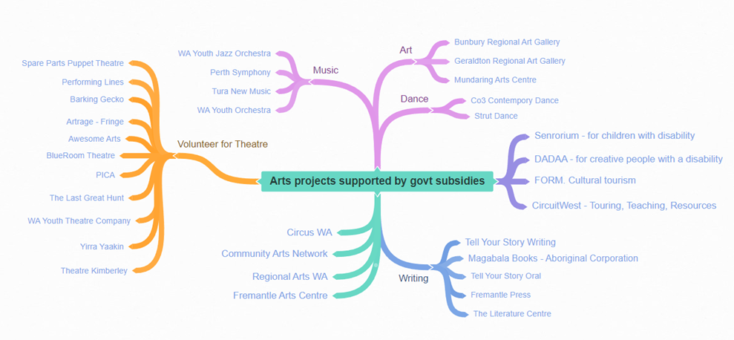

Do this to achieve ATAR success in December
Year 12s can start to wobble as they head towards the end of their school career.
This post provides a step by step pathway to ATAR success. Find it HERE.

Year 12 Burnout Busters
Trying to maintain enthusiasm when it seems more about the past and only vaguely about the future is one of the most common struggles faced by Year 12s.
This post identifies tips, strategies and support that can help Year 12s to get through this tough time.
Read it HERE.

Alternative Paths to uni in WA 2024
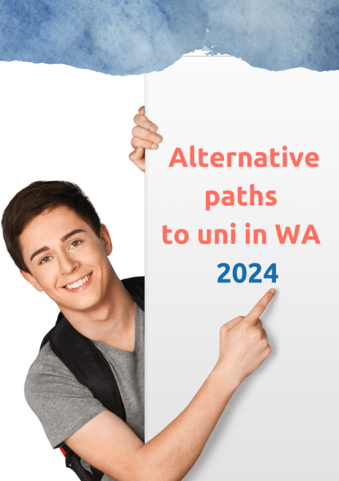
Anxiety is hitting Year 12s as they worry about ATAR scores and getting into the course they want in 2024.
Universities want you to choose to study with them.
They all provide alternative pathways which are often free and which are great preparation for success in undergraduate degrees.
This booklet identifies Alternative paths to universities in Western Australia in 2024. You can get it HERE.

