|  |
| --- |
|  |
| |  |  | | --- | --- | | |  | | --- | |  | | |

[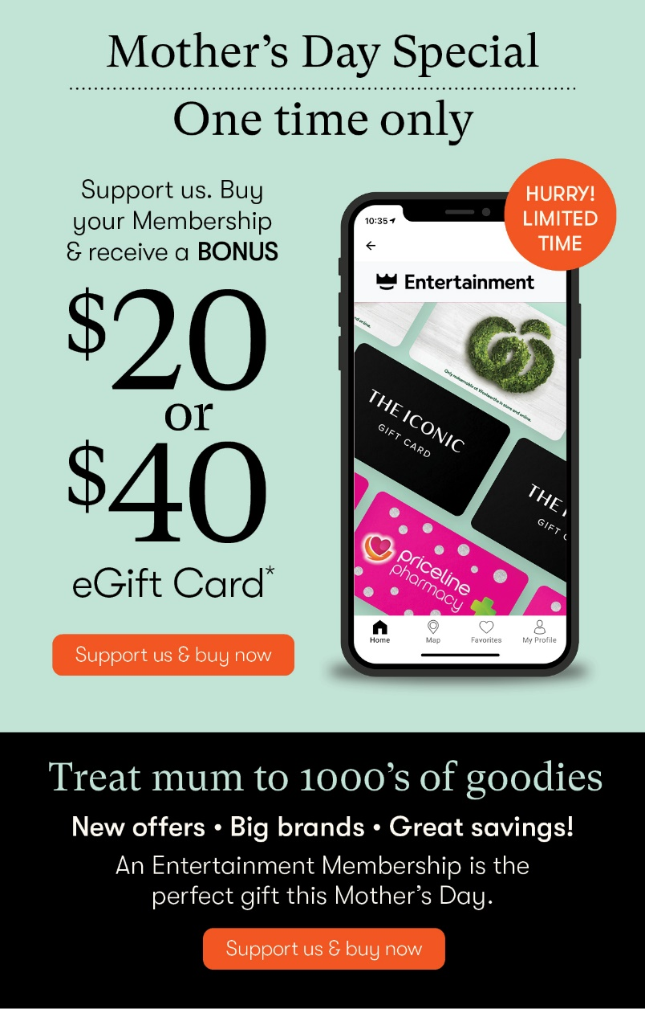](http://link.e.entertainmentbook.com.au/rts/go2.aspx?h=650071&tp=i-1NGB-78-DWw-YLXxC-22-2qM-1c-YLVuo-l5wcUl4Vpw-1Y3ebB&x=186r349%7c52014%7c507530834%7ci-1NGB-78-DWw-YLXxC-22-2qM-1c-YLVuo-l5wcUl4Vpw-1Y3ebB)