Mukinbudin District High School  
 An Independent Public School

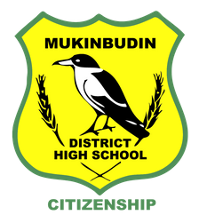

A: White Street, Mukinbudin, WA 6479 | P: 90471053   
E: Mukinbudin.DHS@education.wa.edu.au

**SECONDARY LOCKER PADLOCK CONSENT FORM 2021**

Student Name ________________________________________________ Year ___________

Student Locker No. _______ Padlock Serial No. _____________________

*I understand that I that I will be responsible to pay a replacement fee of $15.00 if the padlock is lost or damaged.*

Parent/Guardian Name ____________________________ Signature ________________________

Student signature ________________________________ Date / /

Mukinbudin District High School  
 An Independent Public School



A: White Street, Mukinbudin, WA 6479 | P: 90471053   
E: Mukinbudin.DHS@education.wa.edu.au

**SECONDARY LOCKER PADLOCK CONSENT FORM 2021**

Student Name ________________________________________________ Year ___________

Student Locker No. _______ Padlock Serial No. _____________________

*I understand that I that I will be responsible to pay a replacement fee of $15.00 if the padlock is lost or damaged.*

Parent/Guardian Name ____________________________ Signature ________________________

Student signature ________________________________ Date / /