In Term 3 Banksia Place 3C have been exploring a range of different climates during our Topic ‘Wonderful Weather’, experiencing a range of them as well throughout our Winter Term!
The students in our class have been focusing on teamwork this term, playing games together, completing group tasks and presentations, understanding others’ opinions and solving problems together. We had a week of swimming lessons this term that was a massive success. I am very proud of everyone for their hard work in the pool.
In the classroom, we have completed the topics of Sharing and Grouping and fractions in Maths, learned about every day and extreme weather types that occur around the world in Topic classes, witnessed different chemical reactions in our exciting science lessons and further enhanced comprehension skills, expressive writing and sequencing in our English lessons.
When visiting the stadium for Physical Education we have perfected the skills of sprinting, the long jump and a range of throws in our Athletics topic, as well as discovering some budding superstars of the future in our AFL topic. During Art lessons we have created a range of pieces closely linked to ‘Wonderful Weather’ including weather symbols and stages of the moon cycle. In the kitchen, we have cooked up a storm of cheese toasties, mini pizzas and our very own cereal bars with some students honing their skills further while at the school Café.
We have had a very busy term of learning and activities this term so I hope everyone has a well deserved rest over the holidays!
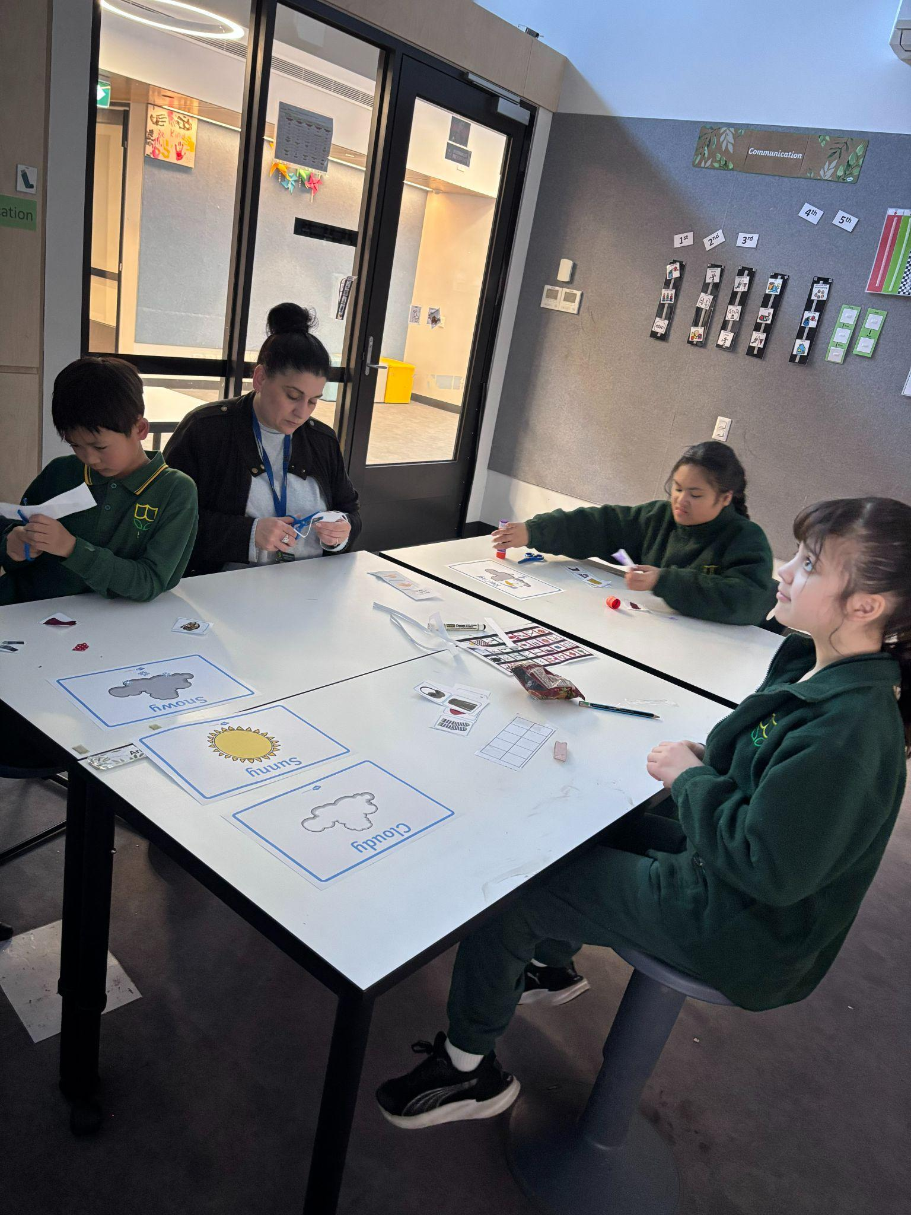
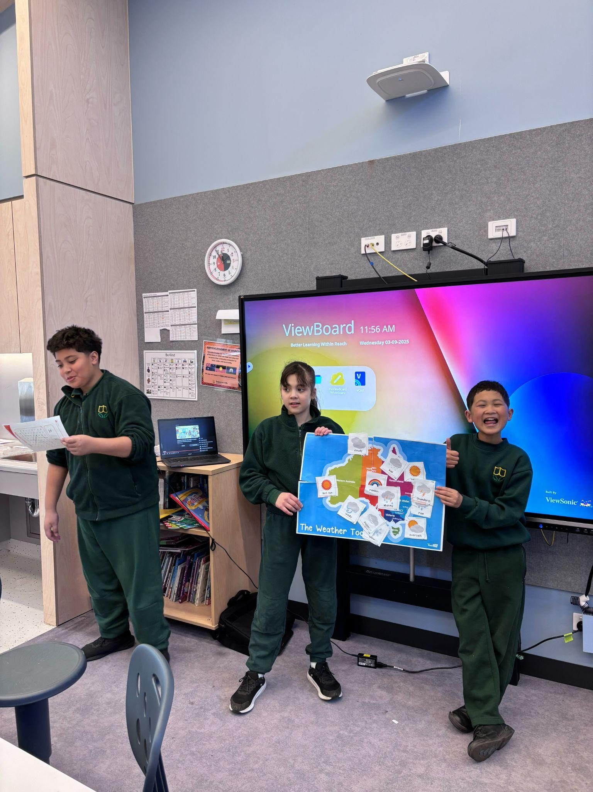
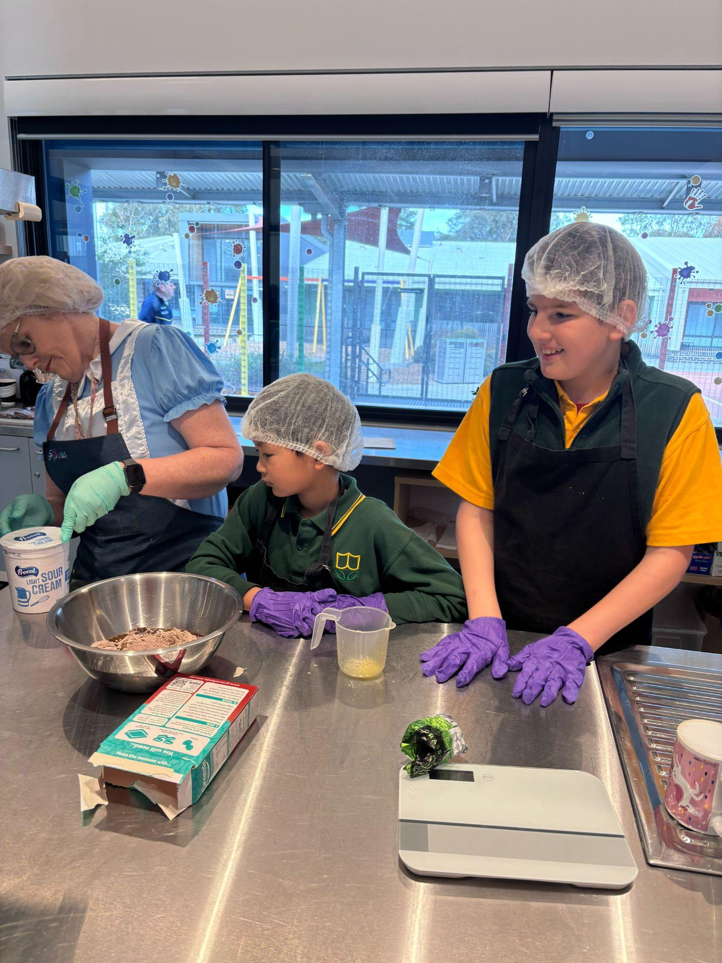
Lorcan and Sandra can’t wait to see you all in our final term of the year.

