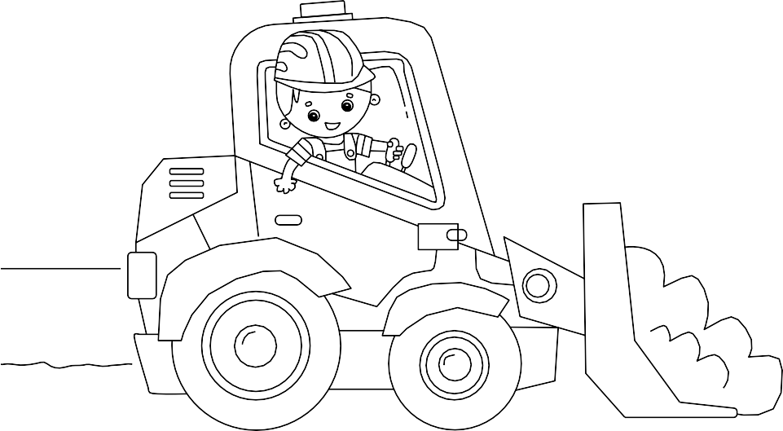
NAME THE CRANE COMPETITION

THIS CRANE IS NAMED: WHY:

WE NEED YOUR HELP TO NAME OUR CRANE!
NAME THE 90 METRE TOWER CRANE ON
OUR NORTH MELBOURNE PRIMARY SCHOOL SITE

YOUR DETAILS

My name is: | My age is:

Please ask your parent or guardian to sign below

Parent/guardian name: Parent/guardian telephone number: Parent/guardian email:

Parent/guardian signature: | Date:

THE CONSTRUCTION PROJECT
Hansen Yuncken is national construction company. We are building a new campus for the North Melbourne Primary School.
The finished product will be able to accommodate an additional 525 students.

THE COMPETITION
Since the crane will be around in North Melbourne until May 2022, we want your help to give it a name so it can be a proper part of the construction team!
The winning student and their immediate

GIVE YOUR ENTRY TO YOUR TEACHER AT NORTH MELBOURNE PRIMARY SCHOOL
Terms and conditions:

There will be multiple outdoor play areas including to the roof of the new building. The new campus is only a short walk down the road from the current school.
We have installed a tower crane in the middle of the site to help move heavy materials around while we work. The crane can reach up to 90 metres in the air, and was built using strong concrete footings, which have been drilled deep into the ground to make sure it is safe and can lift everything we need around the site.
family will be invited to attend a crane naming ceremony on the construction site, where you can see the newly named crane up close.
We will also be awarding a prize for the runner up, and the best coloured entry.

HOW TO ENTER
- Collect your entry form.
- Complete the entry form and colour it in.
- Ask your parent or guardian to sign your entry.
- Hand in the completed form to your primary teacher at North Melbourne Primary School.

Entries close on Friday 12 November.
- The name the crane competition is open to students attending North Melbourne Primary School.
- The prize is the opportunity to attend the official crane naming ceremony and receive a special prize.
- Winners will be notified by the North Melbourne Primary School Principal.
- To be eligible to win, entrants must obtain permission from their parent or guardian on the competition entry form and provide a completed form. By providing parental consent on the competition entry form, the entrant’s parent or guardian consents to be bound by these terms and conditions of entry in their own right.
- Any costs to attend the official crane naming ceremony are the winner’s responsibility.
- The entrant grants Hansen Yuncken the right to use the drawing and name of the crane for the North Melbourne Primary School development.
- By accepting the prize, the winner agrees to be contacted by the Hansen Yuncken project team and to participate in publicity activities as reasonably requested, including
being interviewed and photographed for use in marketing and promotional materials without payment or other compensation.
- The judge’s decision is final.
- Only one entry per child.

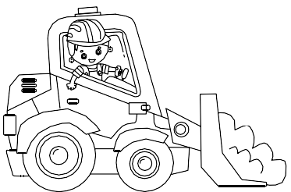
LAST DAY FOR ENTRIES IS FRIDAY 12 NOVEMBER 2021

