

29/11/2024

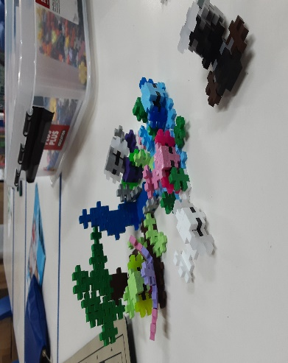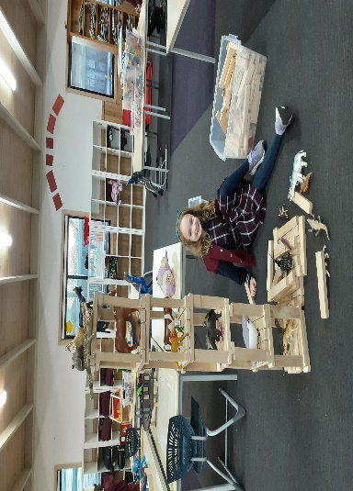[](https://pp.campaustralia.com.au/)

What coming up Rocketeers Holiday Program, we will be open on the 19th Thursday from school closure till 6-30pm and Pupil Free Day on the Friday 20th December from 6-45am to 6-30pm, please book if you need care. We will return on Monday 6th January 2025 for Rocketeers Program.

We Have the Crossing Supervisor visiting the service to give us a talk on road safety this Thursday and Friday.

* Crossing Supervisor Mel/Mel and John
* Big Art Lego
* Making Shortbread

**Activities coming up**

Join in the fun of Outside School Hours Care activities and experiences with Your OSHC and Rocketeers.

**Make a booking**

Book now

**Oatlands Primary School OSHC**