

**7/06/2024**

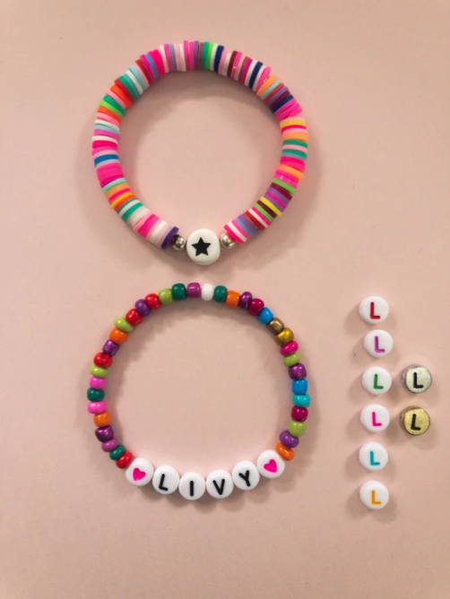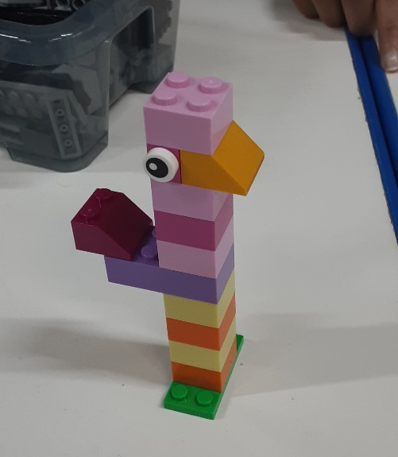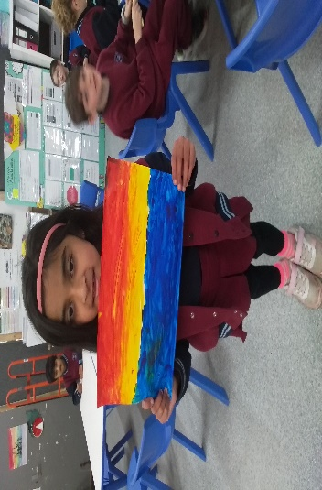](https://pp.campaustralia.com.au/)[](https://apps.apple.com/app/apple-store/id1529575453?pt=120333103&ct=edmbookings&mt=8)[](https://play.google.com/store/apps/details?id=au.com.campaustralia.parent)

**Oatlands Primary School OSHC**

Join in the fun of Outside School Hours Care activities and experiences with Your OSHC and Rocketeers.

**Make a booking**

Book now

* Ping Pong
* Marble Art
* Beaded Jewellery

**Activities coming up**

**A message from your Coordinator**

We hope everyone will enjoy their long weekend! At OSHC, The energy is sky-high as our young artists, builders and adventurers dive into a whirlwind of creativity and fun with their mates! Rain or shine, we are revving up the excitement with indoor activities, sports battles and ping pong showdowns. Don’t miss out on the action-packed fun at OSHC!