

**St Cecilia’s Primary School**

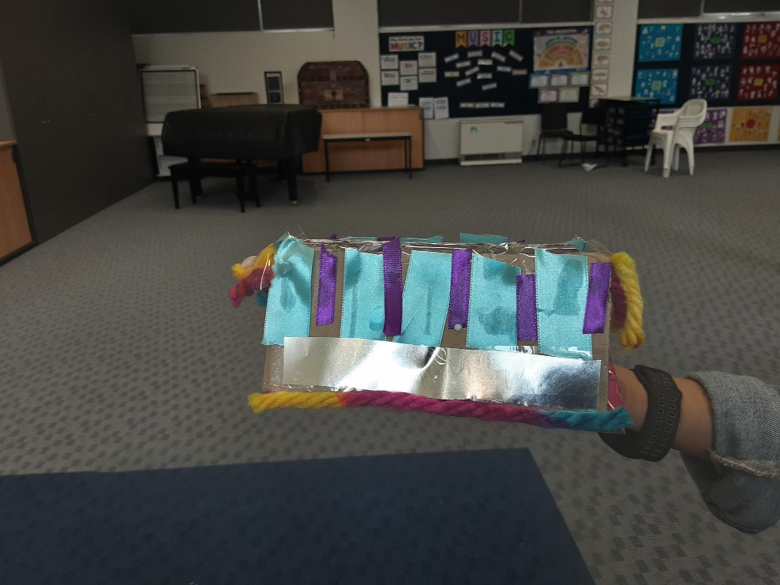 [](https://play.google.com/store/apps/details?id=au.com.campaustralia.parent)[](https://apps.apple.com/app/apple-store/id1529575453?pt=120333103&ct=edmbookings&mt=8)[Graphical user interface, text, application
](https://pp.campaustralia.com.au/)

Join in the fun of Outside School Hours Care activities and experiences with Your OSHC and Rocketeers.

**Make a booking**

Book now

**A message from your Coordinator**

Dear Camp Australia and Saint Cecilia’s Primary School families,

We've been focusing on fostering creativity, imagination, teamwork, and motor skills over the past two weeks. Through crafting, storytelling, and group activities. The children are exploring their creativity and enhancing their social and physical abilities. Our inclusive program ensures that every child feels welcome and valued.

Furthermore, our program places a strong emphasis on enhancing both gross and fine motor skills. Whether it's through arts and crafts or outdoor games, every activity is designed to promote physical development in a fun and engaging way. From painting to running and jumping, your children have been actively engaging their bodies and honing their motor skills.

We want to reassure all parents that Camp Australia is committed to creating an inclusive environment where every child feels welcome and valued. Regardless of background, ability, or interests, our program is designed to cater to the diverse needs of all children. If you have any specific concerns or suggestions regarding inclusivity, please don't hesitate to reach out to our coordinator.

Thank you for entrusting us with the care and enrichment of your children. We look forward to continuing our journey of learning and growth together.

* Lego tower
* Treasure hunt
* Sustainability day

**Activities coming up**