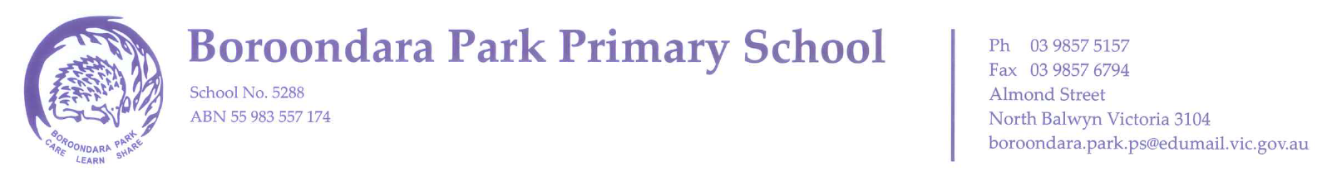

FOUNDATION TRANSITION CALENDAR
FOR STUDENTS BEGINNING SCHOOL IN 2022

Starting school is a major life transition for children and their families. It is a time of change that can be both exciting and challenging, during which children and families adjust to new roles, identities, expectations, interactions and relationships. At Boroondara Park Primary School, we provide a range of activities designed to help children and families become familiar with our school environment and build the relationships crucial to a successful start to school.

School Tours: By appointment
Monday May 24th | 2022 Foundation Information Night 7:00pm
Monday May 24th  9am - 12 noon  Tuesday May 25th  1:50-3:30pm | Open Days
Friday July 16th | Story Time Session One 2:50 - 3:20pm  (reading activity for Pre-School children)
End of July | Enrolments Due
Friday October 8th | Story Time Session Two 2:50 - 3:20pm  (reading activity for Pre-School children)
Tuesday November 9th | 2022 Foundation Transition Information Night 7:00pm  (for parents of enrolled 2022 Foundation students)
Wednesday November 24th | Foundation Transition Session One 2:15 - 3:15pm  (for enrolled 2022 Foundation students)
Wednesday December 1st | Foundation Transition Session Two 2:15 - 3:15pm  (for enrolled 2022 Foundation students)
Tuesday December 7th | Foundation Transition Session Three 10:00am – 2:00pm (for enrolled 2022 Foundation students)

