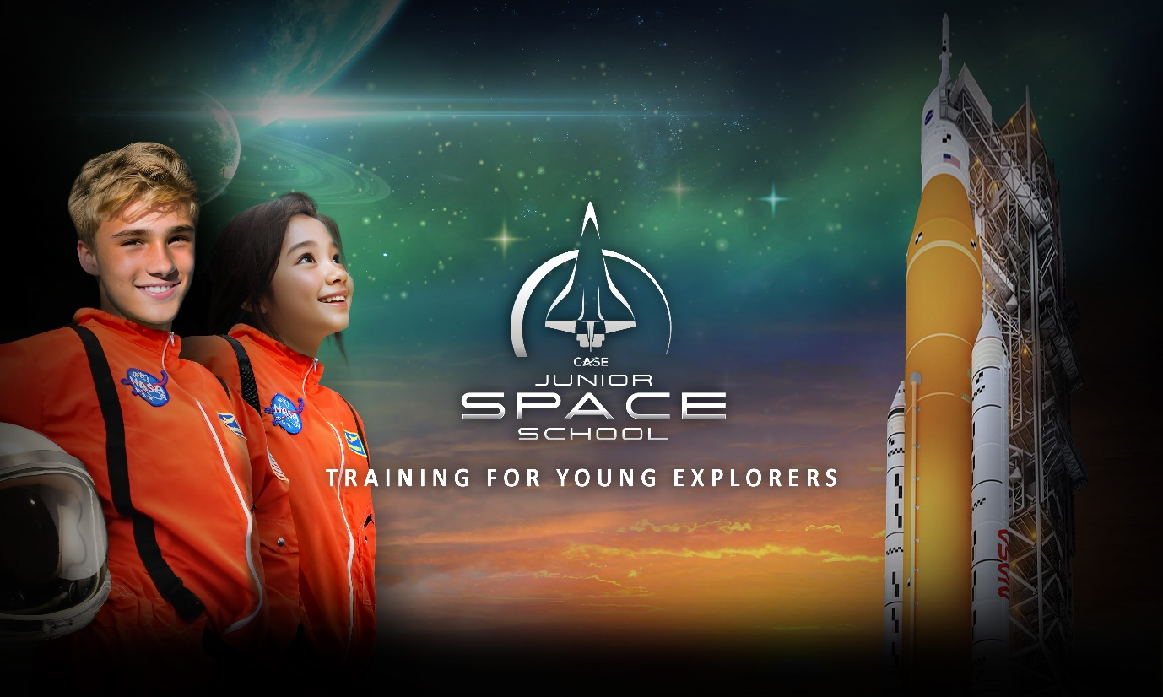
CASE Space School - Now Launching!
Clayfield College is excited to announce our participation in CASE Space School International Study Program during December 2025. All Clayfield College students are invited to join CASE Junior (Year 7, 8 & 9 in 2025) Space School and visit NASA in the USA!
Always at the forefront of innovation, the space industry is the most stimulating environment to inspire the next generation of STEAM-skilled leaders prepared to take on and succeed in our innovation-hungry world.
Demonstrating its robust academic content, CASE study programs are the only international STEAM study programs to have successfully obtained University of California (UC) GPA 5.0 approval. All participants will be eligible to receive a GPA 5.0 academic transcript to differentiate their application into top tier universities at home or internationally.
This immersive, engaging and inspiring learning experience is a wonderful opportunity for students to learn beyond the classroom and be inspired by the opportunities that lie ahead!

For further information visit:
https://actura.com.au/ccspace

Information Evening
6:00pm, Tuesday 30th April 2024, via Zoom
or contact:
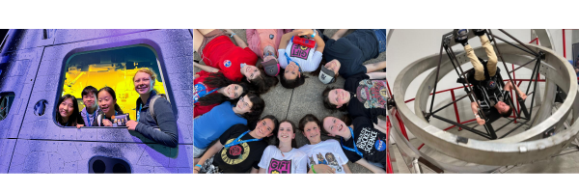
Martin Grelis: martin.grelis@actura.com.au

