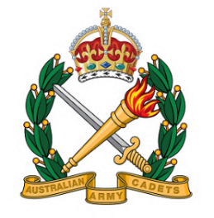
Join the Australian Army Cadets!

Adventure • Leadership • Teamwork

The Australian Army Cadets (AAC) is a youth development program for ages 13–17, offering exciting opportunities to learn leadership, teamwork, and resilience in a military-style environment.

What You'll Do
- Field Craft & Survival Skills: Learn how to set up camps, cook in the field, and stay safe outdoors.
- Navigation & Orienteering: Master map reading, compass use, and GPS navigation.
- Drill & Ceremonial Training: Participate in parades and learn discipline and precision.
- Adventure Activities: Abseiling, Kayaking, Hiking and bush craft, Obstacle courses.
- Leadership Development: Take on roles of responsibility and lead your peers.
- Community Engagement: Represent your unit at local events and ANZAC Day commemorations.

Benefits
- Build confidence and resilience
- Make lifelong friends
- Learn practical skills for life
- Experience teamwork and leadership

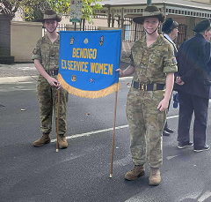
Ready to take the challenge? Intakes will be at the beginning of each school term.
Visit: www.armycadets.gov.au

309 Army Cadet Unit Bendigo (public page)

Local Unit Details

309 Army Cadet Unit
101 Atlas Road
Junortoun 3551

Parade Night: Tuesday nights during school terms, 6:30pm - 9:00pm
Email: 309acu@armycadets.gov.au

