“Bring It On” SOUVENIR T-SHIRT ORDER FORM - $25
Please pay at the General Office, and then place your receipt in an envelope with your order form into the box.
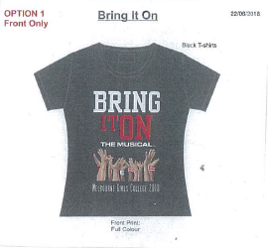
Final date for payment will be Wednesday 25th of July at 4pm.

Sizes available:
Childs 6, 8, 10, 12, 14
Ladies 8, 10, 12, 14, 16, 18, 20
Mens S, M, L, XL, 2XL, 3XL, 4XL, 5XL
……………………………………………………………………………………………………………………………………………………………
NAME:______________________________________________ FORM:_____________
(Please Print)
I would like to order and pay for the following T-Shirt/s:
Size | Quantity | Cost | Subtotal
 |  | $25
 |  | Total:

Melbourne Girls’ College
Yarra Boulevard, Richmond VIC 3121 Telephone: 9428 8955
STUDENT’S NAME: …………………………………………………………………………………………………….
PAYMENT FOR:
AMOUNT:  $ 25.00 |  |  |  |  |  |  |  |  |  |  |  |  |  | CVC: …………………………..
CARD DETAIL: Name…………………………………………………………… |  |  |  |  |  |  |  |  |  |  |  |  |  | Expiry Date: ……………..

