Le Fevre High School
OPEN NIGHT
Wednesday 21 March 2018
6pm to 8pm

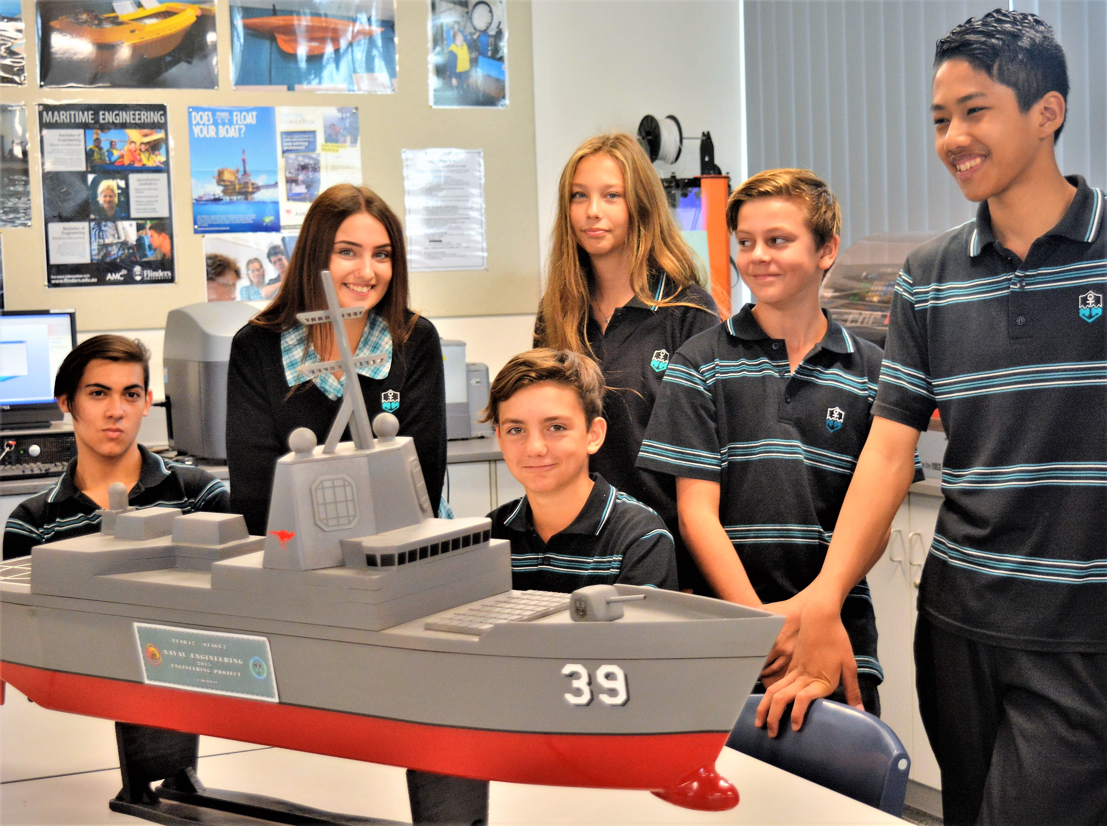

Explore exciting opportunities to build a strong future for your child at our Internationally Accredited School.

Meet the Principal Rob Shepherd and staff members at 6.00pm.

Guided tours of the school after the Principal’s address from 6.30pm.

HIGH ACHIEVERS CLASS Information provided at the Open Night.

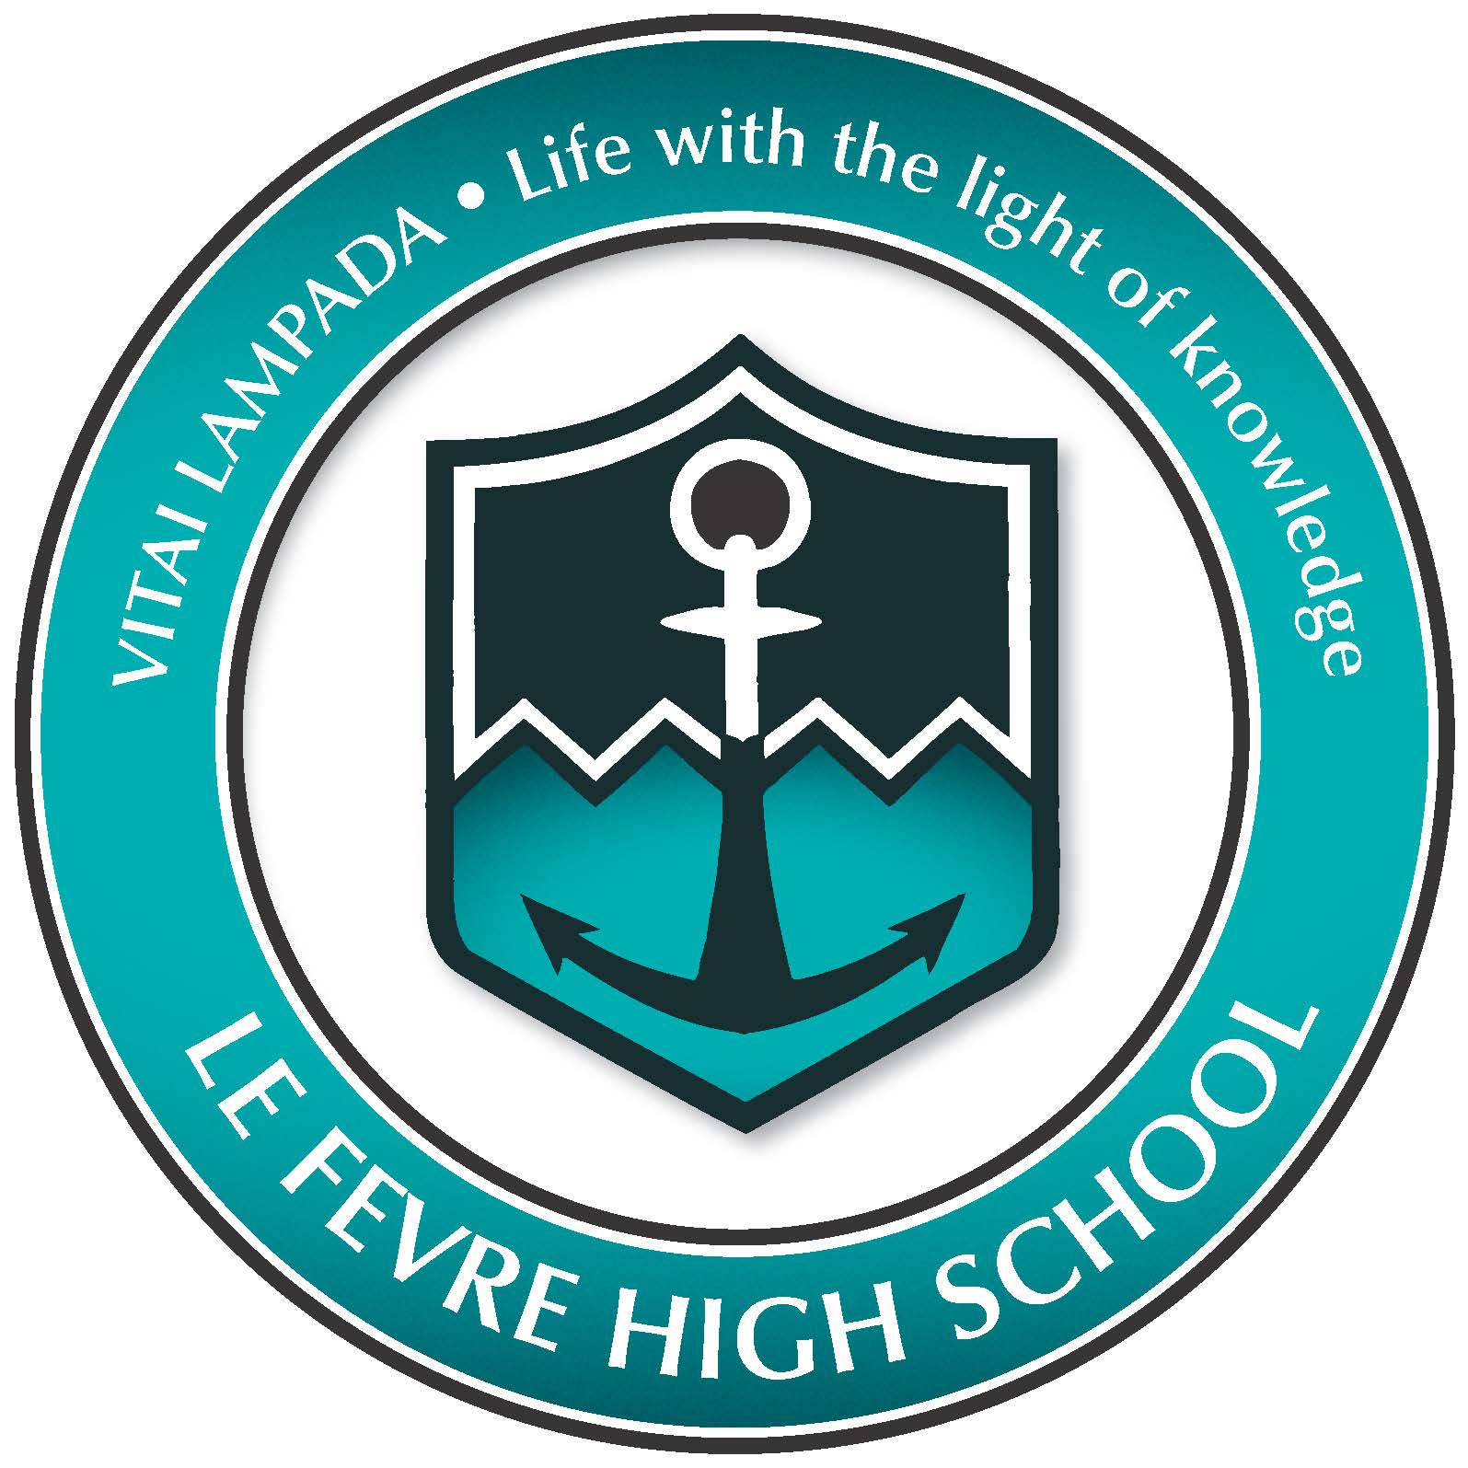 | Le Fevre High School  90 Hart Street, Semaphore South  www.lefevrehs.sa.edu.au  Phone: 8449 7004 for more details



