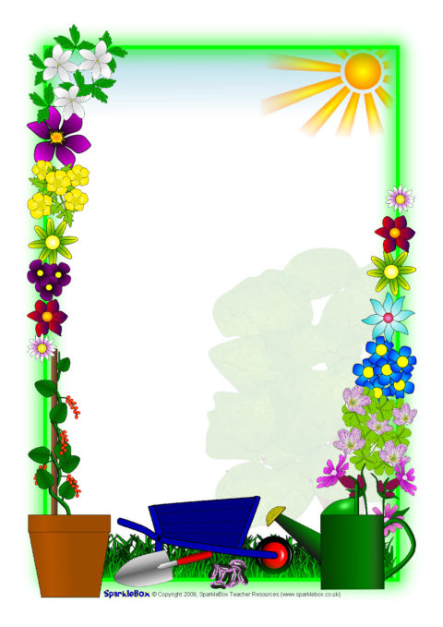

WEST BEACH PRIMARY SCHOOL

WORKING BEE

**Working Bee**

West Beach staff are working on maintaining and improving the vegetable garden and orchard space. We are planning to have a working bee to tidy up the area so it can be ready for sowing new crops. We hope to create a new and exciting outdoor learning space for our students.

**WHEN:** Saturday 26th June

**TIME:** 10am-1pm

**WHERE:** Vegetable Garden and Orchard Space (near native garden area and JP playground)

**WHAT:** Weeding, clearing the garden beds, pruning fruit trees that require pruning, empty compost bins

**BRING:** Some muscles, any useful gardening tools (eg shovel, spade, secateurs, pruners, hedge shears, handsaws, gardening gloves, etc)

There will be a sausage sizzle for all families who attend on the day as a token of our appreciation.

**We hope to see you there!**