*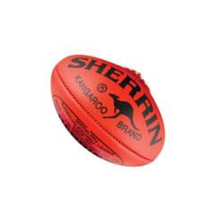Footy Day Meal Deal*

*Friday 16th of September*

***$6.00 Footy Meal Deal***

|  |  |
| --- | --- |
| **Pie**  **Meal Deal**  • Pie  • Donut  • Juice Box | **Sausage Roll**  **Meal Deal**  • Sausage roll  • Donut  • Juice Box |

**Extra Pie or Sausage Roll: $3**

*Please fill in the form below and return to school by Monday 12th September*

We are always looking for people to help package up the meal deal and take them to the grades.

………………………………………………………………………………….....

Student:_______________________ Grade:_____

Sausage Roll Meal Deal: _______________

Pie Meal Deal: ______________________

Extra Pie for $3:__________

Extra Sausage Roll $3: __________________

Amount Enclosed $_______________

Helper Name: _______________ MOB:___________

***Correct change required if possible***