
STATE SCHOOLS’ RELIEF
2026 Year 7 CSEF Uniform Package

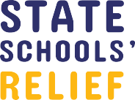
ORDER FORM
Applications for the 2026 Year 7 CSEF uniform package will open from Monday 06 October 2026 (beginning of Term 4, 2026).

School Name:

Student Name:

Date Of Birth:

How to use this order form
This form has been developed to assist schools with recording individual student uniform requirements. Please record the required sizes for your child and then return the form to the school.

Shoes
Please choose one shoe type only. Should you require assistance with sizing, the SSR shoe size conversion chart is available on our website. Indicate the shoe size in the appropriate column below (no half sizes are available).

Uniform
Eligible 2026 Year 7 students will receive one Primary School Wear (PSW) Uniform Voucher value of $85.
Please note: PE items are not included as part of this package.
Shoe Type | UK Size
Darcy Lace Up
Harper Lace Up
T-Bars

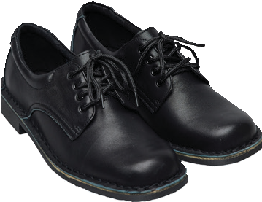
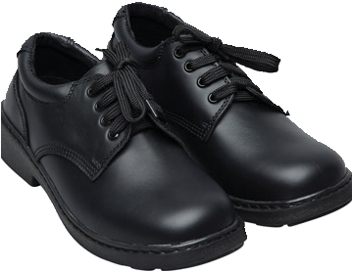
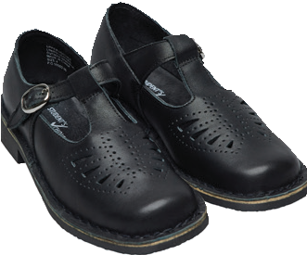
Darcy Harper T-Bars

Parent/Guardian Signature: Date:
Uniform Item
1 x Uniform Voucher | Value $85

Phone Number:

State Schools’ Relief | 1/8 Johnston Court, Dandenong South VIC 3175 | contact@ssr.net.au | 03 8769 8400 | stateschoolsrelief.org.au | ABN 77 455 214 193

