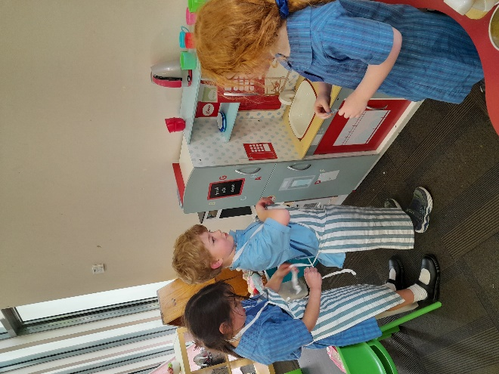

The start of Term 4 has flown by already!

Throughout these past few weeks, we have been continuing to post more regularly on our Class Dojo website. I post photos of the children engaged in the program as well as important dates.

Please let me know if you have any feedback or need to me to resend the link to join our Class Dojo.

The children have helped me by suggesting new toys and activities they would like me to buy for our service. They have been excited to start playing with the new resources

This included a new chess set, magic sand, more planes and car toys and fidget/calming toys for the quiet area.

# What’s been happening…

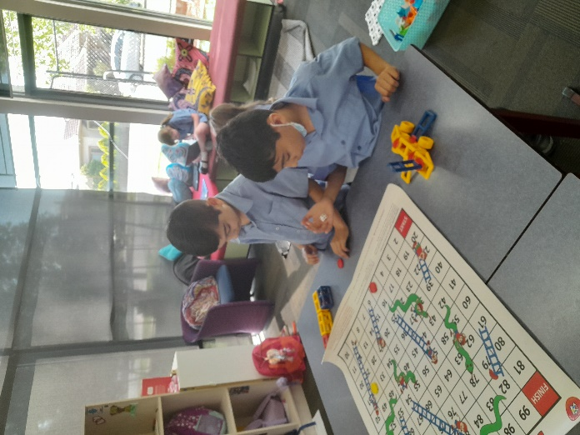

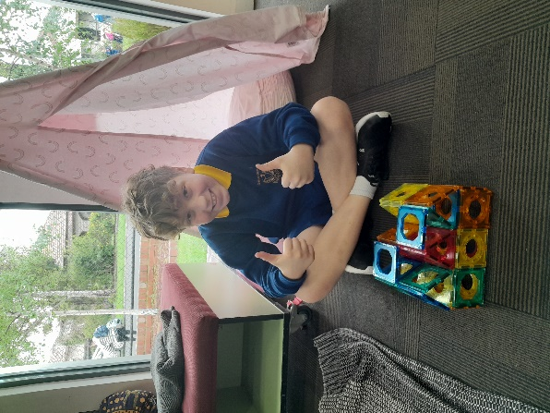

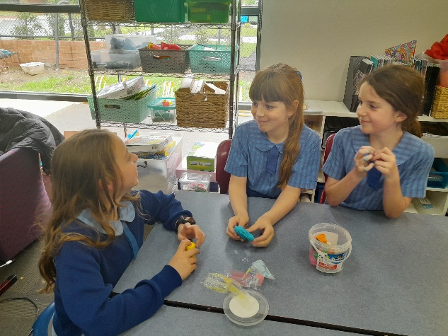

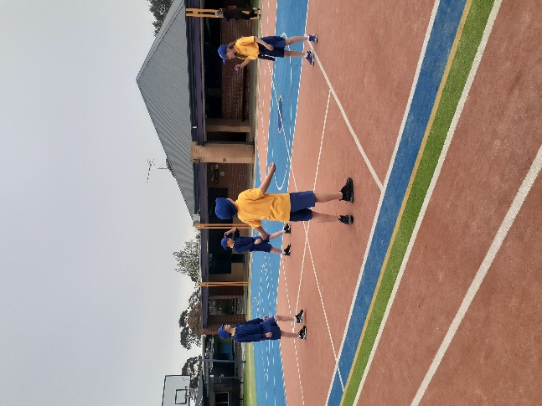

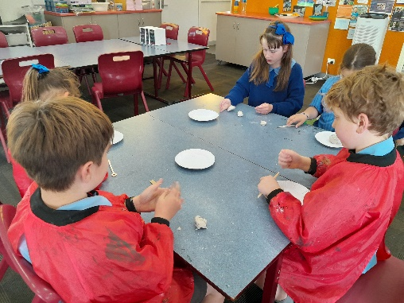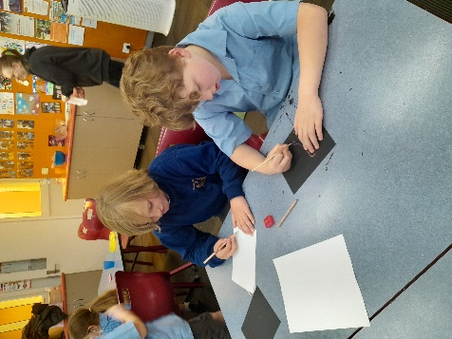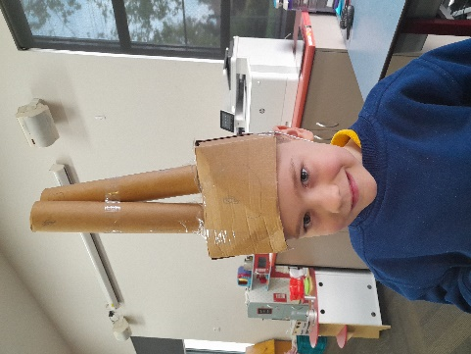

Melbourne Cup Public Holiday

Service Closed

Last day of Term 4

1pm finish

**Quality Area 6: Collaborative partnerships with families and communities**

Over the rest of the term, we will be focusing on families being supported to be involved in the service and contribute to service decisions.

We will be working on this by slowly implementing Class Dojo, which is an online platform to see photos of what the children have been up to.

School closure day

Service closed

If you have any queries or require further assistance, please contact us on 0401 501 661. Our contactable hours are between 7am and 9am and 3pm and 6pm; however, if you leave us a text message or voicemail outside of these hours, we will get back to you as soon as possible.

Furthermore, you can also call our Customer Service & Billing team on 1300 395 735

# Contact Us

# Quality Area Reflection

We have started a bucket of cardboard boxes that would usually go into the recycling bin but instead we are using them for art and craft. By incorporating them with textas, string, pipe cleaners and other materials the children have made some wonderful creations!

We have also been using our creativity with scratch art, drawing and clay

# Art & Craft Experiences

# Important Dates

# Let’s Reflect

# OSHClub Stars

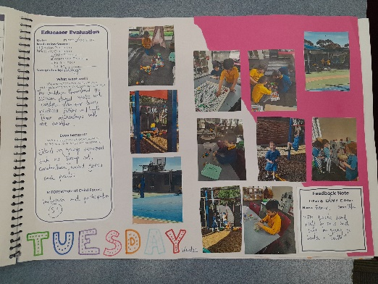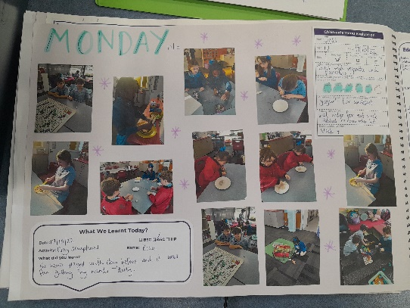

While playing on the playground Adelaide noticed her friend Elena sliding down the bars. When she got up onto the playground, she was nervous to try it. Elena and the educators helped her build confidence by going through each step of where to put her legs and hands. Elena demonstrated how to do it until Adelaide was confident enough to do it without assistance. Well done, Adelaide! It was awesome to see you build your bravery to try new playground tricks and a big thanks to Elena for helping her friend build confidence!

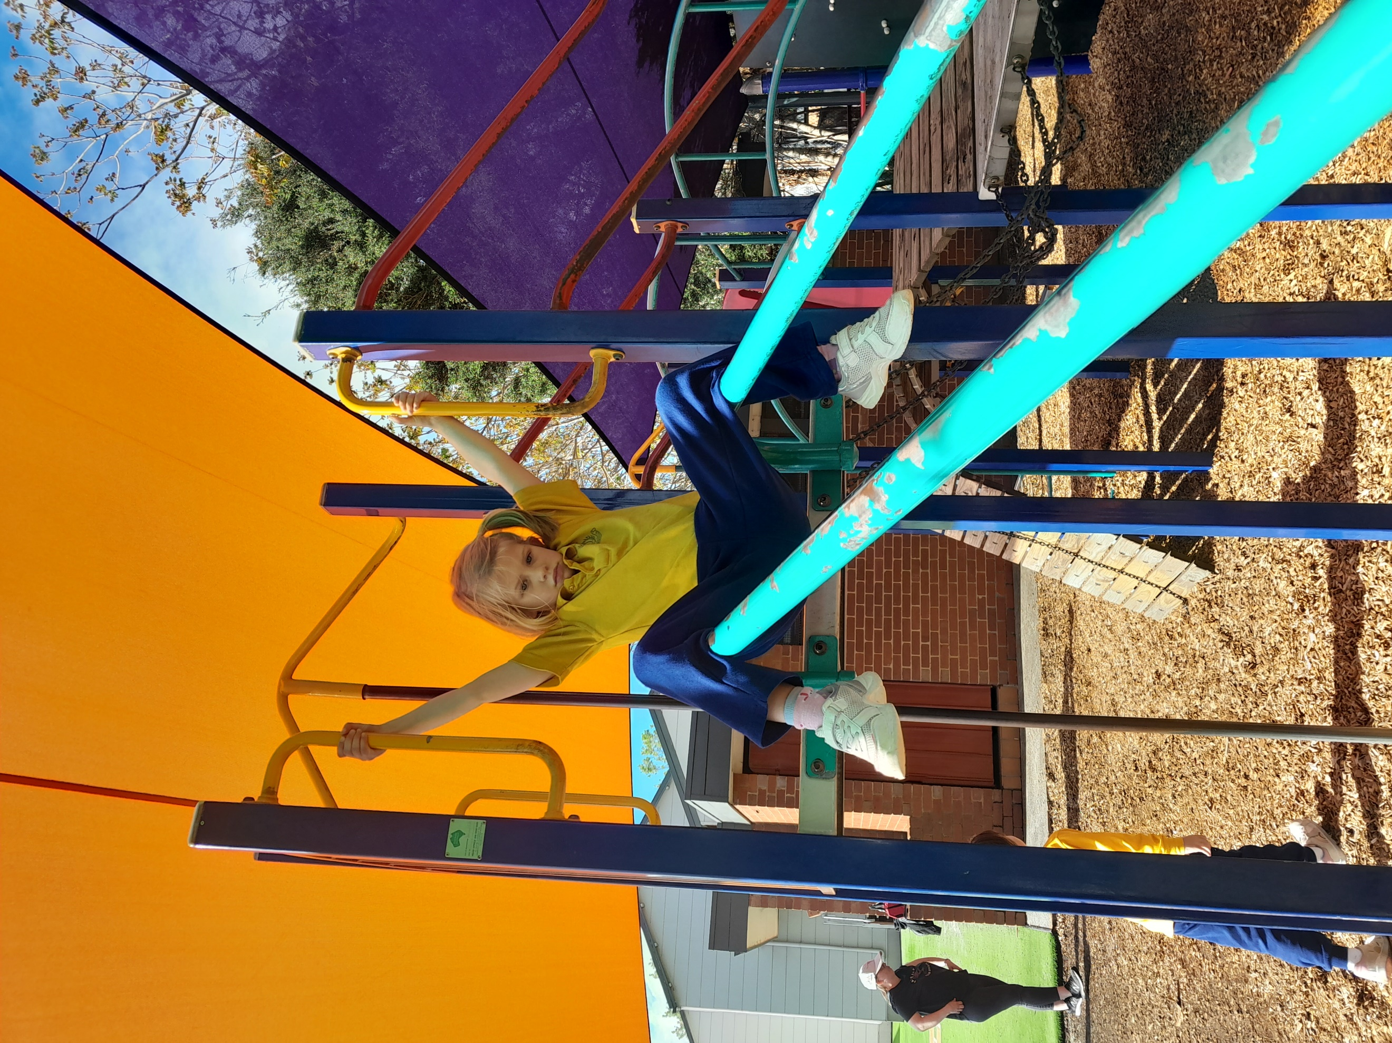

Well done to Taylor for creating cards for all the children that attended during that session. He went around and personally delivered them and read them out loud. Some examples of what he wrote in the cards are that they were kind and they were good helpers.

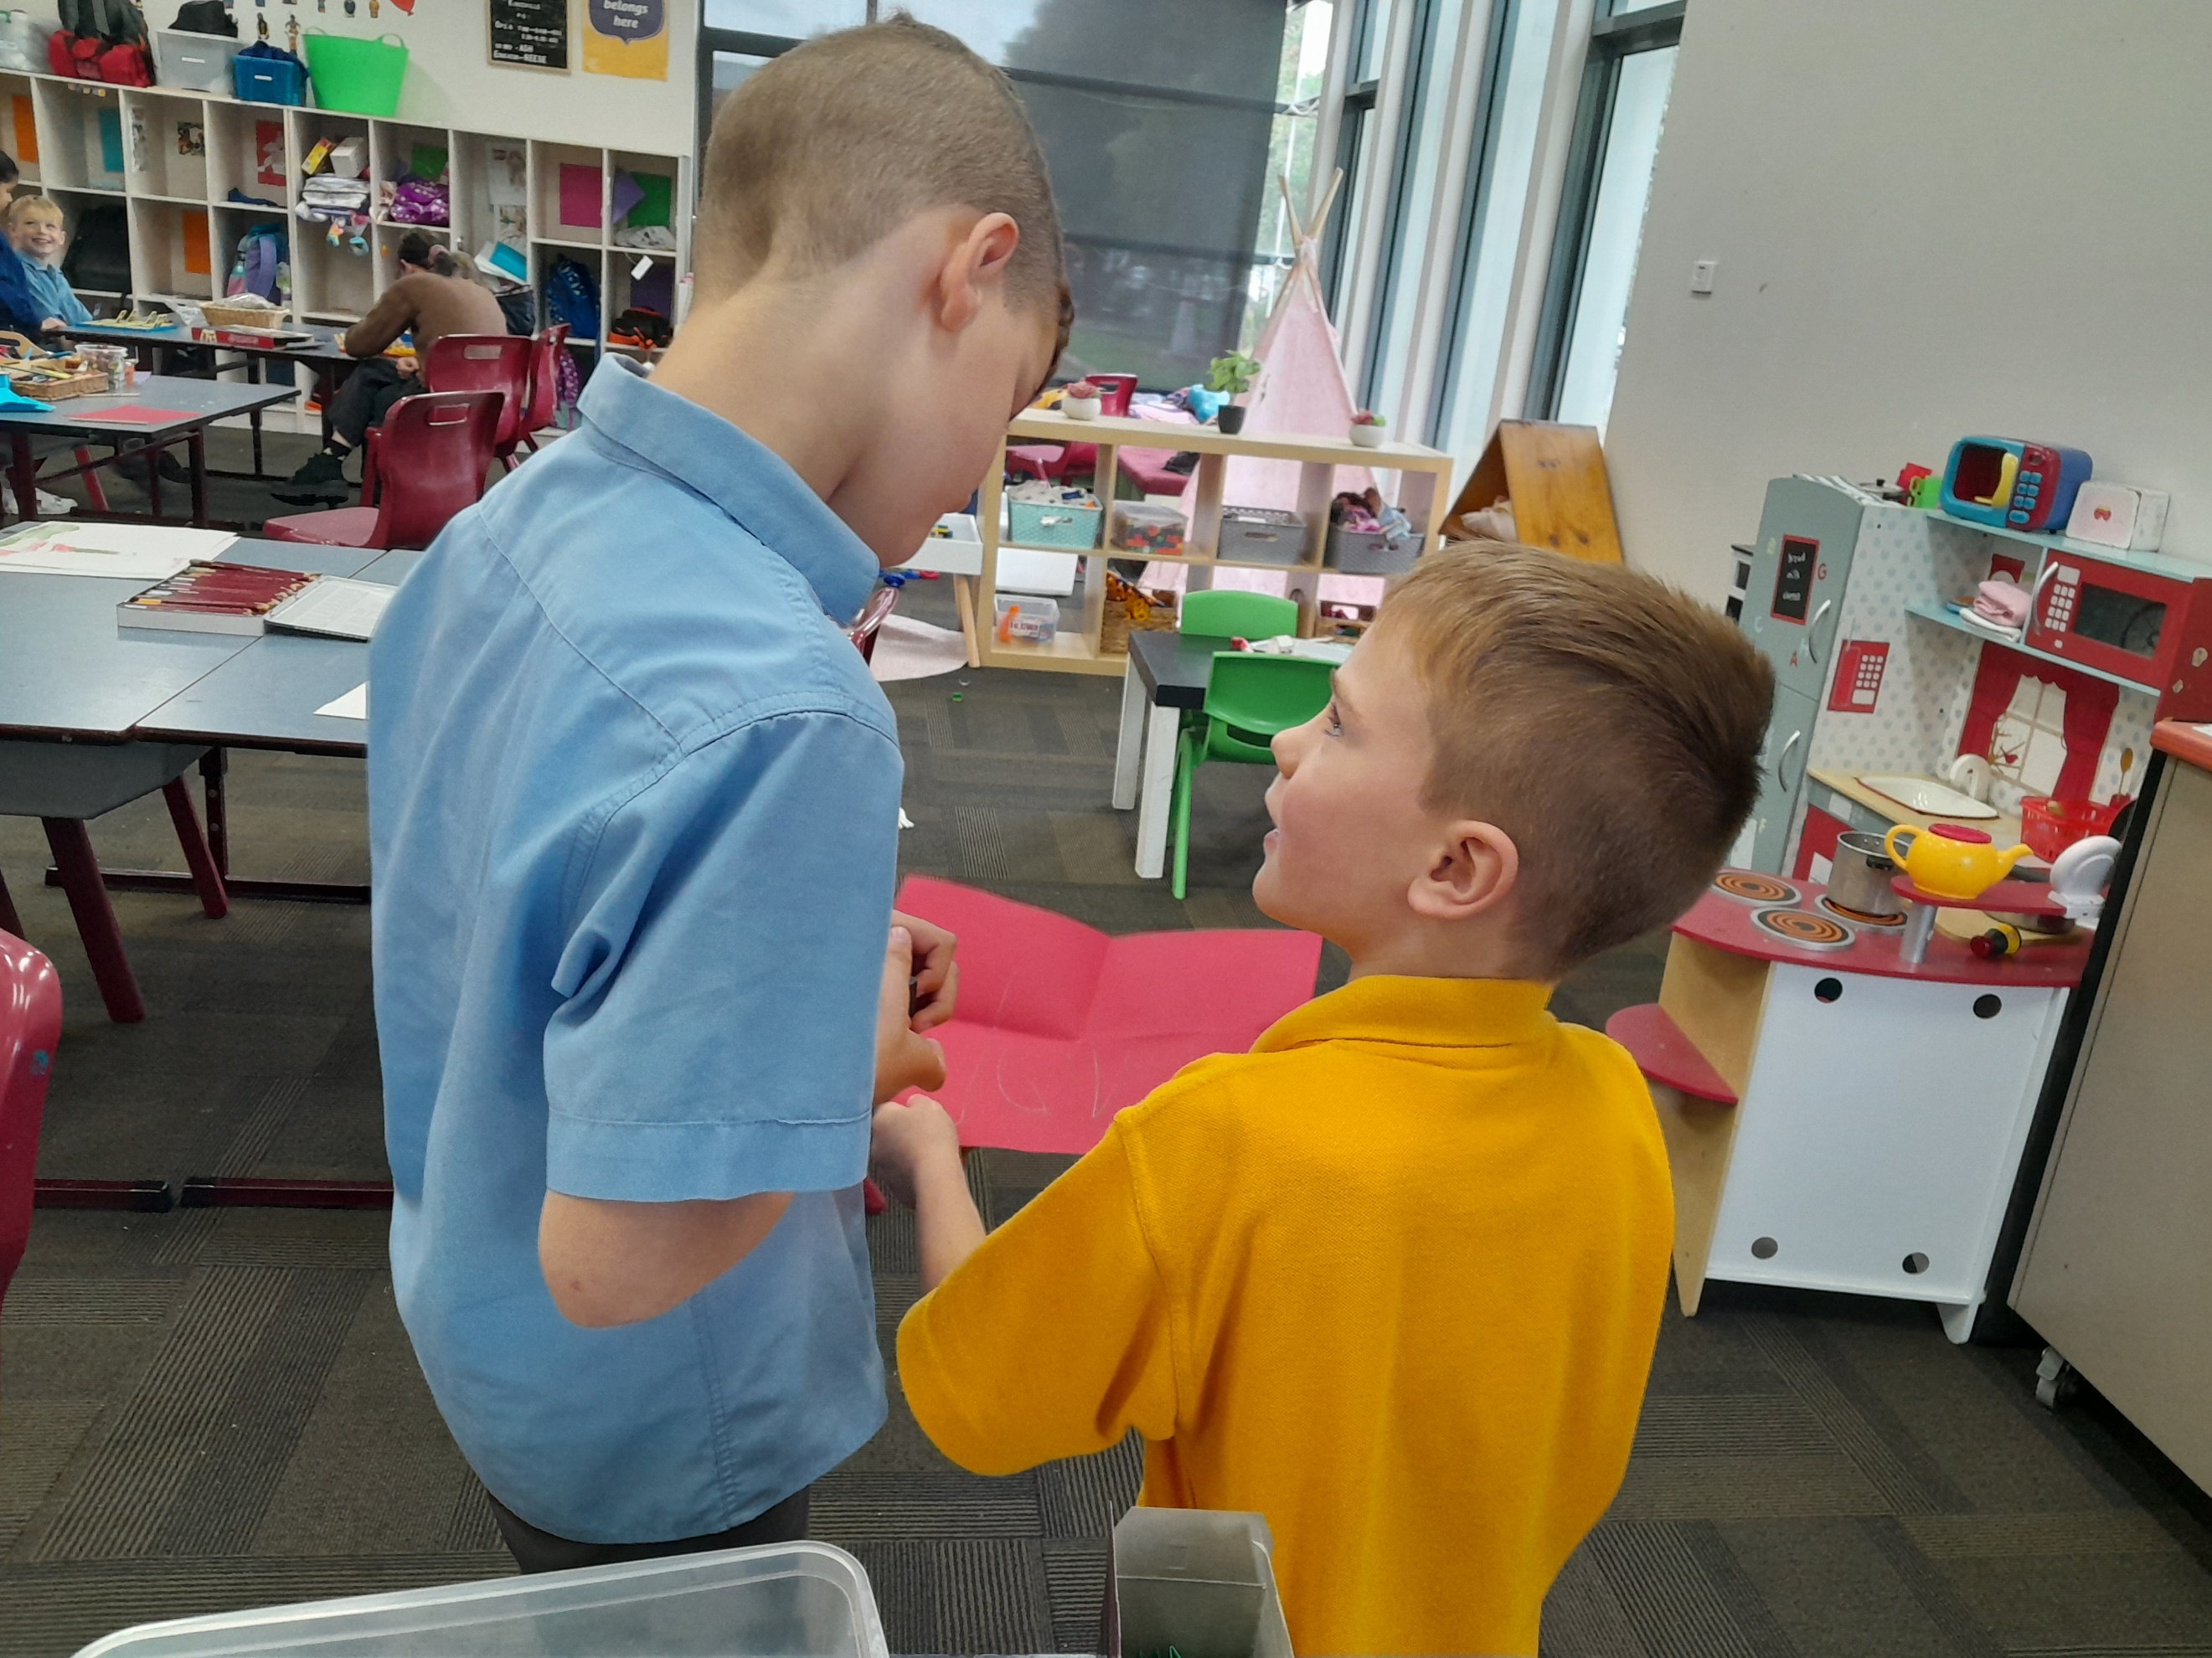

Come in and check our weekly reflection journal!

Inside you’ll find an overview of each day and all the fun activities the children have been enjoying.

Filled with pictures and the kid’s artwork, come in and have a look.

