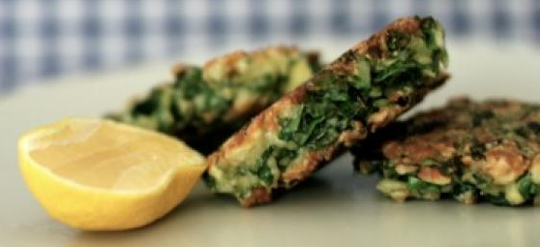


Silverbeet and Haloumi Fritters
Source – www.kidspot.com.au
Harvest – silverbeet, mint, lemon
Vocab Words – haloumi, season
Skills – grate, finely chop, zest, fry
Equipment:  - Metric measuring spoons  - Metric measuring scales  - Chopping boards and grips  - Compost bowls  - Knives  - Grater  - Microplane  - Large bowl and large spoon  - Frying pan  - Egg flip  - Serving Items – platters and tongs | Ingredients:  - 180gm haloumi, coarsely grated  - 2-3 silverbeet leaves, stems removed, finely chopped  - 1-2 tablespoons mint, finely chopped  - Zest of 1 lemon (use microplane)  - 3 eggs  - 300gm sour cream  - 150gm plain flour  - Olive oil, for frying
What to do:
- WASH all garden ingredients & prepare all ingredients as above (in the ingredients list).
- COMBINE - in a large bowl - the haloumi, silverbeet, mint, lemon zest, eggs, sour cream and flour, and season with salt and pepper. Mix well to combine.
- HEAT oil in a large frying pan over medium heat and place spoonfuls of mixture in the pan, then flatten them slightly.
- FRY for 3-4 minutes on each side until golden.
- SERVE.

Notes: Optional – serve with lemon wedges.

