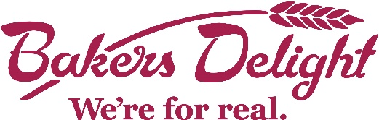
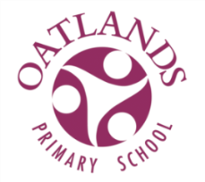

OATLANDS PRIMARY SCHOOL HOT CROSS BUN ORDER FORM EASTER 2023

Bakers Delight Cranbourne would like to offer you the opportunity to purchase delicious Hot Cross Buns and fundraise for our school.
The more buns you purchase the more funds we make for Oatlands Primary School.

For every 6 pack of Hot Cross Buns you order for $9, Bakers Delight Cranbourne will give $2 to our school.

Simply fill in the details below and select how many and which Hot Cross Buns you would like to order, bring your order form together with full payment (please include the correct amount) back to the office by 9am 16/3/23 and your buns will be ready to collect on
Thursday 30th of March (we will send out a message once they arrive).
This is pre-order only and no hot cross buns will be available to purchase on the pick up date.

Remember to ask family and friends if they would like to order some too.

Student’s Name: ________________________ Class: _______________________ Contact No: _____________________________

Name | Traditional  Hot Cross Buns  Qty (per 6 pack)  $9 per 6 pack | Choc Chip  Hot Cross Buns  Qty (per 6 pack)  $9 per 6 pack | Apple & Cinnamon  Hot Cross Buns  Qty (per 6 pack)  $9 per 6 pack | Mocha  Hot Cross Buns  Qty (per 6 pack)  $9 per 6 pack | Fruitless  Hot Cross Buns  Qty (per 6 pack)  $9 per 6 pack | Total $ | Paid

