CAREER NEWS Friday 13 November

As this is the final edition of the Career News for 2020, I would like to take this opportunity to wish all students every success in their final exams and wish them and their families a wonderful summer holiday - filled with special times shared with friends and loved ones.
Stay safe and here’s to a fabulous 2021

Dates to Diarise in Term 4
- Year 12 VTAC very late applications – 6 November to 4 December
Reminder: VTAC 2021 Upcoming Key Dates

VTAC Personal Statement | Friday 4 December 2020
ATARs Released | Wednesday 30 December 2020
Change of Preference (COP) closes | Monday 4 January 2021
January Round International Offers | Thursday 7 January 2021
January Round Domestic Offers | Thursday 14 January 2021
February Offer Rounds | Monday 1 February 2021 onwards
For a full list of cancelled, amended, and new courses, visit VTAC Course Updates

The VTAC website is www.vtac.edu.au
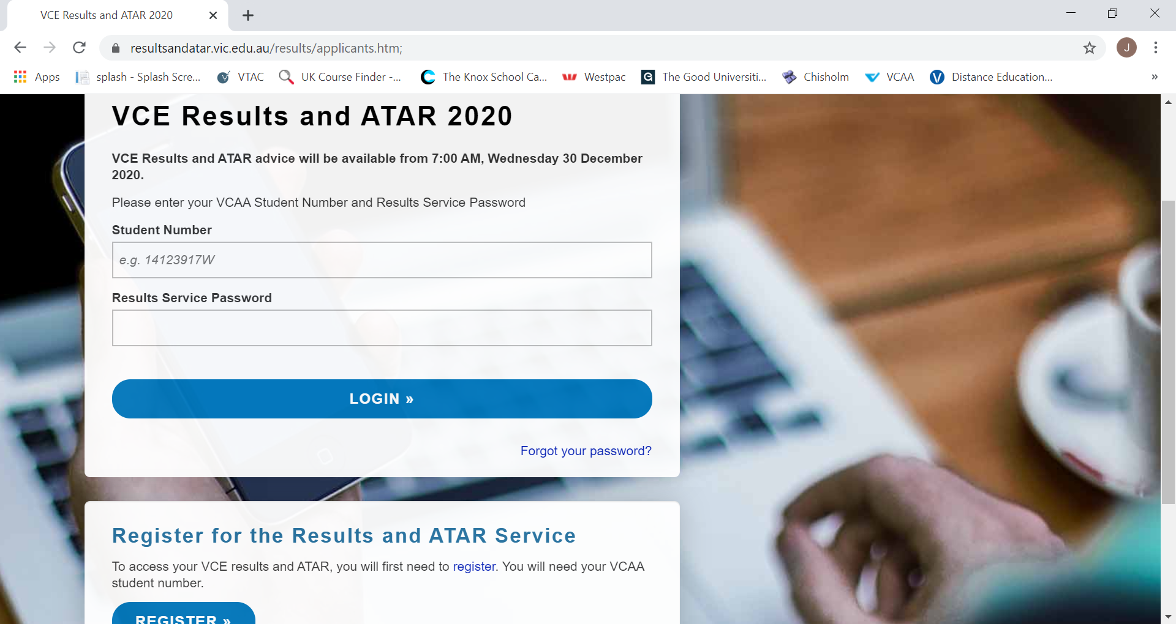 Accessing 2020 VCE Results
VCE study scores, ATAR and VTAC Scaled Study Scores will be available to students via the Results and ATAR website and the Results and ATAR app on Wednesday 30 December 2020 at 7.00am. Students will receive a statement of VCE study scores from the VCAA, and those who applied for courses through VTAC this year and have paid their VTAC processing fees, will be sent an ATAR statement in the mail.

Students who wish to receive their results online, will need to register at https://resultsandatar.vic.edu.au/results/applicants.htm BEFORE results are released. You will need to register again this year as any login details used to access results last year are removed after results were released.
Registrations are already open, and students are encouraged to register soon.
Note: To register, students need their VCAA student number and will be requested to choose a secure password on registering.

Study Assist
Students are encouraged to browse the below link as the Study Assist website provides information to students about Australian Government assistance for financing of tertiary study. There is very useful information on study loans, how one pays back those loans, scholarship opportunities, etc. A useful PDF titled Beyond School Study Guide published in February this year can also be found at - Beyond School Study Guide.
Visit Study Assist to find out more.

Tax File Number
Year 12 students are reminded again that they cannot enrol in a CSP (Commonwealth Supported Place) university course next year without a Tax File Number (TFN). Students who do not have one are reminded to apply for a TFN online and have their identity verified through an interview at a participating Australia Post office by end of the year.
To apply and also to find out about participating Post Offices, visit TFN Application

A USI - Unique Student Identifier is a reference number that creates an online record of your training and qualifications attained in Australia. Current Year 12 students are reminded that you will need a USI number when applying for Commonwealth financial assistance when you enrol at university next year.
Some students may already have one and it is recommended students find or create their USI via https://www.usi.gov.au/ by end of the year.

School Leavers Information Kit
Visit the YourCareer.gov.au School Leavers Support website to know what opportunities are open to you in 2021. A School Leavers Info Service provides tailored support and the School Leavers Information Kit has a range of resources and information to help you understand all your education, training and work options plus assist you in choosing the right option for you.

Access a PDF version of the School Leavers Information kit here.

Websites/Links
- Skills Spiderweb – different jobs need different skills. The Skills Spiderweb shows 12 skills common across many different jobs. View the Skills Spiderweb here.
- Myfuture – a career information & exploration service providing current career information, articles and links to many resources www.myfuture.edu.au

- Careers Online – career research, resume help, job hunting tips, job links, etc. www.careersonline.com.au

- Job Search Australia – free online jobsite, searches can be made by region and state, occupational category, type of employment – casual, part-time, or full-time, and covers a range of occupations. www.jobsearch.gov.au

- Victorian Government Vacancies – find out about government jobs and careers available at the Victorian Government of Australia. www.careers.vic.gov.au
Tips for prospective Uni students:
Download the following useful free apps from iTunes and Google Play -
LOST ON CAMPUS: find every tutorial room, lab, lecture theatre, coffee shop,
carpark, bus stop, even your nearest vending machines and free microwaves on
campus - lost on campus

FAIR: an app designed by the University of Melbourne to walk you through a series
of common scenarios that can lead to breaches of academic integrity, like
plagiarism, with advice on what to do and why it matters - UoM Fair
University Terms
Here are a few of the more commonly used terms to help prospective University students.

Associated Degree – an associate degree is generally a two-year qualification that is made up of two-thirds of a bachelor’s degree and may be offered by both TAFEs and universities. Students often use this as a steppingstone to the full bachelor’s degree.

Assumed knowledge – refers to subjects the university recommends or prefers a student to have studied at school before starting the course
ATAR – Australian Tertiary Admissions Rank – the figure used by UAC and VTAC to calculate the entrance ranking for a university course
Bachelor’s degree – the award/qualification a student gains when they have completed studies in an undergraduate course, which takes between 3 or 4 years of full-time study. This is the traditional starting point of a university qualification.
Bridging Course – an introductory course to help students achieve the preferred entry level to a degree, e.g. a bridging maths course for students who do not have the preferred maths but need it to access a course

Census Date – last day a student can withdraw from their university course and not owe fees

Commonwealth Supported Place (CSP) – a student’s enrolment in a university degree for which the Commonwealth government makes a contribution towards the cost of that student’s education (formerly known as a HECS place)

Credit – if a student has previously studied – perhaps at TAFE – and has Recognised Prior Learning (RPL), the student may be able to receive credit for a subject or subjects in their course. Also often referred to as Advanced Standing.

Double degree – a student can choose to complete a double degree – this integrates studies in two degrees resulting in an award of two degrees, usually after a minimum of 4 years of study. Often also referred to as Combined Degrees.

Defer – a student may choose to delay starting their course. Deferring an offer of a place might mean delaying for 6, 12, 18 or 24 months. Deferment ensures the student is guaranteed their place in their selected course

Elective – a subject that is not core to the degree and is often from another faculty, e.g. a commerce student might choose psychology (from the Arts Faculty) as an elective

Faculty – a department within a university devoted to a particular area of study – so, Faculty of Arts or Faculty of Science

FEE-HELP – a loan scheme for domestic students used to pay all or part of an eligible student’s tuition fees for university courses but cannot be used for additional study costs such as laptops, accommodation, or textbooks. A 25% loan fee may apply.

HECS-HELP – a loan scheme that assists domestic students with a CSP place to pay their contribution. Students may choose to pay their fees upfront, or choose to defer payment via the HECS-HELP loan scheme

Honours – many bachelor’s degrees offer a fourth year – called an Honours year. The Honours year allows students to further focus on a particular an area of interest. The Honours year can either be integrated into a 4-year bachelor’s degree or be offered as a separate year after completion of a 3-year bachelor’s degree

Lecture – a period of teaching given by a lecturer to a large group of students in a lecture theatre; can often be as many as 300 students in a lecture

Major study – an area within a course that allows in-depth study in a particular field. More than one major may be allowed in some courses

Minor study – a grouping of subjects allowing a broader understanding of a few subjects, with less emphasis on in-depth study

Prerequisite – a set of conditions – usually a completion of a subject – that must be met before enrollment in a subject or course is allowed.

SA-HELP – SA-HELP is a loan scheme that assists eligible students to pay for all or part of their student services and amenities fees – so, non-academic fees.
Transcript – this is the university academic record each student receives, like a school report
Tutorial – a period of teaching given to a small group of students – involving discussion and participation

Undergraduate – a student studying at university for a first level degree, e.g. a bachelor’s degree

VET Student Loans – a loan scheme for domestic students used to pay all or part of an eligible student’s tuition fees for TAFE courses, but cannot be used for additional study costs such as accommodation or textbooks. A 20% loan fee usually applies.

Workplace learning – practical training in a workplace, such as internships or practical work experience. This is a hands-on experience – some universities call it Industry Based Learning or Work Integrated Learning.
A labour market characterized by the prevalence of short-term contracts or freelance work as opposed to permanent jobs.
Freelancer
Work from home
Part-time employment

Remember, employers are looking for:

- Skills broader than your discipline
- Skills more than content
- Transferability of skills
- Longevity of skills
- Analytical skills
- So, while at university, set yourself up to be the kind of graduate employers are looking for

- Don’t assume that a certain qualification only leads to employment with certain companies

- Don’t second-guess where the jobs are
HOW? VALUE-ADD by doing Work Experience, Industry-based Learning, Overseas Exchange, taking ‘breadth’ subjects & joining clubs/societies.

