[](https://www.campaustralia.com.au/blog)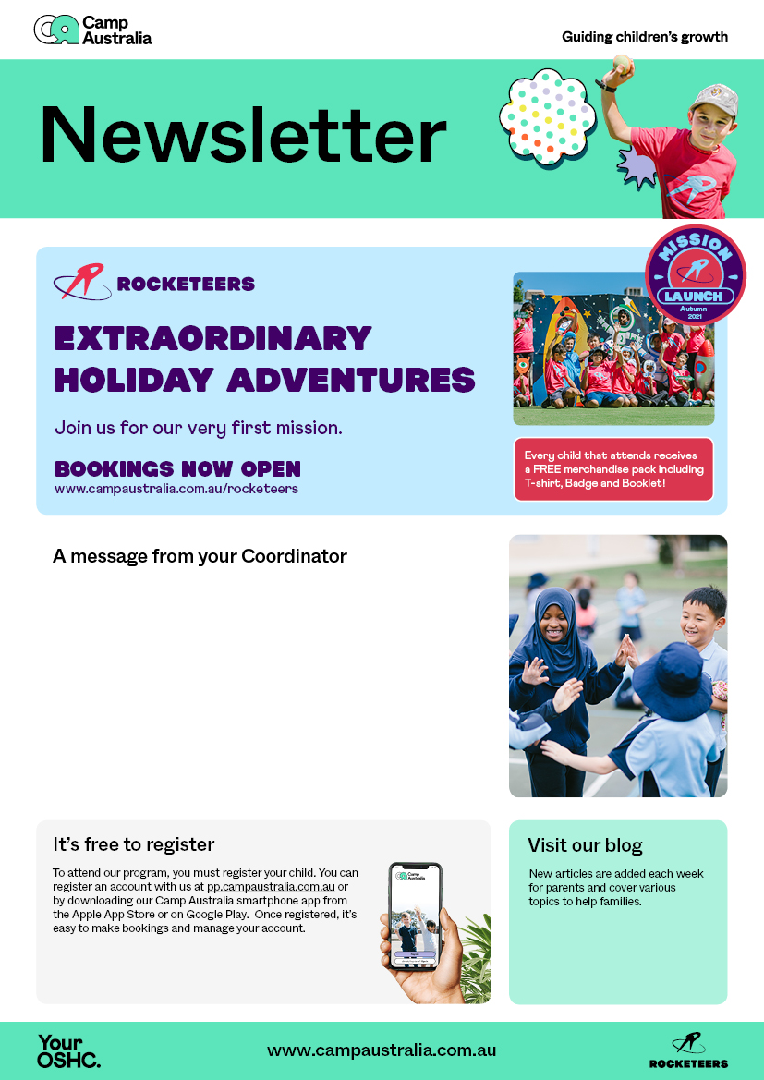[](https://apps.apple.com/app/apple-store/id1529575453?pt=120333103&ct=edmbookings&mt=8)[](https://play.google.com/store/apps/details?id=au.com.campaustralia.parent)

Dear Parents,

The holidays are fast approaching it is time to see what we have on during the school holidays. We have a few schools in our local area running the program during the holidays, If you wish to register your child please log on to your portal.

I also have a list of the school in the area running the program.

Have a safe break and will see you all next term.

Brigitte & Frances