

**20/02/2025**

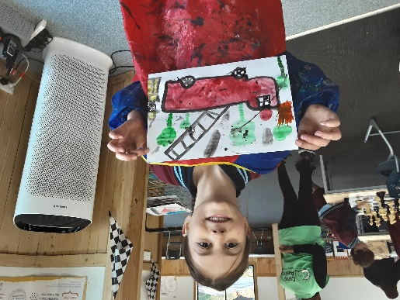[](https://pp.campaustralia.com.au/)

* Kindness Disco
* Kite Creations
* Big Art Friday
* Kindness Scavenger Hunt

**Activities coming up**

Welcome to all the new children and families, we have enjoyed the time settling new Prep many have explored the fun at Before and After School Care. We encourage all family to register your children it is free, so if there is a need at any time your child can be confident that they can be added to our list for care when ever they need care at any time. Children are looking forward to our disco on Friday, where they can dance and enjoy time with friends. Great time to socialize with peers and get involved at OSHC.

Join in the fun of Outside School Hours Care activities and experiences with Your OSHC and Rocketeers.

**Make a booking**

Book now

**Oatlands Primary School OSHC**