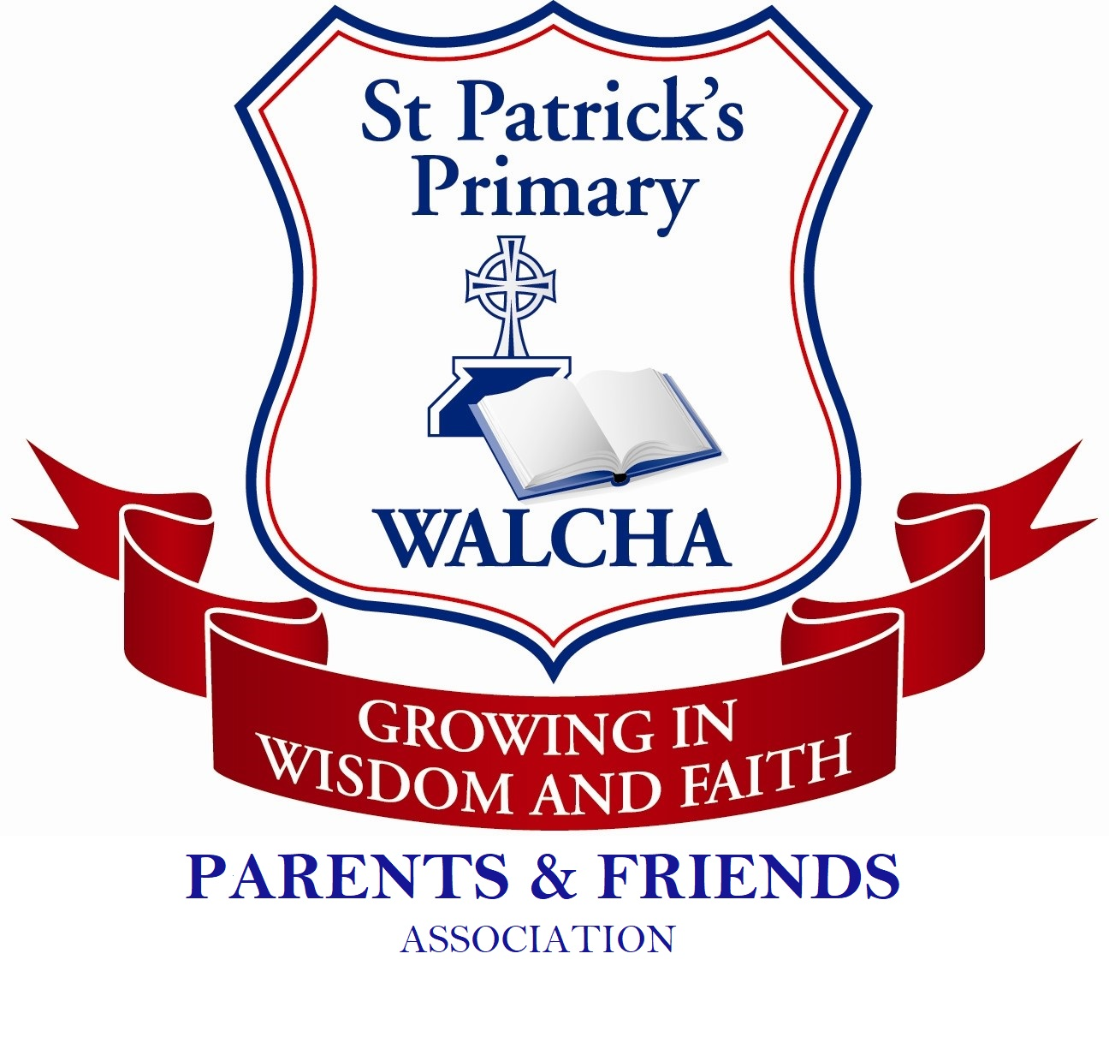
ST PATRICK’S P&F
WINE DRIVE

20% of each and every case will be donated to the St Patrick’s P&F.

WINES | #of Bottles | PRICE
NV Blanc de Blanc |  | $28.00
2019 Semillon Sauvignon Blanc |  | $20.00
2018 Chardonnay |  | $20.00
NV Moscato |  | $20.00
2017 Shiraz |  | $20.00
2016 Cabernet Sauvignon |  | $20.00
2016 The Family (Cabernet Franc/Durif/Merlot blend) |  | $28.00

TOTALS
Mixed cases are accepted. Minimum order is 6 bottles. Please ensure total number of bottles is in multiples of 6. i.e 6, 12, 18, 24 etc.

ORDER
DETAILS

Full Name: Address:

Phone Number: Email:
Yes, please add me to your mailing list to receive updates from Merilba and Special Offers.

Credit Card Details - Visa/Mastercard & American Express

Card Number Name on Card

Expiry / CVV

Forms to be submitted by Wednesday 4th December. Wine will be ready for pickup from St Patrick’s School on Friday 13th December 2019. You will receive an email reminding you of this closer to the date.

Merilba Estates Pty Ltd KIngstown Road, Uralla NSW 2358
ABN 80 101 158 178 LIQUOR LICENSE NUMBER: W880010125-
PH: 02 6778 9145 info@merilbaestatewines.com.au

