CAREER NEWS Friday 22 May

 Dates to Diarise in Term 2
- Law Week 2026 – Monday 18 – Sunday 24 May
- GAT – Tuesday 16 June

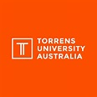 Free Interior Design and Decoration Short Course
Torrens University is offering a free 6-week short course providing an introduction to the principles of interior design and decoration and the fundamentals of interior design.
Across six modules, students will explore colour, lighting, materials, styling, and even how to prepare and present a project to clients. Each module comes with resources and activities to assist students in putting their learning into practice.
Find out more at free Interior Design short course.

 Studying Sports Media at Holmesglen Institute
Holmesglen Institute offers the Bachelor of Sports Media. This degree prepares students for careers in the fast-paced sports and digital media industry. Designed to reflect today’s evolving media landscape, the degree develops practical skills in sports media production, content creation and communication.
The course is delivered in partnership with the St Kilda Football Club, the course provides strong industry engagement and internship opportunities. Experienced educators provide ongoing support to help you graduate confident, adaptable and ready for diverse sports media careers.
Find out more at Bachelor of Sports Media.

 Early Offer Program for 2027 Entry
Lock in an Early Offer and pathway to your dream career.

Secure your place at Federation University in 2027. Finishing high school can be stressful, so why not give yourself peace of mind with Federation University's Early Offer Program?
Not only is an early offer exciting to receive but knowing that you have already secured a place in a degree means you can head into exams fully focused.

Most bachelor degrees are available for early offers, and to view courses accepting Early Offer applications click here. Australian and permanent resident students are eligible to apply, and must ensure they meet the prerequisite subjects for their preferred course.
Applications are open and close on Tuesday 1 December 2026.
Find out more and apply at Early Offer Program.

 CSU Advantage Early Offer Program – 2027 Entry
Get an offer into your dream course before you sit your exams. Get recognised for your personality and soft skills, not just your results. Plus, get access to special events, personalised support, grants and merch just for Charles Sturt Advantage students.

Australian and PR students are eligible to apply, and must address the following three questions:
- How a Charles Sturt degree will enable you to be a positive influence in your community.
- When you showed resilience during a difficult time.
- A time when you demonstrated empathy and why you took the actions you did.

There are more than 50 courses on offer, and students can list up to three in their application. If successful, students will get an offer in order of their preferences.
Round 1 applications are open and close 31 July 2026 with offers being made from 1 September. Round 2 applications open on 1 August 2026 and close closing on 31 August 2026, with offers being made from 23 September 2026.
To find out more and to access the online application, visit Charles Sturt Advantage.

 Career in Health Information Management
According to the Health Information Management Association of Australia (HIMAA) health information management professionals contribute to health outcomes and the healthcare system through best practice health information management.
Health information management professionals work in a variety of roles in all areas of the healthcare system.
While many people work in health information related roles, there are two specialist occupations for health information management professionals:
- Health Information Managers (HIMs)
Health Information Managers plan, develop and manage health information systems for patient, clinical and administrative data necessary for patient care, healthcare planning and funding. They play a key role in the secure, confidential, and legal use of patient information. Health Information Managers are degree qualified through a HIMAA accredited or recognised course.
- Clinical Coders
Clinical Coders are responsible for translating clinical information gathered during a patient’s hospital stay into codes according to a recognised health classification system. Clinical coding information is utilised for planning, resourcing, benchmarking and funding purposes at local, regional and national level. Clinical Coders are either qualified HIMs or are qualified through a VET course accredited by the Australian Skills Quality Authority (ASQA).
In Victoria, La Trobe University offers a HIMAA- accredited Bachelor of Health Information Management.
La Trobe also offers the Master of Health Information Management which requires the successful completion of an Australian bachelor degree (or equivalent), which has contained anatomy and physiology subjects – so degrees in medicine, biomedical science, allied health, or health science.
Students keen on studying to be a Clinical Coder can study the Diploma of Clinical Coding through Victoria University, or the diploma offered by the HIMAA itself - Diploma of Clinical Coding.

Students are invited to browse the HIMAA link provided above which is a great source of information.

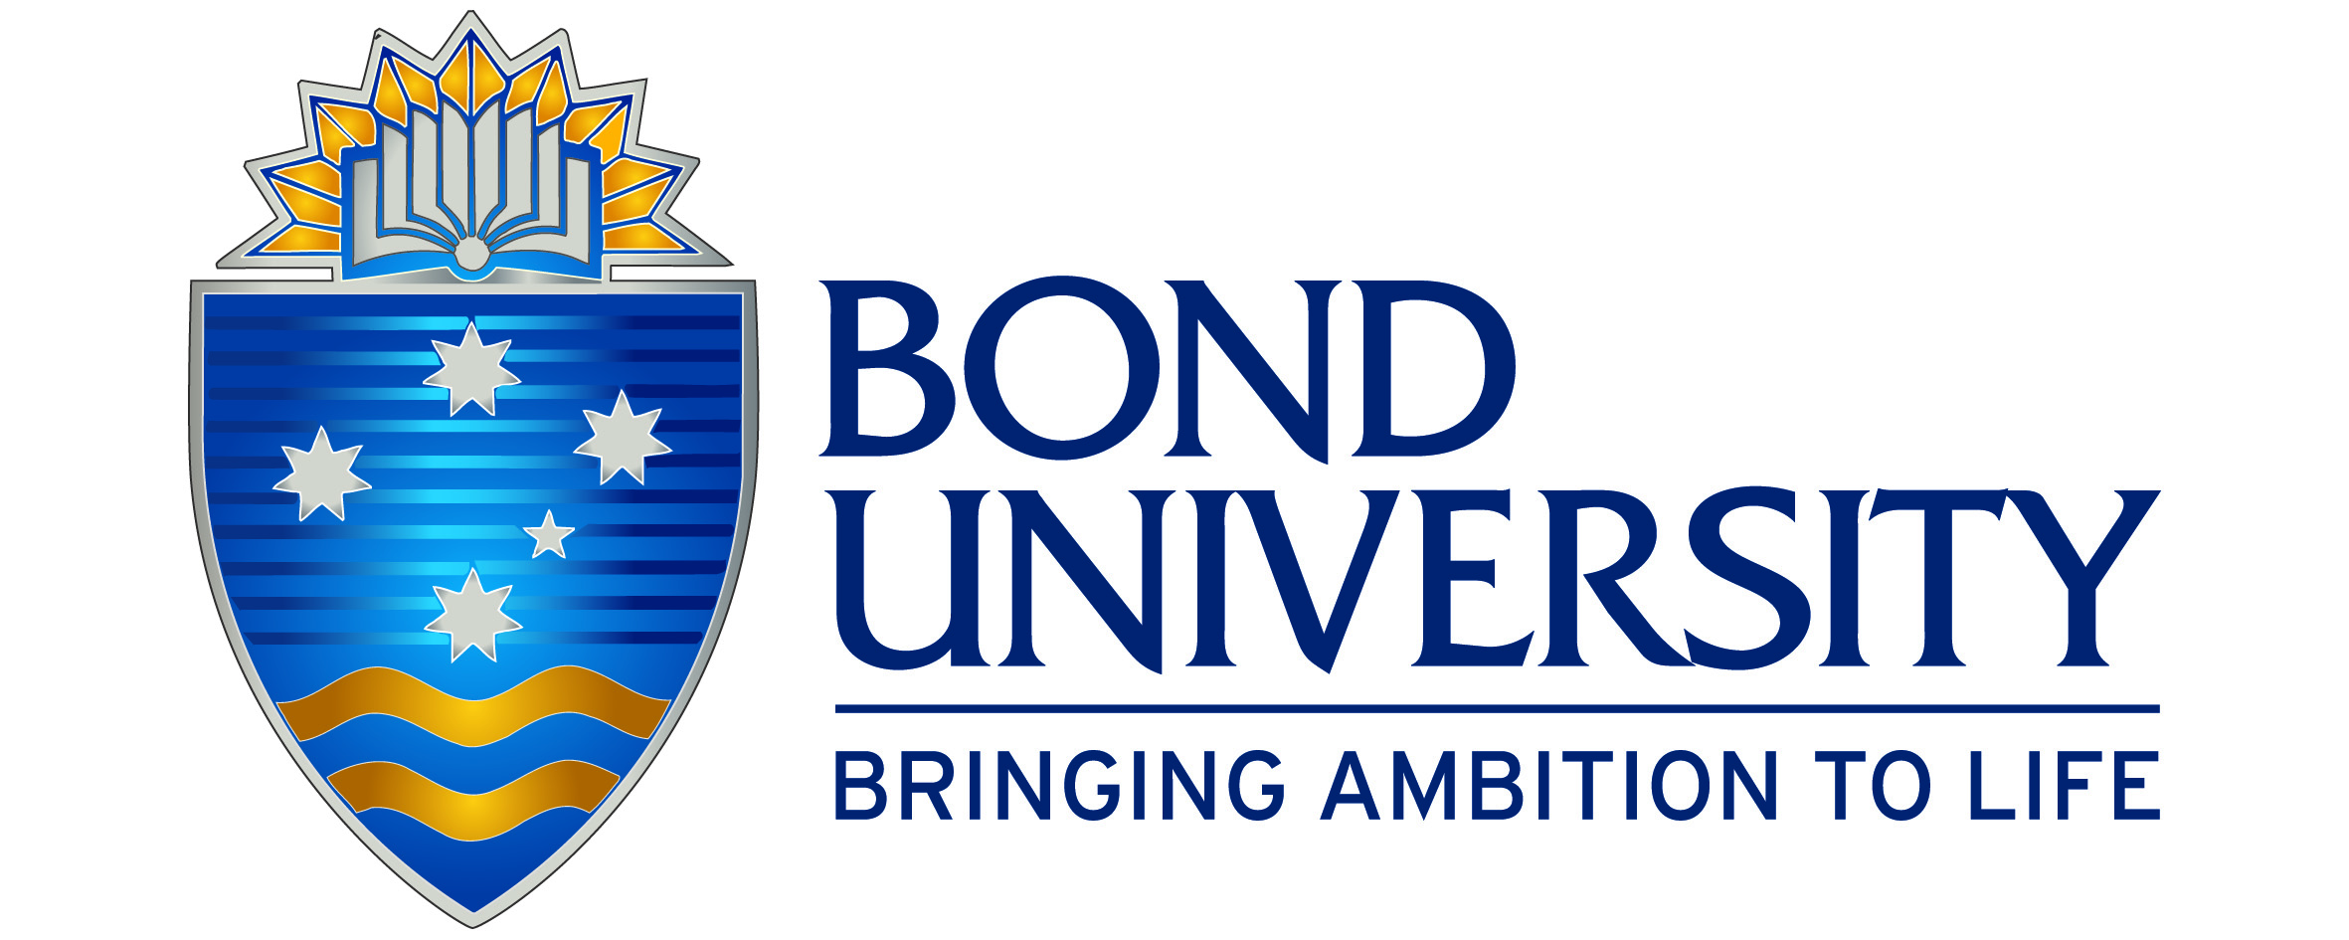 Studying Law at Bond University
Let Bond Law drive your career! Whether you are an undergraduate or a postgraduate student, Bond’s Bachelor of Laws, Juris Doctor or Master of Laws programs offer students a unique opportunity to specialise in Climate Law.

Students in the Bachelor of Laws have the option of specialising in climate law and practice by completing a Climate Law specialisation. Students learn and explore the legal frameworks that govern environmental protection and sustainability and are equipped to be able to use their knowledge and skills to become a specialist in an increasingly important practice area, or advocate for climate action.
Interested students are encouraged to browse the website to familiarise themselves with the structure of the Bachelor of Laws course, particularly the climate law subjects published here. Another useful read is at Climate Law.

 Studying Law at ACU
Want to study law that goes beyond the textbooks?
At ACU, the Bachelor of Laws is all about real-world experience. From pro bono placements with top barristers, firms, NGOs and government departments in Australia and overseas, to mooting and competitions, students learn from judges and legal professionals while building skills that matter. Graduates of this degree are ready to practise law – and live it with purpose.
ACU offers the followiong double-degrees with law:
Arts/ Laws
Arts (Western Civilisation)/ Laws
Biomedical Science/ Laws
Business Administration/ Laws
Commerce/ Laws
Criminology & Criminal Justice/ Laws
Human Rights/ Laws
Laws/ Global Studies
Philosophy/ Laws
Physiological Science/ Laws
Theology/ Laws

To qualify for the degree, a student must also complete at least 80 hours of pro bono placement.
It is also important to note that the Law degree structure and Law unit offerings have been approved by the Victorian Legal Admissions Board and the Legal Profession Admission Board (NSW).
Find out more, including the range of law electives on offer, at Bachelor of Laws.
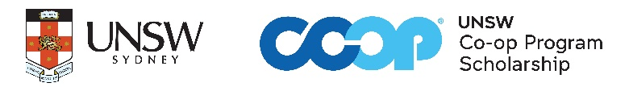 UNSW Co-op Program 2027
Set up by industry and the University of New South Wales (UNSW) the Co-op Program provides career development scholarships for high achieving undergraduate students, offering industry training, leadership, and professional development, networking opportunities, mentoring and financial support. The scholarships are offered in the fields of Business, Science, and Engineering.

The UNSW Co-op Program is open to Year 12 students entering university for the first time, or those commencing university for the first time after a gap year. Candidates for scholarships are not only selected on their academic ability, but also their communication skills, motivation, leadership potential, and passion for their chosen field of study. Any student expecting an ATAR above 96.00 should consider applying.
What do students gain?
- Up to 18 months of relevant industry experience with multiple companies during their degree.
- Receive a $21,600 per annum scholarship for four years.
- Leadership and professional development training.
- Mentoring and support offered throughout their degree.
- Career planning.
- International exchange opportunities.
Joining the Co-op community at UNSW enables you to form life changing connections and opens up a world of opportunities. As a scholar, not only do you gain academic and professional insight from alumni, older scholars, and the broader Co-op community, you also start forming your professional and social network from day one.
Applications have opened and close on 30 September 2026. Students can visit Co-op Program at UNSW Sydney to find out more and apply.



 Biomedicine/Biomedical Science Degrees in Victoria in 2026
INSTITUTION | COURSE NAME | VCE PREREQUISITES | MAJOR STUDIES IN 2026
ACU  M - Melbourne | Biomedical Science  ATAR: 59.25 (M) | Units 3 and 4: a study score of at least 25 in English (EAL) or at least 25 in English other than EAL; Units 3 and 4: a study score of at least 25 in one of Biology, Chemistry, any Mathematics or Physics. | Biomedical Science, Physiological Pharmacology.
DEAKIN  M – Melbourne  G – Waurn Ponds | Biomedical Science  ATAR: 80.25 (M)  71.65 (G) | Units 3 and 4: a study score of at least 25 in English (EAL) or at least 20 in English other than EAL. | Biomedical science (Anatomy, Biochemistry, Biology, Genetics, Physiology), Cellular Biomedicine, Environmental health, Infection and immunity, Medical biotechnology, Medical genomics, Pharmaceutical science.
FEDERATION  Ba - Ballarat  Be – Berwick  Gi – Gippsland | Biomedical Science  ATAR: L/N (Ba)  60.15 (Be)  71.30 (Gi) | Units 3 and 4: a study score of at least 20 in any English; Units 3 and 4: a study score of at least 20 in any Mathematics OR any Science. | Biomedical Science.
FEDERATION  Ba - Ballarat  Be – Berwick  Gi – Gippsland | Biomedical Science (Gippsland Partnership)  ATAR: L/N (Gi) |  | Biomedical Science.
LA TROBE  AW – Albury Wodonga  B - Bendigo  M – Melbourne | Biomedical Science  ATAR: 64.45 (AW)  60.55 (B)  Biomedical Sci (Medical)*  ATAR: N/P (AW)  ATAR: N/P (B) | Units 3 and 4: a study score of at least 25 in English (EAL) or at least 20 in English other than EAL.  *Designed for regional and rural students intending to practice medicine in a regional or rural location, and entry requirements are: Minimum prerequisite ATAR of 80.00. Units 3 and 4: a study score of at least 30 in EAL or at least 25 in English other than EAL. | Biomedical Science.
LA TROBE  AW – Albury Wodonga  B - Bendigo  M – Melbourne | Biomedicine  ATAR: 60.00 (M) |  | Cancer, heart and brain disease, Immunology and infectious disease, Molecular and cellular biochemistry, Physiology and pharmacology.
MONASH  C – Clayton | Biomedical Science  ATAR: 91.05 (C) | Units 3 and 4: a study score of at least 25 in English (EAL) or at least 25 in English other than EAL; Units 3 and 4: a study score of at least 25 in Chemistry; Units 3 and 4: a study score of at least 22 in one of Maths: Mathematical Methods or Maths: Specialist Mathematics or at least 25 in one of Maths: General Mathematics or Physics | Anatomy and physiology, Biochemistry, Biomedical science, Biomedicine, Genetics, Health sciences, Human biology, Human sciences, Microbiology, Molecular and cell biology, Neurobiology, Pathology, Pathophysiology.
RMIT  B – Bundoora | Biomedical Science  ATAR: 70.30 (B)  Biomedical Science (Honours)*  ATAR: 83.45 (B) | Units 3 and 4: a study score of at least 25 in English other than EAL or at least 27 in EAL. Units 3 and 4: a study score of at least 20 in one of Maths: General Mathematics, Maths: Mathematical Methods, Maths: Specialist Mathematics or Physics. Units 3 and 4: a study score of at least 20 in one of Biology or Chemistry. | Anatomy, Biochemistry, Biostatistics, Biotechnology, Cell biology, Chemistry, Genetics, Human pathophysiology, Human physiology, Infection & immunology, Microbiology, Molecular biology, Pharmacology.  *Other majors are also on offer
SWINBURNE  H - Hawthorn | Biomedical Science  ATAR: 60.40 (H) | Units 3 and 4: a study score of at least 20 in English other than EAL or at least 25 in EAL. | Body function and structure for health science, Chemistry 1, Genes and genomics, Infections and immunology in health sciences, Introduction to biochemistry, Musculoskeletal anatomy, Pathophysiology, Physiology in medical and health sciences.
UNI MELBOURNE  P - Parkville | Biomedicine  ATAR: 90.00 (P) | Units 3 and 4: a study score of at least 30 in EAL or at least 25 in English other than EAL; Units 3 and 4: a study score of at least 25 in Chemistry; Units 3 and 4: a study score of at least 25 in one of Maths: Mathematical Methods or Maths: Specialist Mathematics. | Biochemistry and molecular biology, Biomedical engineering systems, Biotechnology, Cell and developmental biology, Genetics, Human nutrition, Human structure and function, Immunology, Infection and immunity, Microbiology, Neuroscience, Pathology, Pharmacology, Physiology, Psychology, Public Health and Epidemiology.
VICTORIA  F – Footscray  St. A – St. Albans  **Not Foundation  Mathematics | Biomedical Science  ATAR: N/P (St. A) | Units 3 and 4: a study score of at least 25 in English (EAL) or at least 20 in English other than EAL; Units 3 and 4: a study score of at least 20 in one of Biology, Chemistry, Health and Human Development, any Mathematics** or Physical Education.  *Higher study scores required | Human Physiology, Molecular Cell Biology.
 | Biomedicine *  ATAR: 80.55 (F)  L/N (St. A) |  | Biomedicine.
Snapshot of Charles Sturt University (CSU) in 2026
- The history of Charles Sturt University dates back to 1895 but CSU was formally incorporated in July 1989 and is one of Australia's newer universities
- Charles Sturt University has three Faculties which comprise of several Schools and centres for specific areas of study and research –
Faculty of Arts and Education
Faculty of Business, Justice and Behavioural Sciences
Faculty of Science and Health

- CSU has campuses in a number of locations and also has various campuses that offer specialist courses, such as theology, education, Terrorism & Security Studies, and policing. These include Albury-Wodonga, Canberra, Goulburn, and Parramatta.
- CSU offers a range of accommodation options to students across six campuses
- CSU offers a broad range of courses, from single subjects to postgraduate studies
- Charles Sturt University and Western Sydney University have partnered to offer a Joint Program in Medicine - Doctor of Medicine. Students are admitted to the Bachelor of Clinical Science (Medicine) / Doctor of Medicine combined program. After completing the first three years, students may either exit with a Bachelor of Clinical Science (Medicine) or progress to years four and five to complete the Doctor of Medicine requirements. On completion of the program students are awarded the Bachelor of Clinical Science (Medicine)/Doctor of Medicine. It is a five-year program taught in Orange, New South Wales.
- Some other courses that may be of particular interest include –

- Bachelor of Communication
- Bachelor of Dental Science
- Bachelor of Pharmacy
- Bachelor of Physiotherapy
- Bachelor of Veterinary Biology / Bachelor of Veterinary Science
- Master of Terrorism and Security Studies

