

**18**/10/2024

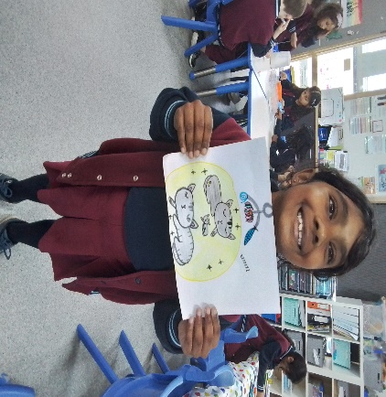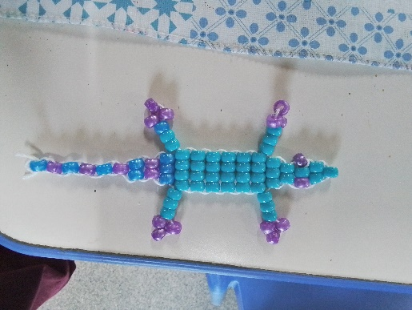[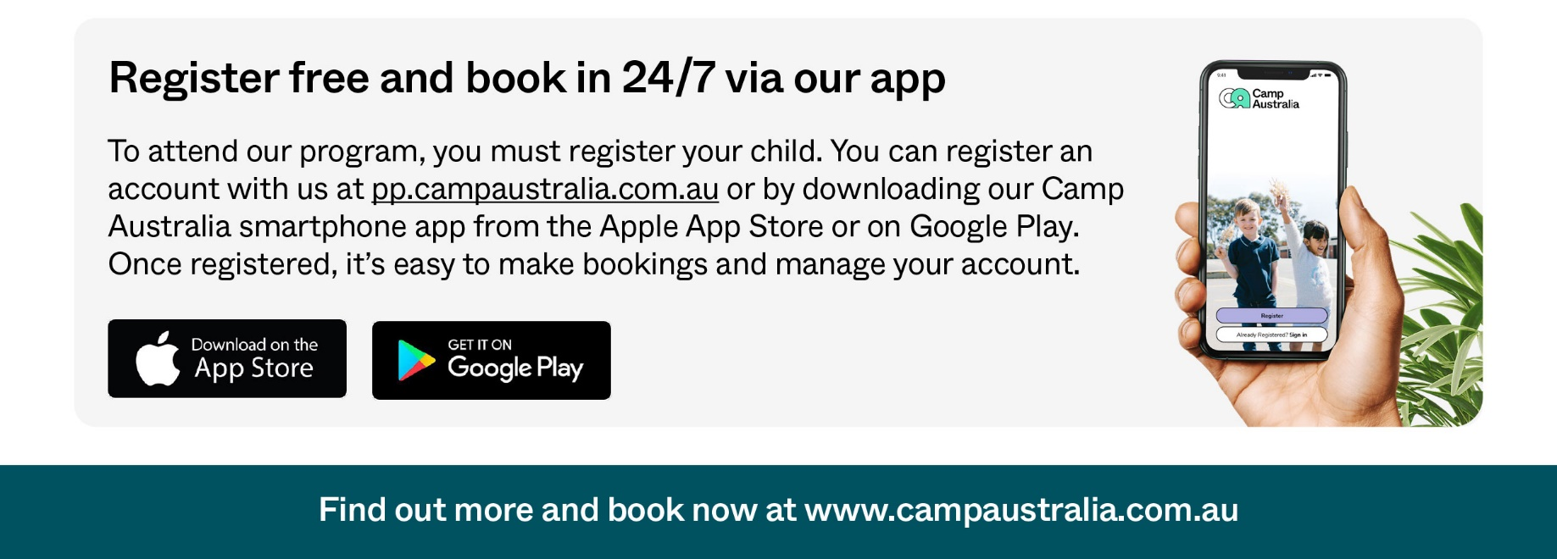](https://pp.campaustralia.com.au/)

We have two Pupil Free days coming up on Friday 1st November 2024 and Monday 4th November, come and enjoy the fun with Bouncing Ballons and lots of Art and Craft to enjoy. Book on the web site for these days. Also the Big Art Comp Term 4 will open on the 15th November, so get creation entry at BSC or ASC. Monday 18th November at 7:30pm Enhancing Your Child’s Social and Emotional Wellbeing, Free webinar with Dr Kaylene Henderson.

* Growing Herbs at OSH
* Big Art Friday
* Healthy Eating

**Activities coming up**

Join in the fun of Outside School Hours Care activities and experiences with Your OSHC and Rocketeers.

**Make a booking**

Book now

**Oatlands Primary School OSHC**