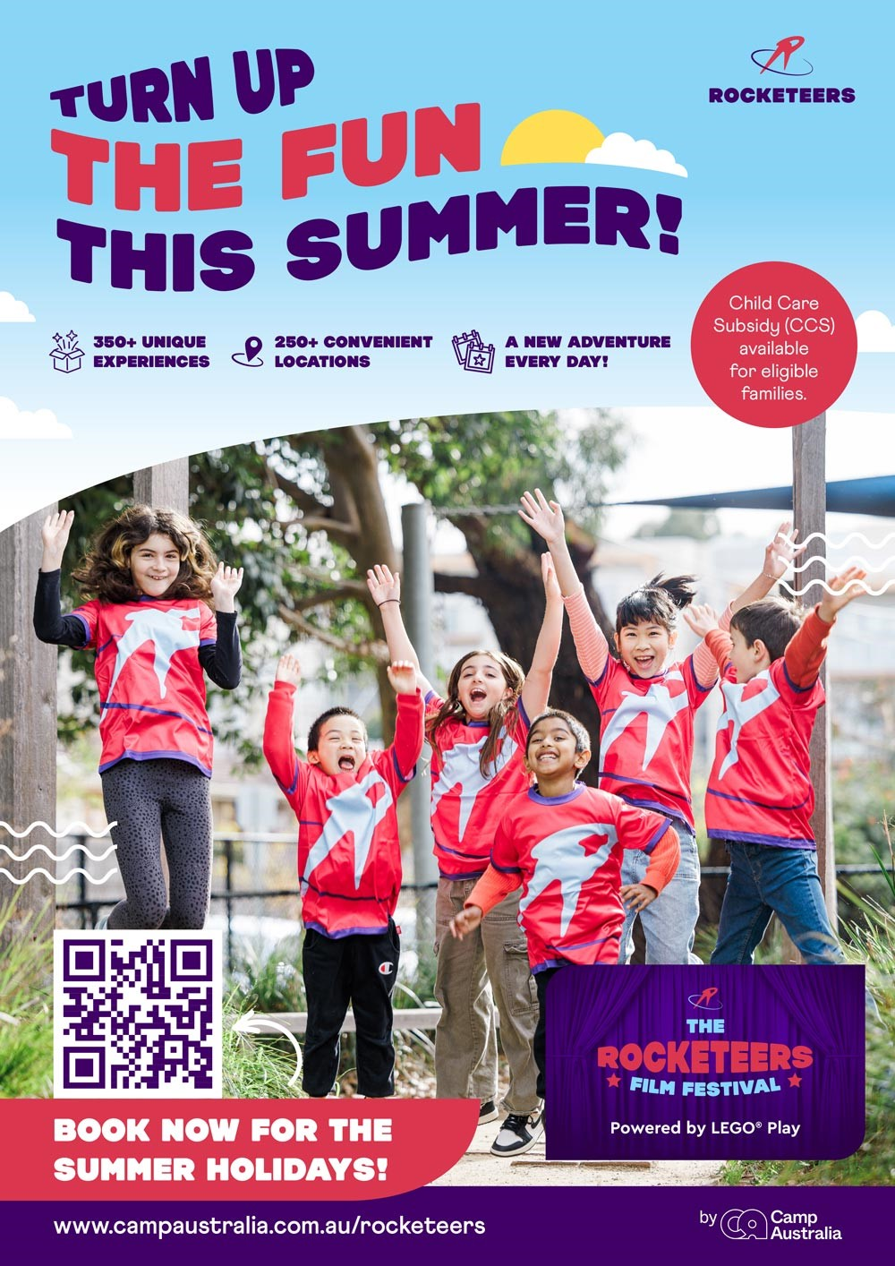
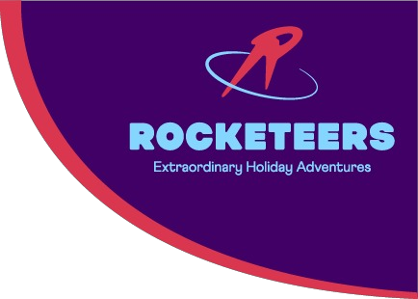

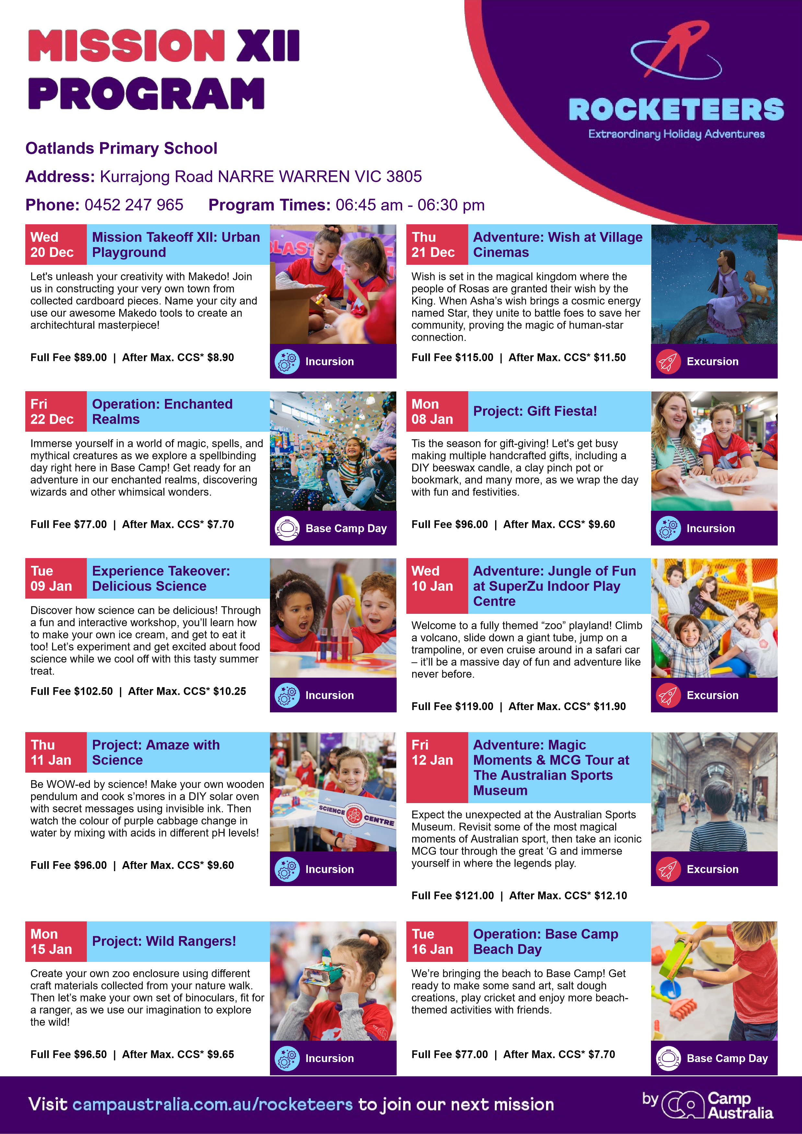
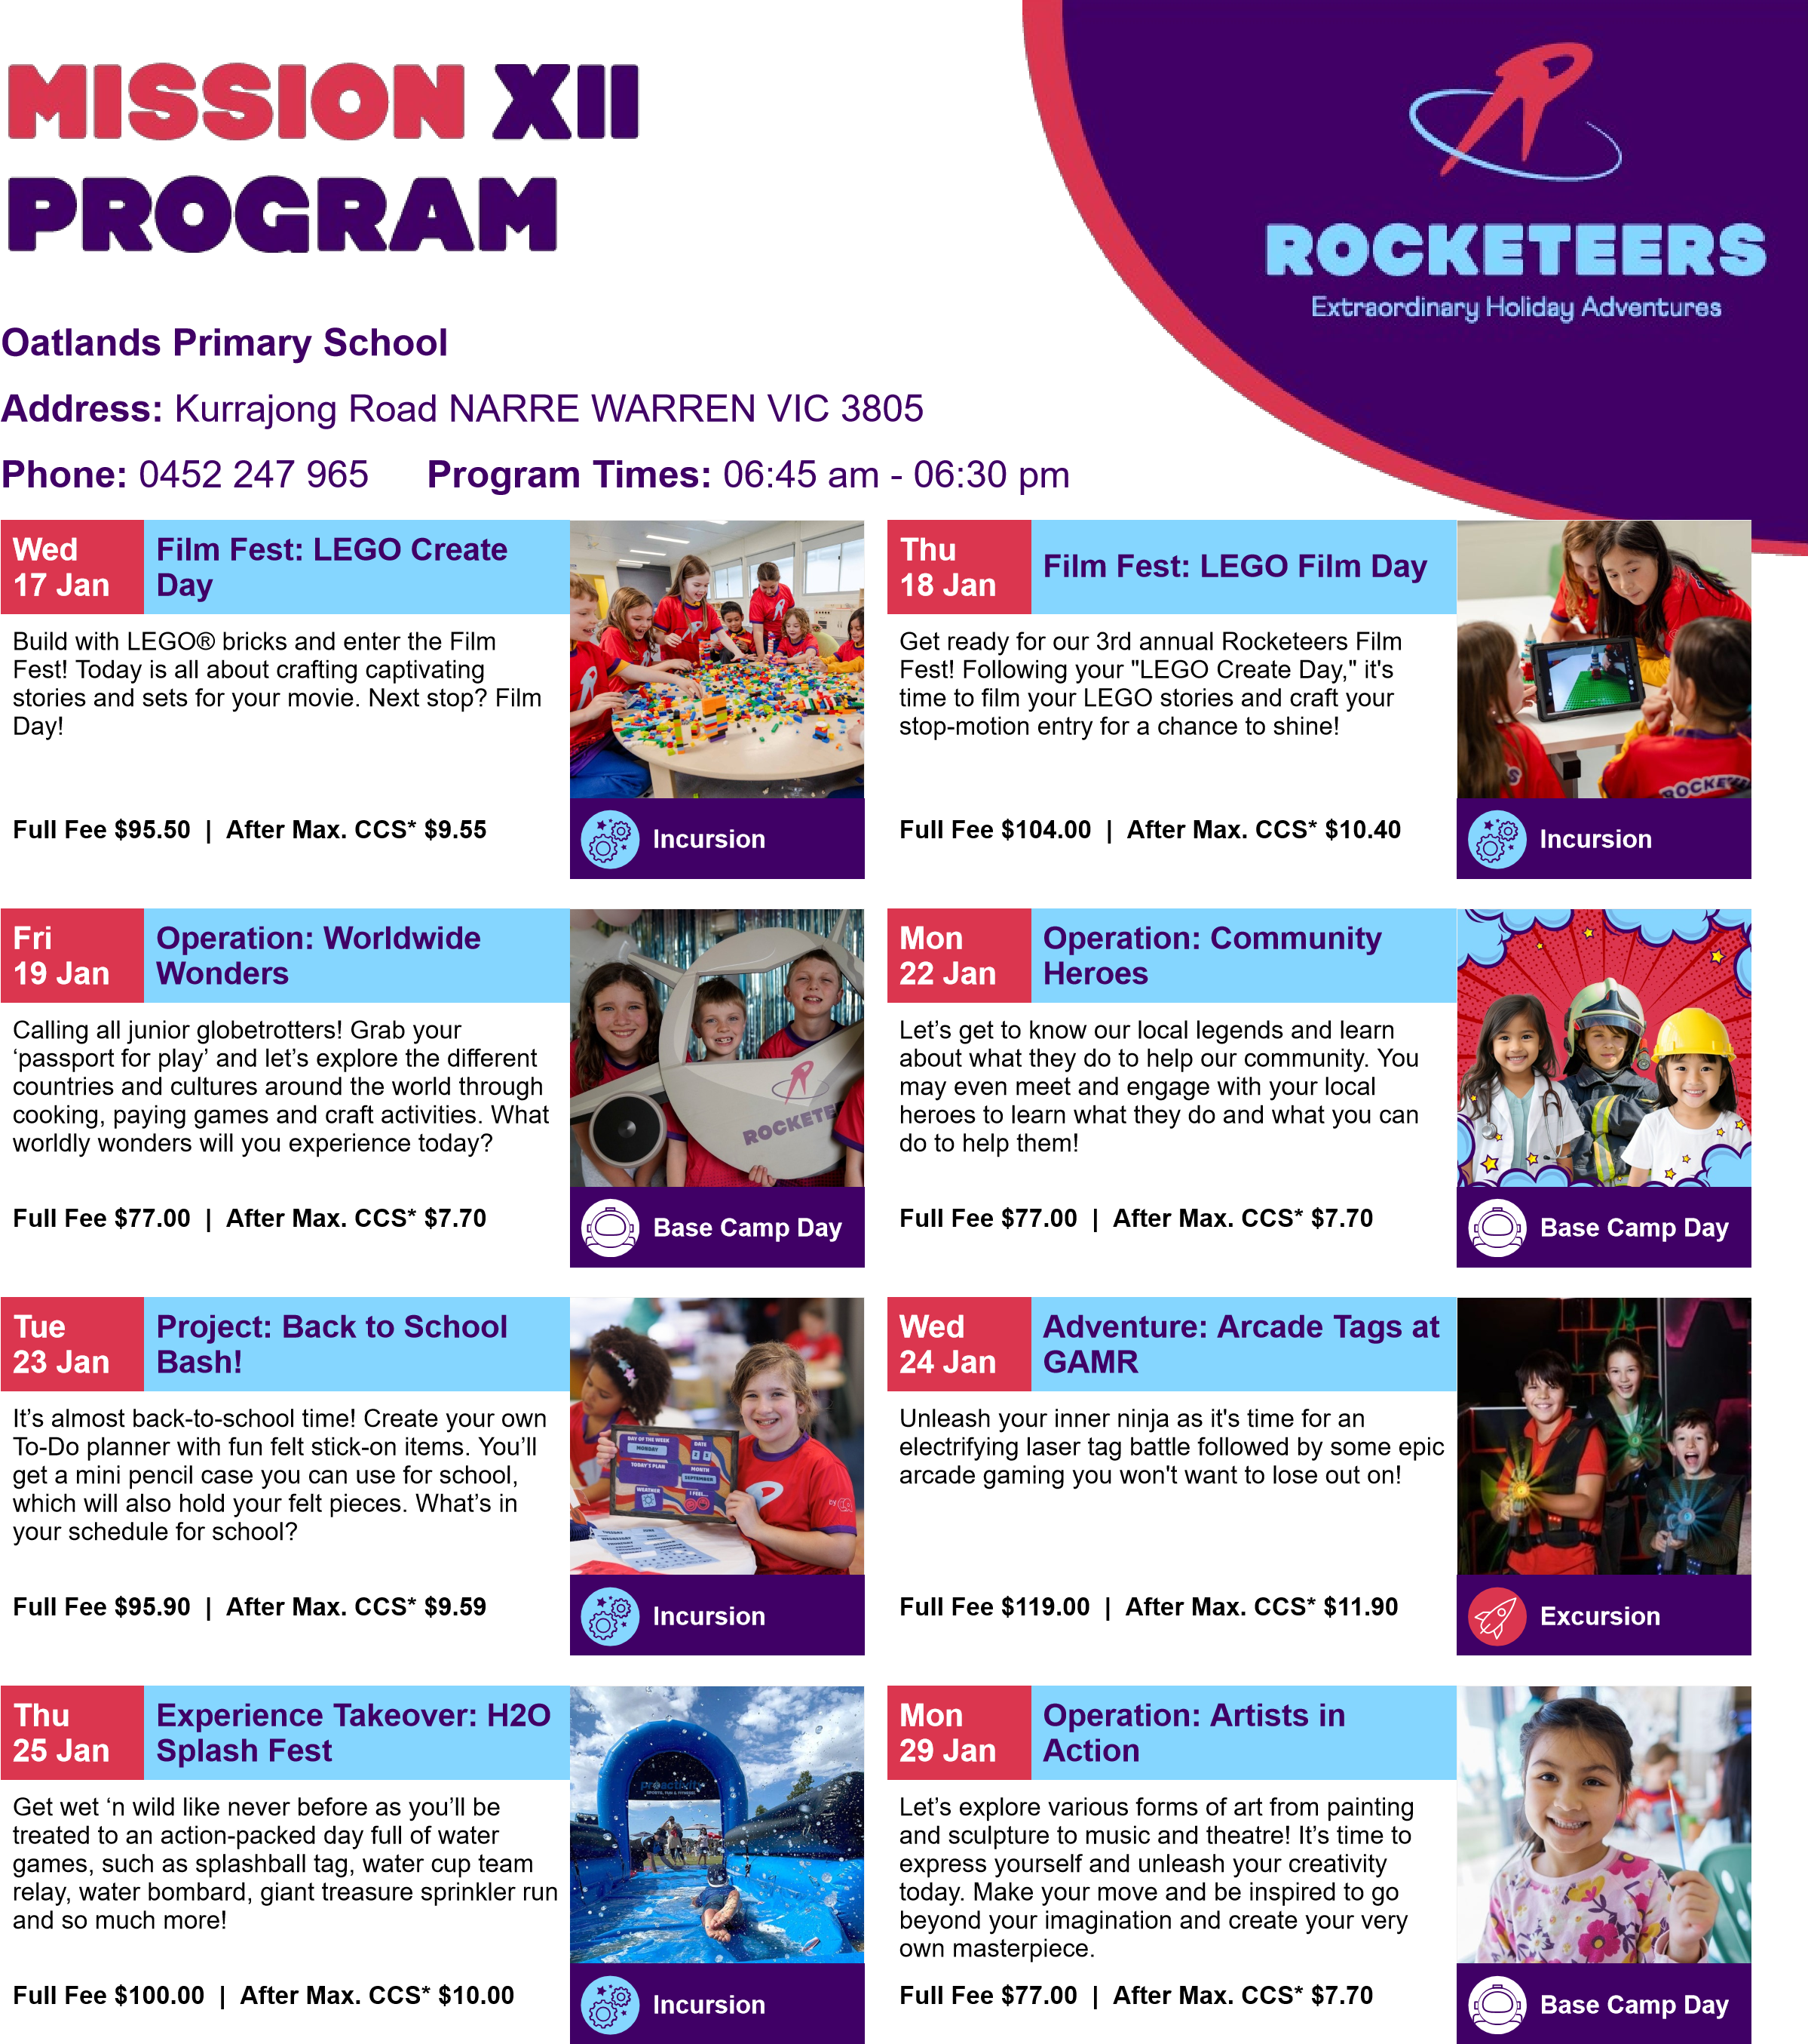
Tue 30 Jan | Operation: Splash Mania | Base Camp Day
Today is all about water play! With a bucket load of awesome activities to let your imagination come to life, let’s roll up our sleeves and get ready for a splashtastic day exploring your creativity and senses.
Full Fee $77.00 | After Max. CCS* $7.70

