Bursaria 4H Newsletter (Term 4)
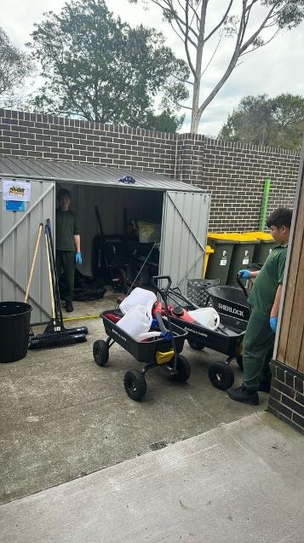
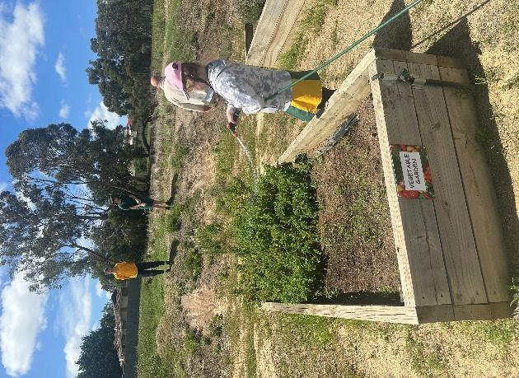
Class 4H has had a wonderful Term 4! We enjoyed taking part in lots of fun and engaging activities throughout the term, and it was fantastic to see the children participate with such enthusiasm. Everyone has worked very hard, and we are so proud of the great progress they have made. Well done, 4H, on a fantastic term.
Here are some pictures of all the fun we had:
We were hugely involved in keeping our school grounds and gardens in tip top shape.

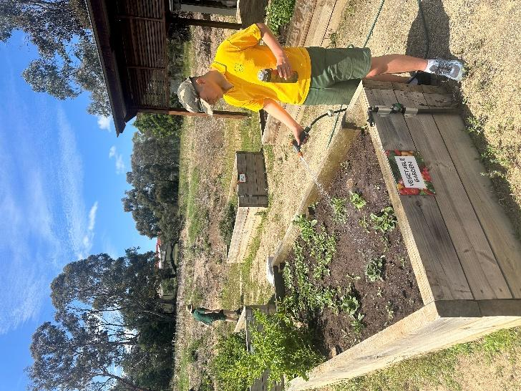

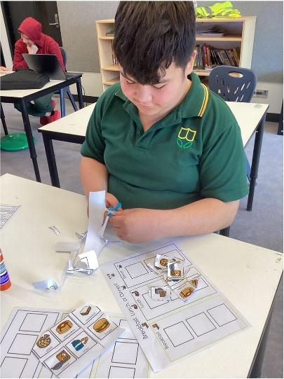
Below you can see we worked our socks off in the classroom too. We particularly loved cut and stick activities. We also realized we had a poet in our midst.

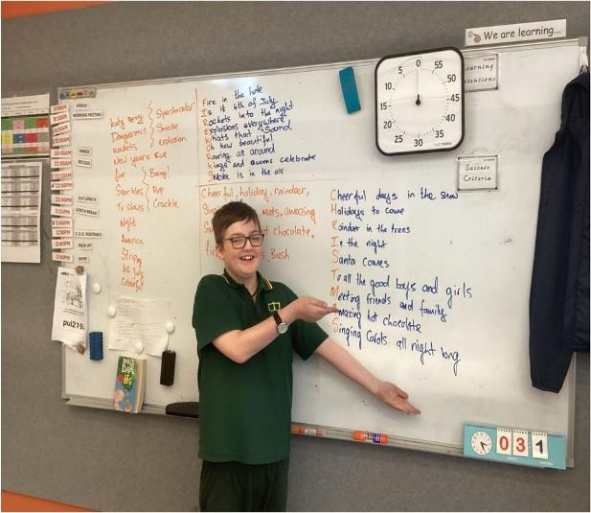
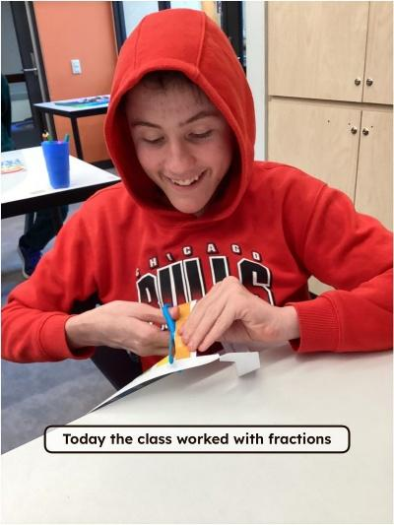

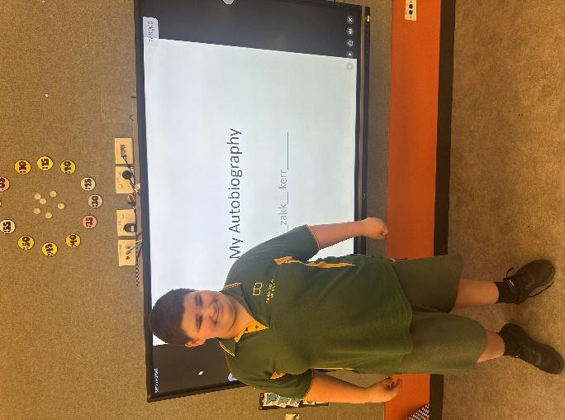
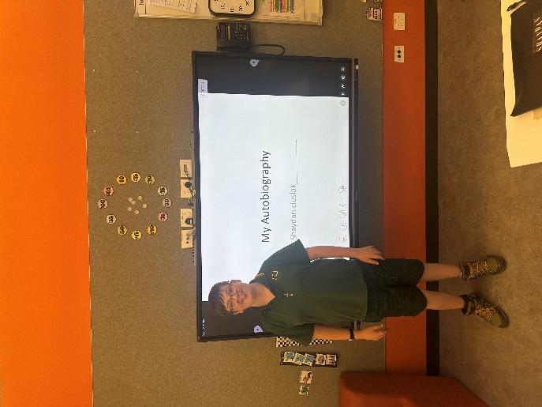
We spent the second half of Term 4 working on our autobiographies.

We presented them to the class in week 10.

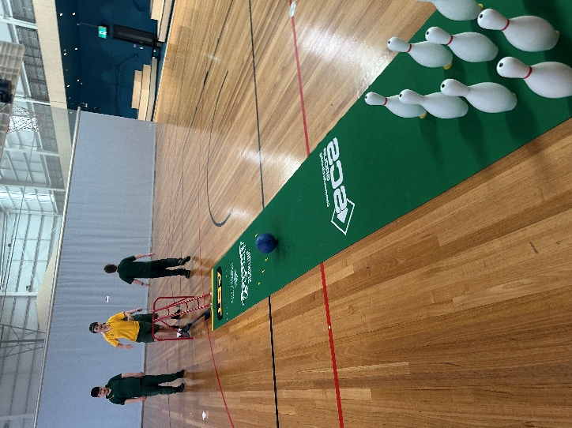
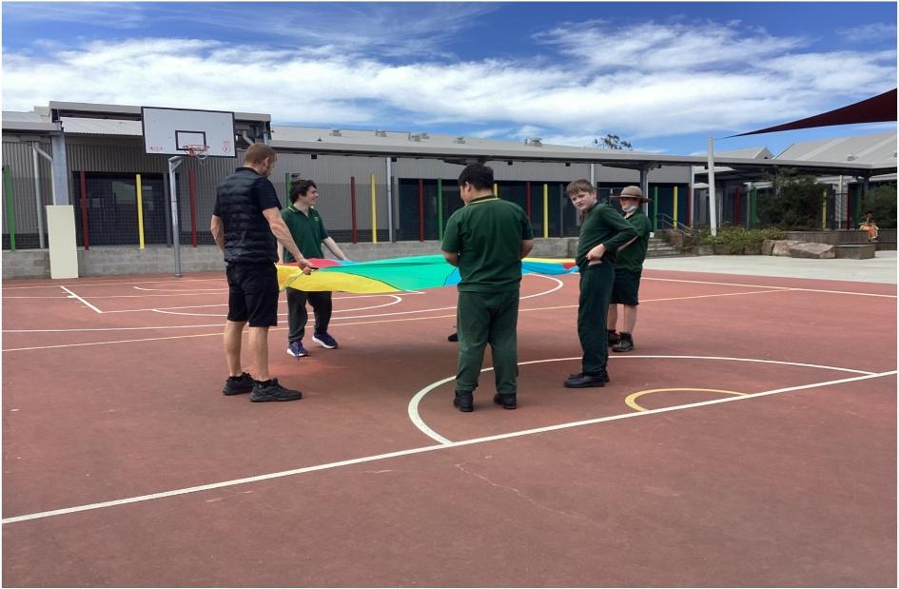
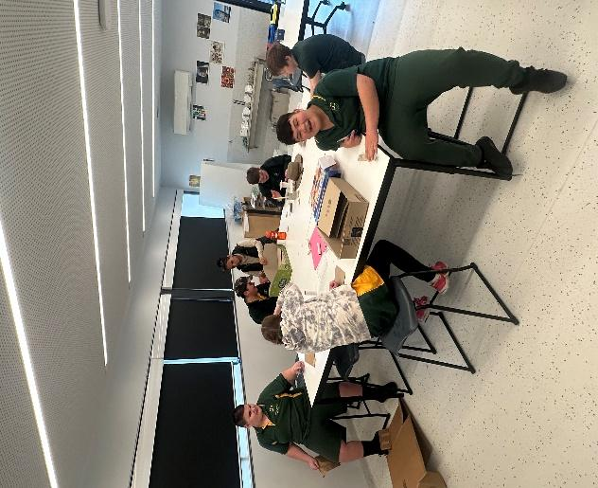
We also had lots of fun during our specialist subjects. Here are some pictures of us having fun during PE in the stadium, Art in the messy lab and a STEM in our outside play area.
Congratulations to everyone in 4H this Term. You can all be so proud of yourselves.
