
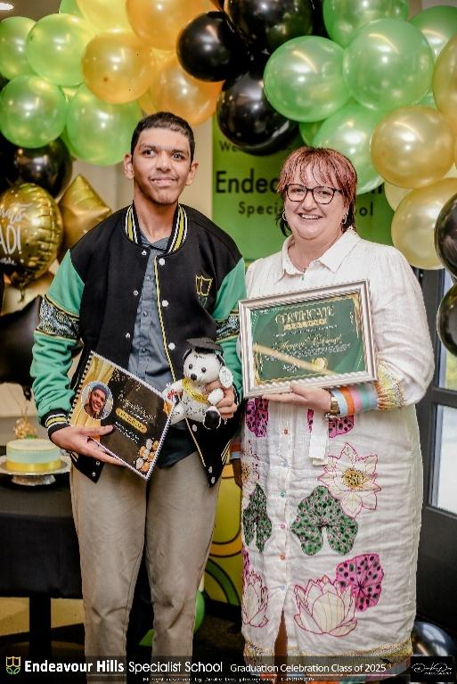
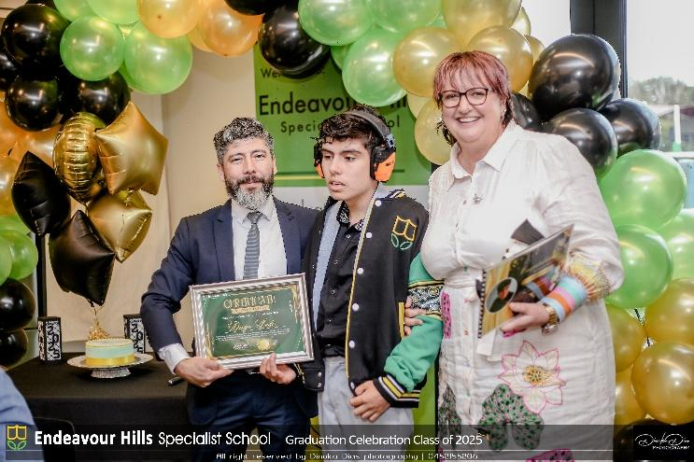
GRADUATION 2025

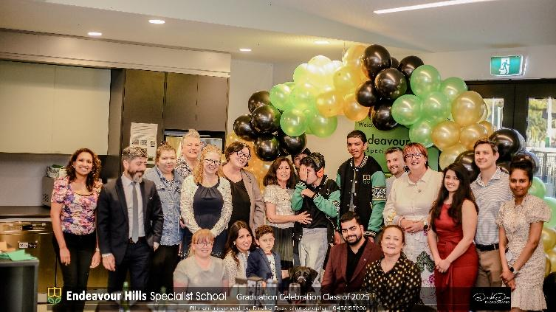
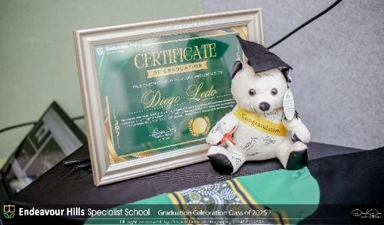
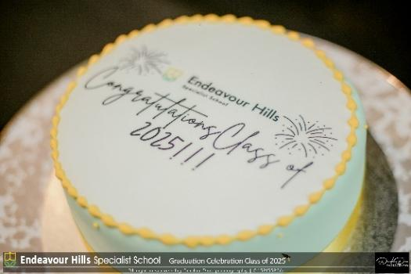
This year, we proudly farewell our first graduates from Endeavour Hills Specialist School - Avneel and Diego. We congratulate them on their achievements and warmly acknowledge the support of their families, peers, and teachers who have been part of their schooling journey.
As Avneel and Diego take their next steps beyond our school community, we wish them every success and happiness. May the confidence, skills, and friendships they have built here guide them as they embark on the next exciting chapter of their lives.
A special thank you goes to our Graduation Committee for organising such a memorable and meaningful event to celebrate this milestone. We would also like to extend our heartfelt thanks to SouthEast Entertainment and Dinuka Dias Photography for generously donating their services, time and equipment to help make the celebration even more special.

