Skills Development – Money Matters

Bill Buster NEW
Friday 11 October, 25 October,
8 November, 22 November and
6 December
Drop in between 9.30am-3.30pm – No charge

A representative from Good Shepherd is onsite for one on one assistance with budgeting, accessing bill hardship programs and government concessions, information about financial rights and referral to financial counselling/community services.

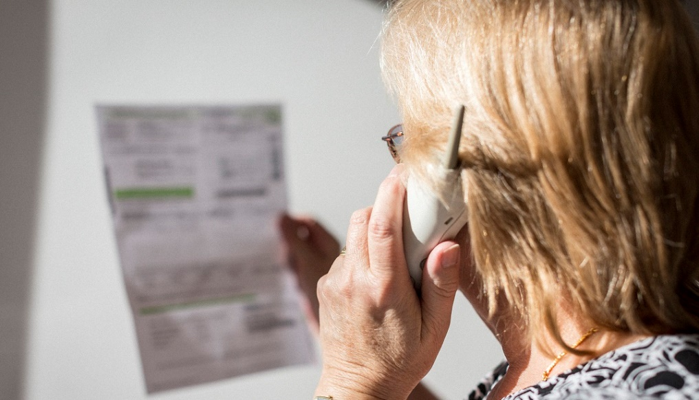

Phone us on 9249 4224 to book or just drop in.

Money & Me NEW
Setting Goals – Begin the journey with money
Thursday 17 October
10am-12noon – No charge
Budget Planning – What suits you
Thursday 24 October
10am-12noon – No charge
Banking and Bills – Control your money
Thursday 31 October
10am-12noon – No charge
Planning for the future – Who can help
Thursday 7th November
10am-12noon – No charge
A Good Shepherd program providing information, money management skills and coaching to help people make better financial decisions. Come to 1,2,3 or all 4 sessions. The choice is yours.
To book email Christian at financialcapabilitywest@goodshep.org.au or call or text 0491 152 910.

