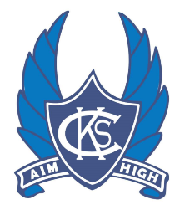
2021 Year 7 Awards

ACE Bella McKean
Art Georgia Kyle
English Ruby Jobling
Health Abby Kill
Humanities Natalie Churchill
Like Minds Natalie Churchill
LOTE William Dowel
Maths Billy Wilson
PE Georgia Kyle
Performing Arts Zi Xin Ye
Science Kayla Sendek
Sport Max Fowles
STEAM Molly Boulter
Technology – Food Georgia Kyle
Technology – Materials Xavier Nicholls
Co-Ordinators Lily Cammarano
Co-Ordinators William Dowel
Excellence Ruby Jobling
Excellence Kayla Sendek
Dux Natalie Churchill

Congratulations to all Award Winners

