CAREER NEWS Thursday 2 April

 Dates to Diarise in Term 2
- VCE and Careers Expo 2026 – Thursday 30 April – Saturday 2 May
- Victorian Careers Show 2026 – Wednesday 13 May – Friday 15 May
- Law Week 2026 – Monday 18 – Sunday 24 May

 VCE and Careers Expo 2026
Early next term, the VCE and Careers Expo 2026 will be taking place!
An extensive range of exhibitors from all over Australia will be in attendance and over and above access to exhibitors, attendees will also have access to VCE and Careers Expo Seminars.
This event will take place at the Melbourne Convention and Exhibition Centre from 9.00am – 3.00pm on Thursday 30 April – Saturday 2 May 2026.
To find out more, or to book a ticket online, visit VCE and Careers Expo.

 What is Medical Imaging and Radiation Sciences?
Monash University offers courses in both Radiography and Medical Imaging (honours) and Radiation Sciences.
Students often ask what the differences are between these two areas of study, and Monash has a detailed information on its website providing answers to these questions.
Students are encouraged to spend some time browsing What is Medical Imaging and Radiation Sciences? Included on this page is a useful YouTube clip, well-worth watching!

 Aspire Program for 2027 Entry
- Aspire Community Impact Program
Open to domestic and permanent resident students only.
Requirements: Year 12 pass, VCE minimum prerequisite study scores and ATAR required.
Students will also need to make a VTAC application.
At La Trobe, we believe there is more to being a good student than marks alone. Have you been a leader? A volunteer? A key part of your community? Then we want to hear from you.
The Aspire Community Impact rewards Year 12 students for their volunteering or community contribution experience with an early conditional offer for most undergraduate courses at La Trobe.

Aspire Community Impact is a great option for students that are looking to use their community service or leadership experience to secure a spot in their dream course at La Trobe.
Successful applicants get an early conditional offer into their dream course at La Trobe, provided they meet the Aspire ATAR requirements and any other general course requirements for entry (such as subject prerequisites or additional entry criteria). Entry into all La Trobe courses is based on competitive selection and there may be limited places available.
A number of Aspire Scholarships, worth $5,000 per year for up to four years, will be awarded to leading eligible Aspire students.

Students can browse the link below which provides information regarding the participating courses and the required Aspire ATAR.
When applying, applicants are required to provide information about the length and frequency of their community service and/or volunteering experience.
Types of volunteering include –

- fundraising for charity
- helping to run a school/community club
- coaching a sports team
- volunteering at a nursing home
- mentoring younger students
- leading as a school or house captain

Students who have volunteered with any of La Trobe’s volunteer partners listed below, will receive an automatic conditional offer# at La Trobe University.
- SES Victoria
- Scouts Victoria
- CFA
- Bendigo Health
- St Vincents De Paul (Vinnies)
- Little Dreamers
- St John Ambulance
- Awards Victoria - The Compass Award
- Duke of Edinburgh's International Award - Australia

# Not necessarily an offer for the course they have applied for

Further details can be found at Aspire Community Impact at La Trobe University. Applications open on Wednesday 1 April 2026 and close Friday 4 September 2026. Students can nominate up to three courses and should do their research as they cannot edit these once their application is submitted.
- Aspire Academic Impact Program
Open to domestic and permanent resident students only.
Requirements: Successful completion of Year 12 and VCE minimum subject requirements and course prerequisites.
Students will also need to make a VTAC application.

Aspire Academic Impact is a great option for Year 12 students who are looking to lock in their future by securing a spot in their dream course at La Trobe.
Instead of an ATAR, La Trobe will use a student’s performance in Year 11 to secure an early conditional offer into a range of courses at La Trobe. It’s the perfect way to take the stress out of Year 12.

Students can submit an application at Aspire Academic Impact at La Trobe University, provide both semester one and two Year 11 reports, and submit a School Endorsement form signed off by a Year 11 or VCE Coordinator.
Applications open Wednesday 1 April 2026 and close on Friday 4 September 2026. Students can nominate up to three courses and should do their research as they cannot edit these once their application is submitted.

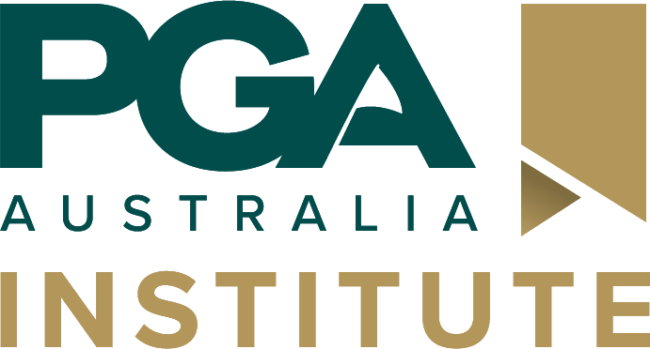 PGA Institute
Whether you aspire to shape the future of the game, inspire the next generation of golfers, or turn your passion into a profession, the PGA Institute’s industry-focused education equips you with the skills, knowledge, and flexibility to succeed.
The PGA Institute is the only Registered Training Organisation (RTO) in Australia dedicated to delivering world-class education and professional development specifically for the golf industry. With courses integrating business, golf training, service, sport, and practical golf skills, the PGA Institute prepares students for diverse career opportunities within the industry.
With pathways to Deakin University, Torrens University, Griffiths University, Holmesglen TAFE, and the PGA of Australia’s Membership Pathway Program, PGA Institute courses serve as the perfect springboard to further education and career progression.
To find out more about programs on offer, visit Study programs - Golf Australia.
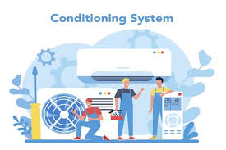 Career in Air Conditioning Technology
According to the Career Cornerstone Centre, air conditioning engineering technologists work in the design, installation, and service of heating and air conditioning systems in residential and commercial buildings. They know how to select and maintain equipment that ensures building comfort.
According to the Good Universities Guide, there are a range of specialised roles in this field, such as –

- Refrigeration and Air Conditioning Draftsperson
Refrigeration and air conditioning draftspersons design and produce working drawings of mechanical systems for refrigeration and air conditioning systems within a building project so that they can be manufactured, constructed, and installed.
Apart from having an aptitude for problem-solving, good communication skills, and being able to work as part of a team, a particular interest must be enjoying technical and design activities.

- Automotive Air Conditioning Fitter
Automotive air conditioning fitters install and repair air conditioning units in various types of vehicles and machinery, such as cars, trucks, vans, and tractors.
Successful fitters enjoy practical and manual activities, have good hand-eye coordination, an aptitude for mechanical work, are able to keep up to date with technological change, and have good problem-solving skills.

- Refrigeration and Air Conditioning Mechanic
Refrigeration and air conditioning mechanics select components, assemble, install, test, fault-find, service and repair industrial, commercial, and domestic refrigeration and air conditioning systems in homes, shops, factories, office buildings, hospitals, supermarkets, and cold stores.
Besides having an aptitude for problem-solving, good communication skills, and being able to work as part of a team, other important personal requirements of these specialised mechanics are being able to work with hand and power tools, enjoy and have an aptitude for technical work, and work patiently, systematically, and thoroughly.

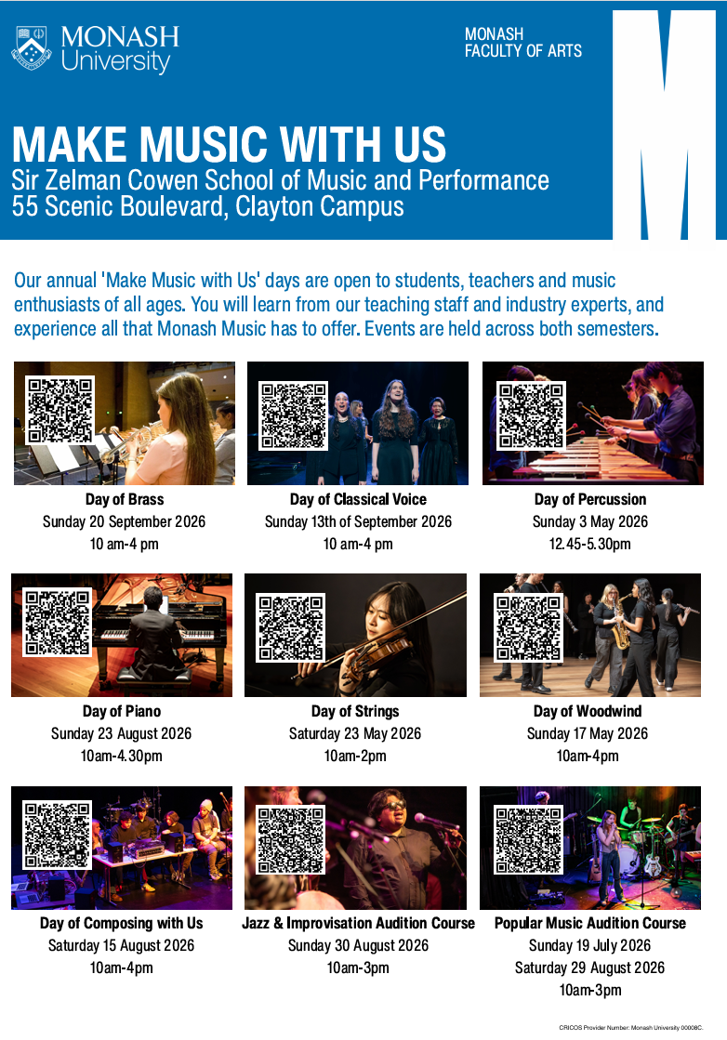
 Human Resources Courses in Victoria in 2026
The Good Universities Guide* states that Human Resources Officers provide administration services for the recruitment and employment of staff. In small organisations, Human Resources Officers are usually responsible for all staffing matters. In large organisations they may specialise in a particular area such as recruitment, wages and entitlements or staff training.
Personal requirements of a Human Resources Officer -
- Good planning, organisational, analytical and decision-making skills
- Good oral and written communication skills
- Tactful and discrete when dealing with people and confidential information

* Good Universities Guide - Human Resources Officer
Usually, human resource majors are offered in business and commerce courses at TAFE and university. For a comprehensive list of all courses offering studies in human resources, including double-degree options, visit VTAC.

INSTITUTION | COURSE | MAJOR STUDIES IN 2026
ACU | Bachelor of Commerce | Accounting, Event Management, Finance, Human Resource Management, Informatics, Management, Marketing.
Charles Sturt University | Bachelor of Business  Also offered in the  Bachelor of Business Studies | Accounting and Financial Management, Advertising, Agribusiness, Entrepreneurship, Ethics and Social Responsibility, Finance, Human Resource Management, IT Management, Legal and Industrial Relations, Management and Leadership, Marketing, Marketing, Communication and Digital Media, Project Management, Psychology, Strategic Communication, Strategic Planning, Sustainability.
Deakin University | Bachelor of Commerce | Accounting, Business analytics, Digital finance, Economic analytics, Economics, Emerging technology, Entrepreneurship, Event management, Finance, Financial planning, Global and social impact, Human resource management, International business, International trade, Management, Management information systems, Marketing, People management, Production management, Project management, Property investments, Recruitment and talent acquisition, Retail management, Sustainability and Development, Wealth management.
Deakin University | Bachelor of Human Resource Management (Psychology) | Human resource management, Psychology.
Federation University | Bachelor of Business (Marketing and Management) | Business strategy, Consumer behaviour, Data and information systems, Future of business, Introduction to marketing, Marketing communication, Social media marketing. Note: Covers units in HR in the 2nd year of the course.
La Trobe University | Bachelor of Business | Agribusiness, Digital business, Economics, Enterprise, Event management, Finance, Human resource management, International business, Management, Marketing, Tourism and hospitality.
Monash University | Bachelor of Business | Accounting, Banking and finance, Business analytics and statistics, Business law, Business management, Business studies, Economics and business strategy, Financial econometrics, Human resource management, International business, Marketing, Sustainability and responsible management, Taxation.
RMIT University | Bachelor of Business  Also offered in the  Business Professional Practice Degree | Blockchain Enabled Business, Business Information Systems, Business and Technology, Economics, Entrepreneurship, Finance, Financial Planning, Global Business, Human Resource Management, Logistics and Supply Chain, Management and Change, Marketing, Social Impact, Strategy and Innovation.
Swinburne University | Bachelor of Business  Also offered in the Business Professional Degree | Accounting, Business administration, Business analytics and analysis, Entrepreneurship, Financial planning, Human resource management, Logistics and supply chain management, Management, Marketing, Sports management.
Victoria University | Bachelor of Business | Accounting, Banking and Finance, Business Analytics, Event Management, Financial Risk Management, Human Resource Management, Information Systems Management, International Trade, Management and Innovation, Marketing, Supply Chain and Logistics, Tourism and Hospitality Management.
 Snapshot of Australian Catholic University in 2026
- ACU has over 34,000 students nationally spread over seven campuses across Australia and a campus in Rome – ACU Campuses.
- ACU is ranked #1 in Australian for graduate employer satisfaction, with more than 95% of its graduates finding employment within 4 months of graduation, and is ranked in the top 50 universities in the world for nursing – Excellence at ACU.
- Besides its wide range of institutes and centres, ACU has four faculties –
Education and Arts
Health Sciences
Law and Business
Theology and Philosophy
- Student Accommodation is offered at a number of the ACU campuses.
- ACU has relationships with more than 200 universities and educational institutions in the Americas, Europe, Africa and Asia, with over 25% of bachelor’s degree students travelling overseas during their studies. Students can attend an overseas university in more than 35 countries, complete international internships, and work in community programs around the world – all while receiving credit towards their degree – Study Abroad and Exchange and Study Overseas.
- Community engagement is also a core part of every student's experience at ACU, to the point where it's embedded within its courses. This allows students to give back to their communities and make a difference through opportunities such as volunteer experience programs – Community Engagement.
- ACU has a number of alternative admission pathways including the recently launched ACU Guarantee. The ACU Guarantee program offers eligible Year 12 students a place at ACU based on their Year 11 results. Of course, the final exams still matter – and students still need to finish Year 12 to validate their offer – ACU Guarantee.
- ACU has an Elite Athlete and Performer Program (EAPP) which has been designed to support and encourage elite student athletes in managing both areas of their life to ensure that they achieve their goals. Elite athletes and performers have access to a range of support services, academic resources, and funding opportunities – Elite Athlete and Performer Program.
- ACU offers many courses and introduced a number of new courses recently.
