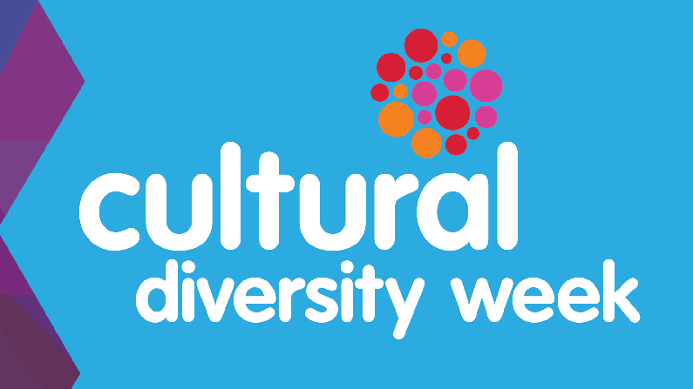**Cultural Diversity Week 15th- 19th March 2021 (week 8) Camelot Harmony Day Friday 19th March**

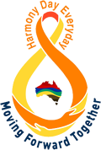

**Curiosity, Conversation, Community**

**Lani (EAL Leader) Danielle (Community Engagement Leader)**

**Ash, Kerryn, Ilana**

|  |  |  |  |
| --- | --- | --- | --- |
| All week |  | Bell Music: National Anthems and popular songs from Australia, China, India, Korea, Cambodia, Malaysia and Egypt  Danielle to organise and upload | Assembly Week 7  Friday 12/3  Ash/School leaders  Introduce Cultural Diversity Week  Inform community of activities taking place at school in following week |
| Monday 15/3/21 | Roll call  Good morning in different languages | Lunch  What’s in your lunchbox?  Food packed from ‘home’, 20 mins eating time, conversation about what you have brought to eat today, country it is from, how is it prepared, when is it eaten? |  |
| Tuesday  16/3/21 | Roll call  What is your favourite food from your culture? | Lunchtime Club – ART in Library Ilana &Lani  Traditional pattern tiles from around the world.  *This can also be a buddy task F & 5, 1 & 6* |  |
| Wednesday 17/3/21 | Roll call  What is your favourite cultural celebration? | Lunchtime Club - Dancing  Bollywood & Irish Dancing, Bluey!  GYM  Ash |  |
| Thursday 18/3/21 | Roll call  What is a tradition in your family? | Lunchtime Club - Sports from different countries  AFL, Bocci on Oval  Kerryn |  |
| Friday 19/3/21 | Roll call  What languages can you communicate in? | Camelot Harmony Day Free dress day – free & Optional Dress up  in traditional cultural clothing from a country of your choice  Eg. India – sari, Japan – kimono, colours that reflect your country Eg. China – red, Australia – yellow & green *Harmony Day wellbeing tasks will be placed in Level folders on Google drive. These can be complete on Friday before assembly.* | Assembly Week 8  Friday 19/3  Ash/School leaders  Tie all cultural activities together and celebrate Cultural Diversity week |