**CAREER NEWS** **Friday 19 May**

** Dates to Diarise in Term 2**

* **Victorian Careers Show 2023 –** Thursday 18 – Saturday 20 May
* **Victorian Law Week 2023 –** Monday 15 – Sunday 21 May

 **Early Offer Scheme**

**Open to domestic and PR students only**

**Requirements: Year 12 pass, meet VCE prerequisite study scores, and ATAR required**

*RMIT’s Early Offer Scheme values the entire experience of a student and provides diverse opportunities for students to leverage their acquired skills into their future career and find the right journey to their desired learning outcome.*

Australian and Permanent Resident students can apply for one course and must apply at the following RMIT link - [**Early Offer Scheme**](https://www.rmit.edu.au/study-with-us/applying-to-rmit/local-student-applications/access-rmit/early-offer).  The eligible courses on offer are also found at this link.

The application process requires students to -

1. Choose two of the following categories:

* Analytical and Critical Thinking
* Leadership
* Communication
* Creative Thinking and Innovation

1. Write a 200-word statement of their experience for each of the two chosen categories.
2. Supply supporting documentation verifying their involvement in the two categories they have written about.

Applications are open, and close on the 17 September 2023.  Conditional offers will be released by 28 September 2023.   The conditional offer will become unconditional should students complete Year 12, meet the course prerequisites, and attain the Early Offer ATAR required.  **Students must also make a VTAC application.**

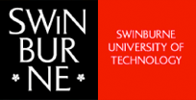 **News from Swinburne University**

* ***New* Cyber Security Double Degrees at Swinburne**

Swinburne University is now offering the following double degrees that can give students an extra edge in their career in Cyber Security.

• [Bachelor of Laws/Bachelor of Cyber Security](https://www.swinburne.edu.au/study/course/bachelor-of-laws-bachelor-of-cyber-security/)

• [Bachelor of Criminal Justice and Criminology/Bachelor of Cyber Security](https://www.swinburne.edu.au/study/course/bachelor-of-criminal-justice-and-criminology-bachelor-of-cyber-security/)

• [Bachelor of Business Analytics and Analysis/Bachelor of Cyber Security](https://www.swinburne.edu.au/study/course/bachelor-of-business-analytics-and-analysis-bachelor-of%20cyber-security/)

Students only keen on studying a single degree can browse [Bachelor of Cyber Security](https://www.swinburne.edu.au/course/bachelor-of-cyber-security/).

* **Environment & Sustainability at Swinburne**

*Preserving the earth begins with an understanding of the current landscape.*  
The environment and sustainability courses offered at Swinburne are an exploration into what it means to champion and sustain the earth for future generations. Courses are deigned to provide foundational knowledge and practical skills through an emphasis on *conservation, land management, horticulture, renewable energy* and more. *An environment and sustainability course could lead to a future in floristry, horticulture, retail, writing, and beyond.*

**Swinburne offers courses in -**

* [Conservation and Land Management](http://www.swinburne.edu.au/study/find-a-course/environment-sustainability/conservation-land-management/)
* [Environmental Science](http://www.swinburne.edu.au/study/find-a-course/environment-sustainability/environmental-science/)
* [Climate and Social Justice](https://www.swinburne.edu.au/courses/find-a-course/arts-humanities-social-sciences/climate-social-justice/)
* [Horticulture and Landscape](http://www.swinburne.edu.au/study/find-a-course/environment-sustainability/horticulture-landscape/)

**Visit** [**Environment & Sustainability**](http://www.swinburne.edu.au/study/find-a-course/environment-sustainability/?utm_source=Facebook&utm_medium=Evironmental&utm_term=mobile&utm_campaign=AlwaysOn) **to find out more.**

 **Business Explorer Program 2023**

*Join the Monash Business School* ***business explorer*** *taster session and choose from a range of activities to learn more about the many different courses and careers available across all areas of business, economics, and commerce.*This *free* event is open to students in Years 11 and 12 who are considering studying business at university, and is a great way to explore the diverse world of commerce through a choice of taster sessions in accounting, economics, banking and finance, management, marketing, entrepreneurship and analytics, statistics and actuarial studies. Lunch will also be provided.

**Date:** Tuesday 27 June 2023  
**Time:** 10.00am – 3.15pm

**Venue:** Monash University, Caulfield Campus

**Registration is essential and places are limited. Register at** [**Home - Business Explorer | Monash Business School | Monash University**](https://www.monash.edu/business/business-explorer/home)**.**

 **News from RMIT University**

* **Tech & Trades Experience Day**

RMIT is hosting a *free* ***Tech and Trades Experience Day*** for Years 10, 11 and 12 students and their parents/guardians.  Students can experience hands-on workshops from various fields in Future Technologies and Trades to gain practical knowledge, tour facilities, and interact with teachers, current students, and industry. Lunch is provided, and there are prizes to be won!   
 **Date:** Saturday 29 June 2023  
**Time:** 9.00am – 2.25pm  
**Location:** City Campus

**Register to participate at** [**Tech & Trades Experience Day 2023 - RMIT University**](https://www.rmit.edu.au/events/2023/june/tech-and-trades-experience-day)**.**

* **Bachelor of Space Science at RMIT**

*Do you want to be part of Space 2.0? Have you thought about human spaceflight, space tourism and even missions to Mars?*

The Bachelor of Space Science at RMIT University allows students to prepare for an exciting career in the growing space industry. In addition to space science and physics, students will study complementary courses in *satellite remote sensing, mathematics, IT and data analytics, signal and systems engineering* as well as *spaceflight systems design*. During their studies, students will have the opportunity to undertake a 12-week industry placement so they can immerse themselves in the world of space. These placements are run through Boeing, Geoplex and Nova Systems.   **Find out more at** [**Bachelor of Space Science at RMIT University**](https://www.rmit.edu.au/study-with-us/levels-of-study/undergraduate-study/bachelor-degrees/bachelor-of-space-science-bp330)**.**

 **What is a Paralegal?**

The [Centre for Paralegal Studies](https://paralegal.com.au/what-is-a-paralegal/) states that *paralegals play an integral role in the legal profession, and they can offer significant assistance in the delivery of legal services.*

*They work in various types of organisations including law firms, government agencies and corporate legal departments. The use of paralegals in the profession can allow legal services to be delivered more efficiently and more cost effectively.*

Although paralegals are not solicitors or barristers, they often perform tasks that are of a legal nature. However, this does not mean that only people who are undertaking a law degree or are currently working in a legal environment can obtain a role as a **paralegal**.  With the right training, skills and knowledge, opportunities for paralegal roles are available to people from a wide range of disciplines including business and management.

**In Victoria, a number of universities offer studies in *Legal Disputes, Criminology, Criminal Justice, etc. and all lead to careers in the paralegal services.***

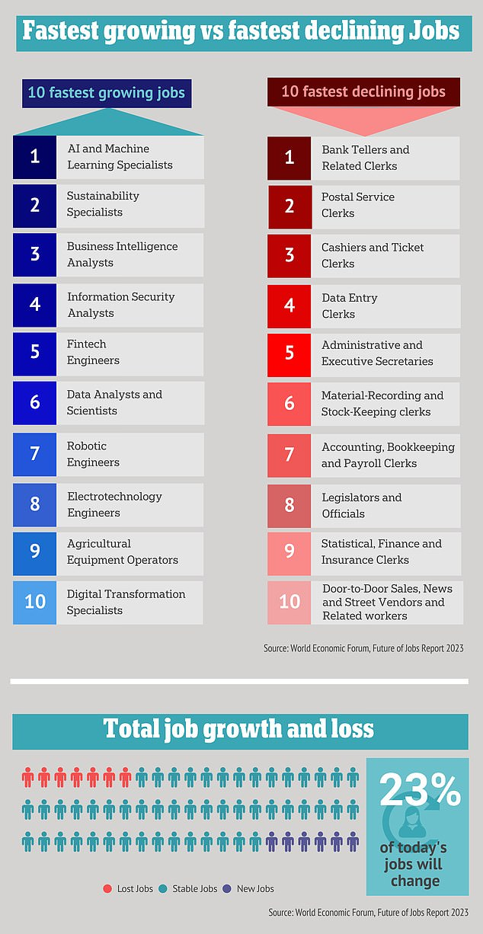

In the next five years, almost a quarter of jobs (23%) are expected to change through growth of 10.2% and decline of 12.3%, according to the [Future of Jobs 2023: These are the fastest-growing jobs | World Economic Forum](https://www.weforum.org/agenda/2023/04/future-jobs-2023-fastest-growing-decline). Employers anticipate**69 million new jobs to be created and 83 million eliminated** - a net decrease of 14 million jobs, or 2% of current employment.  
 **Students are encouraged to browse the link above to learn more about where jobs are growing, and where others are declining, as the more knowledge one has, the more informed one’s decisions will be.**

 **Human Resources Courses in Victoria in 2023**The Good Universities Guide**\*** states that *Human Resources Officers provide administration services for the recruitment and employment of staff.  In small organisations, Human Resources Officers are usually responsible for all staffing matters.  In large organisations they may specialise in a particular area such as recruitment, wages and entitlements or staff training.*

**Personal requirements of a Human Resources Officer -**

* Good planning, organisational, analytical and decision-making skills
* Good oral and written communication skills
* Tactful and discrete when dealing with people and confidential information

**\***[**Good Universities Guide - Human Resources Officer**](https://www.gooduniversitiesguide.com.au/careers-guide/browse/human-resources-officer)

Training to become a Human Resources Officer can take place at TAFE or university.  Below are some of the courses offered in Victoria.  Often human resource majors are offered in business and commerce courses at TAFE and university.  **For a comprehensive list of all courses offering studies in human resources, including double-degree options, visit**[**VTAC**](http://www.vtac.edu.au/)

|  |  |  |
| --- | --- | --- |
| **INSTITUTION** | **COURSE** | **MAJOR STUDIES IN 2023** |
| **ACU** | [Bachelor of Commerce (HRM and Management)](https://www.acu.edu.au/course/bachelor-of-commerce-hrm-and-management) | Human Resources, Management. |
| **Charles Sturt University** | [Bachelor of Business Studies](https://study.csu.edu.au/courses/business/bachelor-business-studies) | Accounting, business, business studies, entrepreneurship, finance, ***human resource management***, information technology, international business, management, marketing, online technologies, small business management, social media. |
| **Deakin University** | [Bachelor of Commerce](https://www.deakin.edu.au/course/bachelor-commerce) | Accounting, Business analytics, Economics, Emerging technology, Entrepreneurship, Event management, Finance, Financial planning, Global and social impact, ***Human resource management***, International business, International trade, Management, Management information systems, Marketing, People management, Production management, Project management, Property investments, Recruitment and talent acquisition, Retail management, Social entrepreneurship, Wealth management. |
| [Bachelor of Human Resource Management (Psychology)](https://www.deakin.edu.au/course/bachelor-human-resource-management-psychology) | Human resource management, Psychology. |
| **La Trobe University** | [Bachelor of Business (Human Resource Management)](https://www.latrobe.edu.au/courses/bachelor-of-business) | Human resource management. |
| **Monash University** | [Bachelor of Business](https://www.monash.edu/study/courses/find-a-course/2023/business-b2000) | Accounting, Banking and finance, Business analytics and statistics, Business law, Business management, Business studies, Economics and business strategy, Financial econometrics, ***Human resource management***, International business, Marketing, Taxation. |
| **RMIT University** | [Associate Degree in Business](https://www.rmit.edu.au/study-with-us/levels-of-study/undergraduate-study/associate-degrees/ad029) | Accounting, Business, Economics, Entrepreneurship, Global Business, ***Human Resource Management***, Information Technology, Leadership, Legal Studies, Logistics and Supply Chain Management, Management, Marketing. |
| **Swinburne University** | [Bachelor of Business](https://www.swinburne.edu.au/course/bachelor-of-business) | Accounting, Accounting and finance, Business administration, Business analytics and analysis, Entrepreneurship and innovation, Finance, ***Human resource management***, Logistics and supply chain management, Management, Marketing, Sports management. |
| **Victoria University** | [Bachelor of Business](https://www.vu.edu.au/courses/bachelor-of-business-bbns) | Accounting, Analytics, Banking and Finance, Event Management, Financial Risk Management, ***Human Resource Management***, Information Systems Management, International Trade, Management and Innovation, Marketing, Supply Chain and Logistics, Tourism and Hospitality Management. |

 **Snapshot of James Cook University (JCU) in 2023**

* JCU is the second-oldest university in Queensland and is dedicated to research in areas such as marine sciences, biodiversity, tropical ecology and environments, global warming, tourism, and tropical medicine
* JCU is also a leading university in the tropics and ranked in the top 300 universities in the world - [Times Higher Education World Rankings](https://www.timeshighereducation.com/world-university-rankings/2022/world-ranking#!/page/0/length/-1/sort_by/rank/sort_order/asc/cols/stats)
* JCU has a number of [campuses](https://www.jcu.edu.au/about-jcu/campuses) with the main campuses being in [Townsville](https://www.jcu.edu.au/about-jcu/campuses/townsville) and [Cairns](https://www.jcu.edu.au/about-jcu/campuses/cairns), and there is an international campus in [Singapore](https://www.jcu.edu.au/about-jcu/campuses/singapore)
* Some of the most highly sought after [courses](https://www.jcu.edu.au/courses-and-study) offered at JCU include:  
   [Bachelor of Medicine Bachelor of Surgery](https://www.jcu.edu.au/courses-and-study/courses/bachelor-of-medicine,-bachelor-of-surgery)

[Bachelor of Dental Surgery](https://www.jcu.edu.au/courses-and-study/courses/bachelor-of-dental-surgery)   
 [Bachelor of Physiotherapy](https://www.jcu.edu.au/courses-and-study/courses/bachelor-of-physiotherapy)   
 [Bachelor of Veterinary Science](https://www.jcu.edu.au/courses-and-study/courses/bachelor-of-veterinary-science)   
 [Bachelor of Marine Science](https://www.jcu.edu.au/courses-and-study/courses/bachelor-of-marine-science)

* JCU has six colleges and one centre
* [College of Arts, Society and Education](https://www.jcu.edu.au/college-of-arts-society-and-education)
* [College of Business, Law and Governance](https://www.jcu.edu.au/college-of-business-law-and-governance)
* [College of Healthcare Sciences](https://www.jcu.edu.au/college-of-healthcare-sciences)
* [College of Medicine and Dentistry](https://www.jcu.edu.au/college-of-medicine-and-dentistry)
* [College of Public Health, Medical and Veterinary Sciences](https://www.jcu.edu.au/college-of-public-health-medical-and-veterinary-sciences)
* [College of Science and Engineering](https://www.jcu.edu.au/college-of-science-and-engineering)
* [Indigenous Education and Research Centre](https://www.jcu.edu.au/ierc)
* JCU offers a broad range of student exchange programs - [JCU Global Experience](https://www.jcu.edu.au/global-experience)
* **Fast Facts for Health or Veterinary Science Applicants**

JCU has a few programs where a combination of a [written application](https://www.jcu.edu.au/division-of-tropical-health-and-medicine/application-forms) and academic results is required for selection including ***dental surgery, medicine, and veterinary science***. Students applying for one or more of these courses should take note of the recommendations made at the above link.

