St Mary’s Ascot Vale

A message from the team
This week, our focus has been on expressing emotions and kindness through art. The children explored how art can communicate what we love and care about. Whether it’s creating a heart-shaped sculpture for someone special or simply making something that makes them smile.
Using different materials like clay, paint, and loom bands, the children have been busy designing their own masterpieces. They enjoyed the sensory process of shaping clay from scratch, waiting for it to dry, and painting it with brushes and rollers to bring their creations to life. Some children even used colours to write their names or to represent something unique about themselves. We’ve also seen a burst of creativity with loom band art, from colourful butterflies to tiny pineapples, often made as gifts for friends and educators, the small acts of kindness expressed through art.
Some of these beautiful artworks are now proudly displayed on our WOW WALL, where children share their ideas, emotions, and imagination. Each piece tells a little story about how they see the world and how they feel in the moment.

Check out the fun!
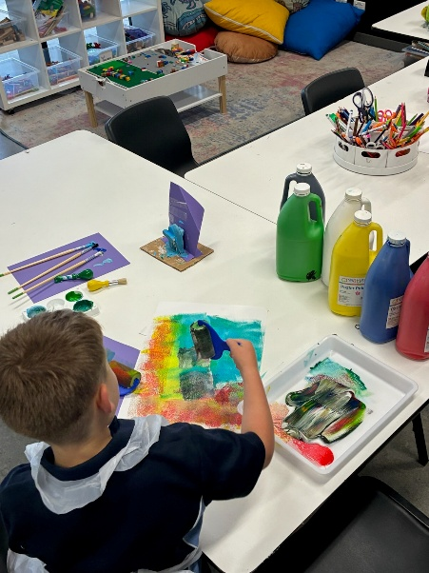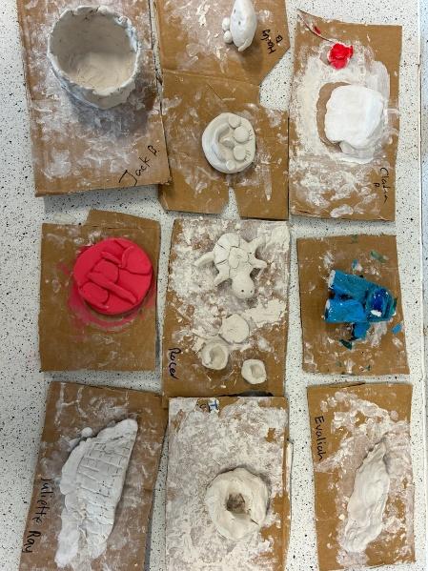

Important Dates

- World Hello Day
November 21, 2025
- World Children's Day
November 20,2025

Term Dates
October 6, 2025 – December 19, 2025

Projects we are working on

- LEGO challenges
- “My masterpiece” clay project

Make a booking!
Experience the fun of MACSEYE's OSHC program at St Mary’s Ascot Vale today!
Call our friendly team: 0493 136 327 or 1300 501 029
Visit us: 74 Roseberry St, Ascot Vale (7:00 am – 9:00 am & 2:30 pm -6:00 pm)
Email: enrolments@macseye.vic.edu.au | Website: www. macseye.vic.edu.au

