We’re celebrating Autism!
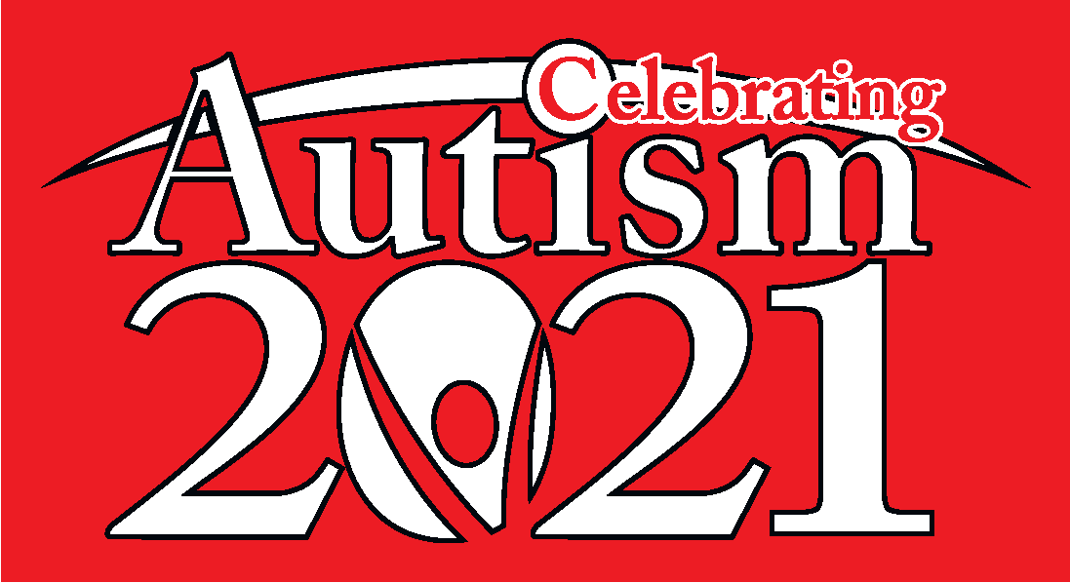

You’re all welcome to join us at our 2021
Jacanarama Fun Run / Walk

When: Wednesday 31st of March
Where: Bike / Walking Track on the Oval
Times: Primary Years: 9.30am – 10.30am
Middle Years: 1.30pm – 2.30pm
Secondary Years: 11.30am – 12.30pm
(please note time changes to Middle & Secondary)
*Hope to see you there and thank you for your support!

