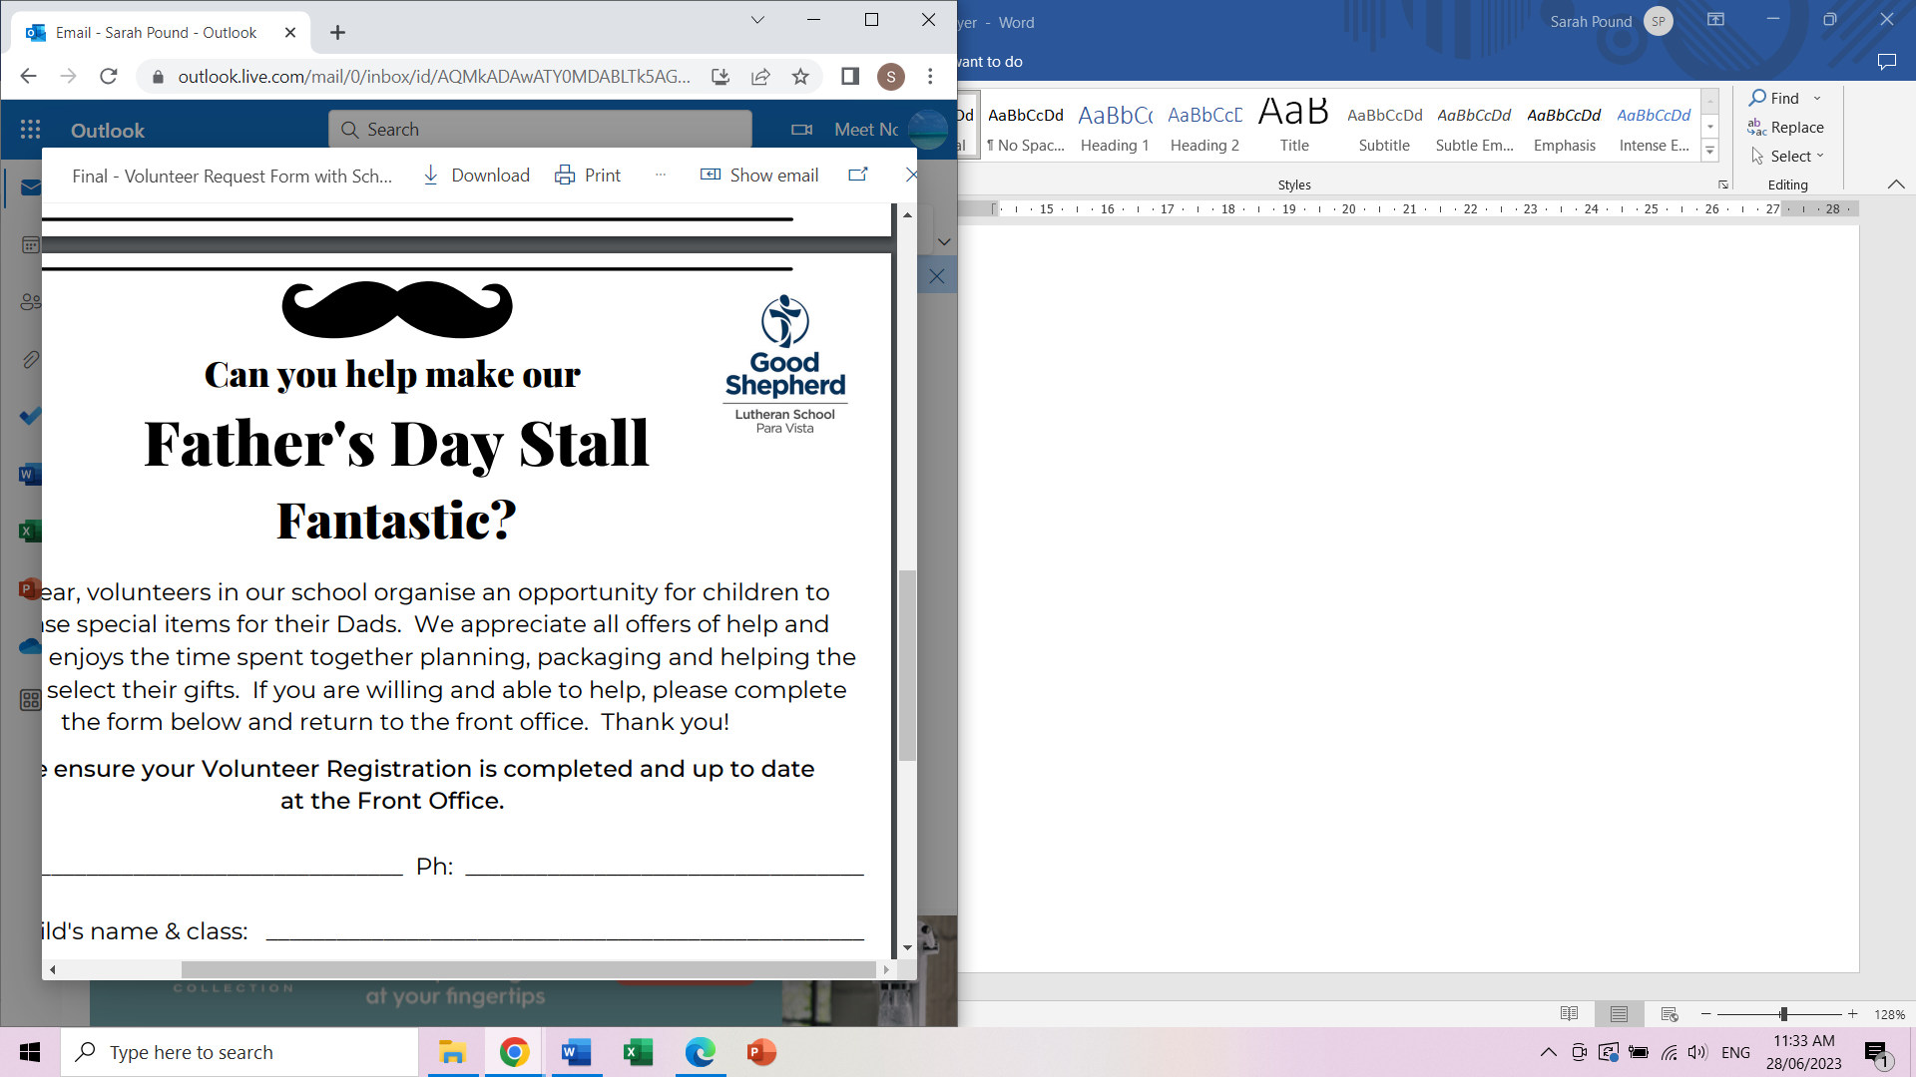Can you help make our

Mother’s Day Stall

Fantastic?

Each year, volunteers in our school organise an opportunity for children to purchase special items for their Mums. We appreciate all offers of help and are seeking volunteers for setting up, supporting the children with their buying and/or packing up of the Mother’s Day Stall. Please complete the form below and return to the front office. Thank you!

Name Phone

Oldest child’s name & class

We will collate offers of help and confirm your days/times.

I can help:

Wednesday 7th May 11.05am – 12.25pm

Wednesday 7th May 1.25 – 2.55pm

Thursday 8th May 8.50 – 10.30am

Thursday 8th May 11.05am – 12.25pm

Thursday 8th May 1.25 – 2.55pm

Friday 9th May 2.15 – 2.55pm

For more information, please contact the Front Office or Sarah Pound 0431156318. RSVP April 30th (Wednesday week 1, term 2)

Thank you for helping to make this a wonderful celebration.

**Please ensure your Volunteer Registration is complete and up to date at the Front Office. Thank you.**

Can you help make our

Mother’s Day Stall

Fantastic?

Each year, volunteers in our school organise an opportunity for children to purchase special items for their Mums. We appreciate all offers of help and are seeking volunteers for setting up, supporting the children with their buying and/or packing up of the Mother’s Day Stall. Please complete the form below and return to the front office. Thank you!

Name Phone

Oldest child’s name & class

We will collate offers of help and confirm your days/times.

I can help:

Wednesday 7th May 11.05am – 12.25pm

Wednesday 7th May 1.25 – 2.55pm

Thursday 8th May 8.50 – 10.30am

Thursday 8th May 11.05am – 12.25pm

Thursday 8th May 1.25 – 2.55pm

Friday 9th May 2.15 – 2.55pm

For more information, please contact the Front Office or Sarah Pound 0431156318. RSVP April 30th (Wednesday week 1, term 2)

Thank you for helping to make this a wonderful celebration.

**Please ensure your Volunteer Registration is complete and up to date at the Front Office. Thank you.**