**CAREER NEWS** **Friday 2 February**

** Dates to Diarise in Term 1**

** What the Career Centre can assist you with?**

|  |  |
| --- | --- |
| Apprenticeships Information | Résumé Writing Skills |
| Cadetships & Traineeships | SATs |
| Career Expos | Scholarship Opportunities |
| Careers Testing - Morrisby Profile | Subject Selection Counselling |
| GAP Year Opportunities | TAFE Courses & Programs |
| Individual Interviews | Tertiary Application Process - Interstate |
| International Study | University Courses & Programs |
| Interstate Universities | University Extension Studies |
| Interview Skills | VCAA Information |
| Open Days | VET delivered to Secondary Schools |
| Overseas Exchange Programs | VTAC Process |
| Part-time & Casual Job Opportunities | Weekly *Career News* Updates |

# **Description: ATOlogo.gif Tax File Number (TFN)**

Any student will need at tax file number if he/she starts work (part-time and full-time) and all students planning on a tertiary education require one when they start. Importantly, current Year 12 students are reminded that they cannot enrol in a CSP (Commonwealth Support Place) course at university without a Tax File Number, so it is worthwhile getting an application submitted early. **Visit** [**Apply for a TFN | Australian Taxation Office**](https://www.ato.gov.au/Individuals/Tax-File-Number/Apply-for-a-TFN/)

 **World University Rankings 2024 | Times Higher Education (THE)**The *Times Higher Education* World University Rankings 2024 include 1,904 universities across 108 countries and regions. Below are the top 20 universities in Australia.

|  |  |
| --- | --- |
| **Rank** | **University** |
| 37 | [University of Melbourne](https://www.timeshighereducation.com/world-university-rankings/university-melbourne) |
| 54 | [Monash University](https://www.timeshighereducation.com/world-university-rankings/monash-university) |
| 60 | [The University of Sydney](https://www.timeshighereducation.com/world-university-rankings/university-sydney) |
| 67 | [Australian National University](https://www.timeshighereducation.com/world-university-rankings/australian-national-university) |
| 70 | [The University of Queensland](https://www.timeshighereducation.com/world-university-rankings/university-queensland) |
| 84 | [UNSW Sydney](https://www.timeshighereducation.com/world-university-rankings/unsw-sydney) |
| =111 | [University of Adelaide](https://www.timeshighereducation.com/world-university-rankings/university-adelaide) |
| =143 | [The University of Western Australia](https://www.timeshighereducation.com/world-university-rankings/university-western-australia) |
| 148 | [University of Technology Sydney](https://www.timeshighereducation.com/world-university-rankings/university-technology-sydney) |
| 180 | [Macquarie University](https://www.timeshighereducation.com/world-university-rankings/macquarie-university) |
| 199 | [Queensland University of Technology](https://www.timeshighereducation.com/world-university-rankings/queensland-university-technology) |
| 201-250 | [Curtin University](https://www.timeshighereducation.com/world-university-rankings/curtin-university) |
| 201-250 | [University of Newcastle](https://www.timeshighereducation.com/world-university-rankings/university-newcastle) |
| 201-250 | [Swinburne University of Technology](https://www.timeshighereducation.com/world-university-rankings/swinburne-university-technology) |
| 201-250 | [University of Wollongong](https://www.timeshighereducation.com/world-university-rankings/university-wollongong) |
| 251-300 | [Deakin University](https://www.timeshighereducation.com/world-university-rankings/deakin-university) |
| 251-300 | [Griffith University](https://www.timeshighereducation.com/world-university-rankings/griffith-university) |
| 251-300 | [La Trobe University](https://www.timeshighereducation.com/world-university-rankings/la-trobe-university) |
| 251-300 | [RMIT University](https://www.timeshighereducation.com/world-university-rankings/rmit-university) |
| 251-300 | [University of Tasmania](https://www.timeshighereducation.com/world-university-rankings/university-tasmania) |

**Visit** [**World University Rankings 2024 | Times Higher Education (THE)**](https://www.timeshighereducation.com/world-university-rankings/2024/world-ranking) **to find out more.**

 **Geospatial Science at RMIT**Starting from 2024, *Geospatial Science* will now be available as part of the **Bachelor of Science** program as a **major**. This change presents a valuable opportunity for students to expand their knowledge and skills in this captivating field without the need to pursue a separate degree. Students who elect to do this major will delve into the fascinating realm of maps and spatial analysis, dive into satellite imagery and laser sensors, GPS technology, geographic information systems (GIS), digital twins, virtual reality, robots, and artificial intelligence. Students will use the skills they acquire in mapping and spatial data analysis to contribute towards UN sustainable development goals.

**Visit** [**Bachelor of Science - Geospatial Sciences major**](https://www.rmit.edu.au/study-with-us/levels-of-study/undergraduate-study/bachelor-degrees/bachelor-of-science-bp350/geospatial-sciences-major?mkt_tok=MjA0LUJYSy0wOTAAAAGP0xdmWsAHoIehpIofburx-X6i54cVg3eLnkQ2TGq6YOCNfP47eCaeXWAdCwjoOpe-mZLWtSLk5HUVpZpPfcVQ3Q-bsf0lHny6X6NQ0jU3_IfE8w) **to find out more.**

 **Victoria Police Careers Information Session**

Victoria Police is hosting an exclusive ***Careers Information Session*** for members of the community who are interested in a career with Victoria Police.

*Come along and learn more about the recruitment process, training at the Police Academy, general duties policing, career pathways, specialty units and more.*

**Date:** Thursday 15 February 2024  
**Time:** 5.00pm - 7.00pm  
**Venue:** Victoria Police Centre, 311 Spencer Street Docklands

This is a unique opportunity to observe the exciting world of policing. Members of the public are not usually granted access to the VPC, so get excited about this chance and grab a ticket.

**To find out more, and to reserve a ticket, visit** [**Victoria Police Careers Information Session**](https://www.eventbrite.com.au/e/victoria-police-careers-information-session-victoria-police-centre-vpc-tickets-792852472087?utm_source=Facebook&utm_medium=Social&utm_campaign=Recruitment&fbclid=IwAR2V5X300-atm5iSyMOkokHpy_M6jIADwOVmb2-V6zmgVFfL8p8Lyq2DKMk)

 **Careers in Aviation in the Navy**

*Helicopters are critical to Navy operations, delivering supplies, personnel, resources, and defensive capability. Our Pilots fly sophisticated aircraft such as the MH-60R and EC135 Helicopters and are complemented in the cockpit by Helicopter Mission Commanders who oversee navigation and weapon systems.*

Experience some of the world's most technologically advanced helicopters, choosing from a variety of exciting roles in the cockpit, in the workshop, or in support.

**Browse** [**Navy - Aviation Information**](https://navy.adfcareers.gov.au/jobs/aviation?page=1&perPage=21&query=&tab=category-about) **and watch the useful videos, etc. Also browse** [**Navy - Aviation Jobs**](https://navy.adfcareers.gov.au/jobs/aviation?page=1&perPage=21&query=&tab=category-jobs) **to gain an insight into the various jobs on offer.**

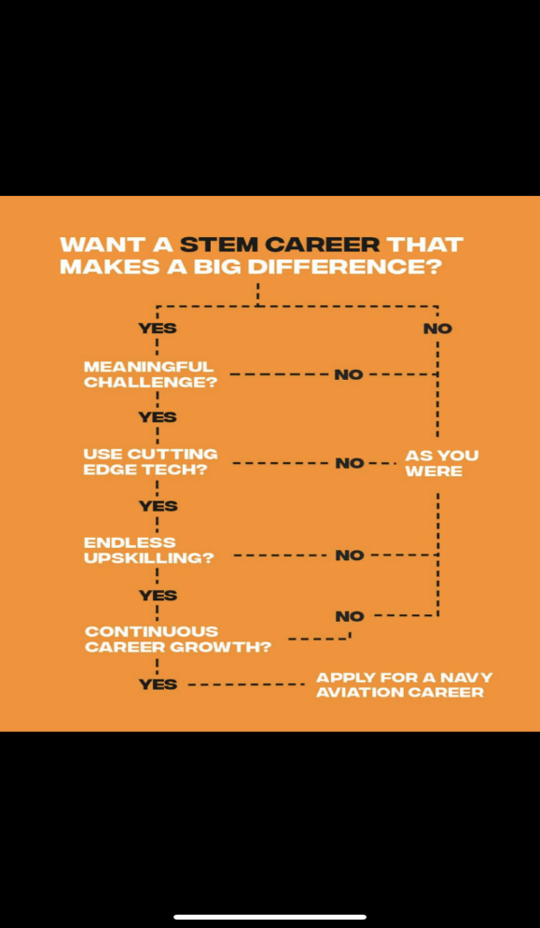

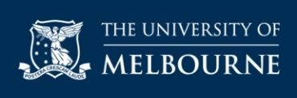 **The Hansen Scholarship 2024**The ***Hansen Scholarship Program*** aspires to nurture and significantly expand the horizons of Australian students who may otherwise struggle to access a high-quality university education.  
  
Each year the University of Melbourne recognises talented students from around Australia who have demonstrated resilience to adversity, and a commitment to supporting others. Through fully funded accommodation at Little Hall, tailored mentoring and extracurricular activities, and focused financial support, Hansen Scholars are equipped with the skills and knowledge to make an impact at Melbourne and beyond. The scholarship is worth up to $108,000. Eligible applicants must be Australian or PR citizens, be on track to achieve a minimum ATAR of 90.00, and experience financial challenges, e.g. applicant or their family receive Centrelink benefits.

**Selection is based on:**

* Track record of academic excellence and a commitment to academic success in university studies
* Demonstrated ability to achieve success in the face of adversity and overcome obstacles
* Demonstrated ability to apply skills and strengths towards activities which benefit others
* Demonstrated ability to work effectively in a team and lead those around you
* Likelihood of thriving as a Hansen Scholar and actively contributing to the Hansen Scholarship Program

**Benefits of the scholarship include –**

* guaranteed accommodation at Little Hall, at no charge, for the standard full-time, three-year undergraduate degree;
* an allowance of up to $4000 per year for general living expenses for the standard full-time duration of the undergraduate degree;
* access to a mentoring program, pastoral care, and development programs available to all students at Little Hall as well as a tailored program of mentoring and support exclusively for Hansen Scholars;
* a comprehensive and bespoke mentoring program will connect recipients to leaders in their chosen field, while program patron Jane Hansen AO will offer sponsorship and support

Applications open on 5 February 2024, and close on 3 April 2024.

**Find out more, including answers to FAQs, information about the program patron, and current Hansen Scholar profiles, at** [**The Hansen Scholarship Program**](https://study.unimelb.edu.au/study-with-us/hansen-scholarship-program)**.**

Travel and/or tourism courses are offered at a number of Victorian institutions. Some of these courses are listed below.   
Students are encouraged to visit [**VTAC**](http://www.vtac.edu.au/) for a comprehensive list.

|  |  |  |
| --- | --- | --- |
| **UNIVERSITY** | **COURSE** | **MAJOR STUDIES IN 2024** |
| **Holmesglen Institute** | [**Certificate III in Tourism**](https://www.holmesglen.edu.au/explore-courses/hospitality-tourism-and-events/travel-and-tourism/vocational-education/certificate-iii-in-tourism) | Administration, book tourism products, communications, international airfares, lead tour groups, provide accommodation services, provide quotations, sell tourism products and services, source airfares, use reservations systems. |
| **La Trobe University** | [**Bachelor of Business (major in Tourism and Hospitality)**](https://www.latrobe.edu.au/courses/bachelor-of-business) | Tourism and hospitality. |
| **Victoria University** | [**Bachelor of Business (major in Tourism and Hospitality Management)**](https://www.vu.edu.au/courses/bachelor-of-business-bbns) | Accounting, Analytics, Banking and Finance, Business Analytics, Event Management, Financial Risk Management, Human Resource Management, Information Systems Management, International Trade, Management and Innovation, Marketing, Supply Chain and Logistics, ***Tourism and Hospitality Management.*** |
| [**Diploma of Travel and Tourism Management**](https://www.vu.edu.au/courses/diploma-of-travel-and-tourism-management-sit50116) | Business, Hospitality, Tourism & Events. |
| **William Angliss Institute** | [**Bachelor of Tourism**](https://www.angliss.edu.au/courses/tourism/tourism/bachelor-of-tourism/) | Designing for the Visitor Experience, Destination Concepts, Economics and Global Impacts, Financial Concepts, Innovation and Entrepreneurship, Introduction to Marketing, Introduction to the Tourism Industry, Management Fundamentals, Niche Tourism, People and Place, Planning for Tourism, Risk and Legal Issues, Strategy Change and Leadership, Taking Responsibility for Tourism and Hospitality, Tourism Attraction Management, Tourism Distribution Systems, Tourism Futures, Tourism Theories and Concepts, Visitor Services. |
| [**Bachelor of Tourism (Ecotourism)**](https://www.angliss.edu.au/courses/tourism/tourism/bachelor-of-tourism-ecotourism/) | Delivering Thematic Interpretation, Designing Thematic Interpretation, Designing for the Visitor Experience, Destination Concepts, Economics and Global Impacts, Financial Concepts, Innovation and Entrepreneurship, Interpret Natural Landscape, Introduction to Marketing, Introduction to the Tourism Industry, Management Fundamentals, People and Place, Risk and Legal Issues, Strategy Change and Leadership, Taking Responsibility for Tourism and Hospitality, Tourism Attraction Management, Tourism Distribution Systems, Tourism Futures, Tourism Theories and Concepts, Understanding Natural Landscapes, Visitor Services. |
| [**Bachelor of Tourism (Marketing)**](https://www.angliss.edu.au/courses/tourism/tourism/bachelor-of-tourism-marketing/) | Designing for the Visitor Experience, Destination Concepts, Digital and Social Media in Tourism, Economics and Global Impacts, Financial Concepts, Innovation and Entrepreneurship, Introduction to Marketing, Introduction to the Tourism Industry, Management Fundamentals, People and Place, Risk and Legal Issues, Strategy Change and Leadership, Taking Responsibility for Tourism and Hospitality, Tourism Attraction Management, Tourism Distribution Systems, Tourism Market Research, Tourism Marketing Data and Analytics, Tourism Theories and Concepts, Tourist Behaviour, Visitor Services. |
| [**Bachelor of Tourism and Hospitality Management**](https://www.angliss.edu.au/courses/tourism/tourism/bachelor-of-tourism-and-hospitality-management/) | Current Issues in Tourism and Hospitality, Financial Analysis and Decision Making, Financial Concepts, Food and Beverage Knowledge, Food and Beverage Service Management, Human Resource Operation for the Services Industry, Innovation and Entrepreneurship, Introduction to the Tourism Industry, Management Fundamentals, Menu Design and Engineering, People and Place, Project Restaurant, Risk and Legal Issues, Strategy, Change and Leadership, Sustainable Procurement for the Hospitality and Tourism Industry, Taking Responsibility for Tourism and Hospitality, Tourism Attraction Management, Tourism Theories and Concepts, Wine Design. |
| [**Associate Degree in Tourism**](https://www.angliss.edu.au/courses/tourism/tourism/associate-degree-tourism/) | Destination Concepts, Economics and Global Impacts, Financial Concepts, Introduction to Marketing, Introduction to the Tourism Industry, Management Fundamentals, Niche Tourism, People and Place, Risk and Legal Issues, Tourism Attraction Management, Tourism Distribution Systems, Tourism Theories and Concepts, Visitor Services. |
| [**Diploma of Travel and Tourism Management**](https://www.angliss.edu.au/courses/tourism/travel/diploma-of-travel-and-tourism-management/) | Australian and International destination knowledge, Tour guiding, business relationships, computer reservations, conflict and diversity, finance and budgeting, leading and managing people, selling and booking. |