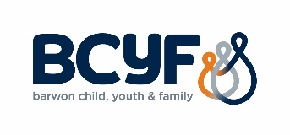
Home Interaction Program for Parents and Youngsters
Free - Fun - Play Based Learning
HELP YOUR CHILD DEVELOP, BUILD RELATIONSHIPS AND ENCOURAGE THEIR LOVE OF LEARNING
HIPPY supports you for 2 years with a Mentor who will practice and discuss the activities with you at home visits. You then play the HIPPY activities with your child during the week when it suits you.
All materials, resources and support are provided free of cost.
- Can you dedicate 2 hours a week during term times for Home Visits, Gatherings and playing HIPPY with your child?
- Will your child be at least 3 years old by the end of April 2023 and starting school in 2025?
If yes, then join us for HIPPY in 2023-2024 by completing the details below and email to Angela.Duncan@bcyf.org.au or phone the HIPPY Leader (Angela Duncan) on 0428 445 267 for more information.

Child’s name: | DOB:
Parents/Carers names:
Address: | Postcode:
Contact Number/s:
Email:
Has family previously done HIPPY? | Yes No
Single Parent family or out of home care? | Yes No
Household has a Health Care Card? | Yes No
Language/s Spoken at home:
Is child Aboriginal or Torres Strait Islander? | Yes No
Referrer – contact person and service:
Date of referral:
Referral source: Self

Other ……………………….

Please note: This is an expression of interest only and does not guarantee a place in the HIPPY Program for 2023-2024.
Offers are subject to Program funding approval from DSS.

HIPPY is funded by the Australian Government through the Department of Social Services. The Brotherhood of St Laurence holds the licence to operate HIPPY in Australia.

