STC South Camberwell Cricket Club

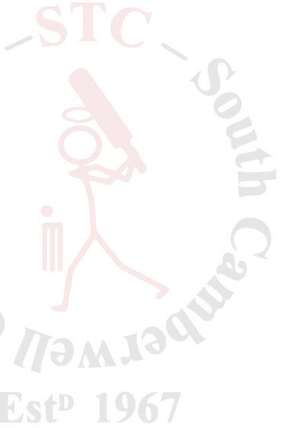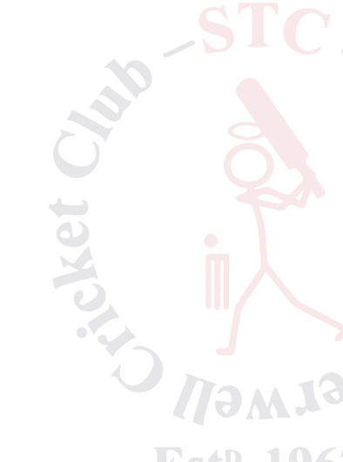

Season 2024/25

**GIRLS WANTED!**

**STC are again looking for girls to join Master Blasters cricket program season 24/25. All abilities welcome from 6–10 years**

**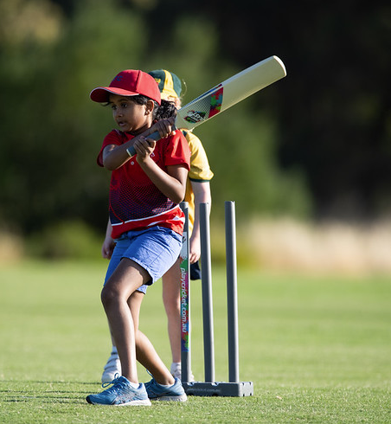*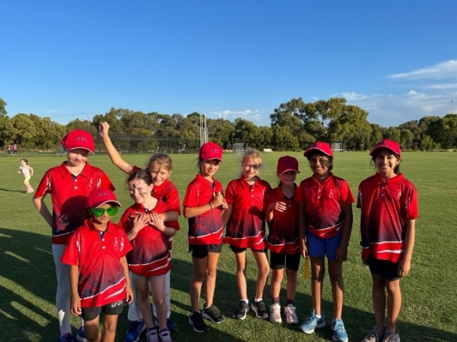***

Registrations are now open! Click [here](https://www.playhq.com/cricket-australia/register/3c6ebb) to register

Only **$99** for the season to play

**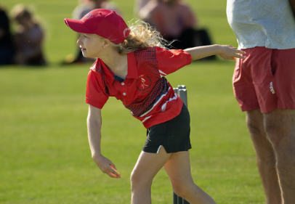*Why play at STC?***

We are a supportive, family friendly club with number of teams for all levels of ability

We have strong ties to the local community

We have a proud history of inclusion and participation

***All girls of any skill level are welcome!***

The girls will participate in the mixed boys/girls Blaster skill sessions beginning in October at Ferndale Park on Fridays at 4pm with the girls only tournament games to be played on Wednesday evenings from 5:00pm through Feb/March

For further information contact the club at info@stccricket.com.au or Chanika Dias- [chanika.dias@gmail.com](mailto:chanika.dias@gmail.com) or

Nick Adams- [adamsnickj4@gmail.com](mailto:adamsnickj4@gmail.com)

Nettleton Park – Gardiner Parade, Glen Iris 3146

[www.stccricket.com.au](http://www.stccricket.com.au)