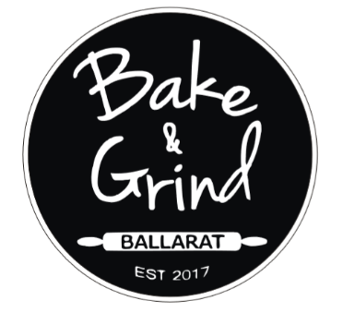
DONUT DRIVE
Northway
SELLERS NAME:________________________________
ORDERS DUE BACK TO:__________________________
ORDERS DUE BACK BY: ______29/3________________
DELIVERY DATE:_____________5/4________________
COST PER PACKET:_$18 Pack A and B, $15 Pack C__

Northway Shopping Centre
Cnr Norman & Doveton Sts
Ballarat North Vic 3350
Ph: 5332 8642
Delacombe
Delacombe Town Centre
315 Glenelg Highway DONUTS COME IN PACKS OF 6, THERE ARE 3
Smythes Creek Vic 3351 PACKS TO PICK FROM:
Ph: 5335 7616

PACK A: CHOCOLATE & NUTELLA LOVER
- Nutella M&M, Nutella Freckle (jam filled), Snickers Pods, Choc Mousse Oreo,
Choc Mint, Cookies & Cream
PACK B: ALL SORTS
- Apple Custard, Golden GayTime, Vanilla Slice, White Choc & Raspberry, Strawberry Mousse & White Choc, Jam & Cream
PACK C: CLASSIC
- 3 Jam, 3 Jam & Cream
BUYERS NAME | PACK A | PACK B | PACK C | COST ($)
TOTAL OF DONUT ORDER (QUANTITY) |  |  |  | GRAND TOTAL $_____

