[](http://www.kiallagolf.com.au/)

[**www.kiallagolf.com.au**](http://www.kiallagolf.com.au)

**SPECIAL NEW MEMBER OFFER.**

**LIMITED TIME ONLY**

**$280 for full membership up to 31 March 2020.**

**Contact:** [**secretary@kiallagolf.com.au**](mailto:secretary@kiallagolf.com.au)

**Phone: 5827 1390**

**Kialla Golf Club is situated at 360 Central Kialla Road, Kialla just 12km South of Shepparton’s C.B.D.**

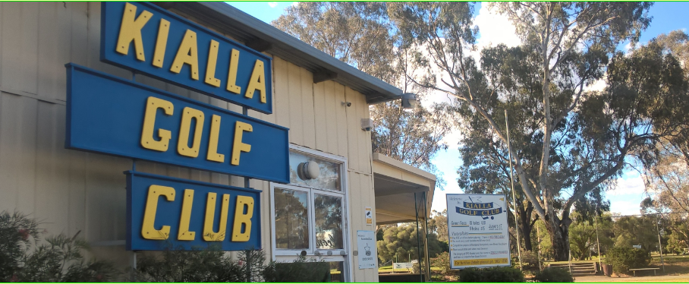

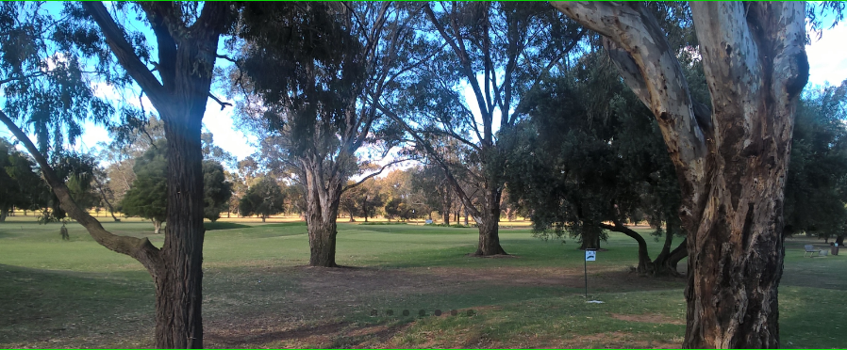

**Competitions are held every Wednesday (Women), Thursday (Men) & Saturday (All) plus a number of special days throughout the year.**

**See below some recent reviews posted on google:**

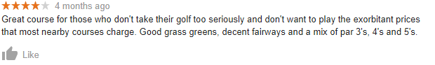



**If full membership is not for you Green Fees are just $15 for 18 holes so come out and enjoy this well-kept golf course.**