Melbourne Girls’ College
Yarra Boulevard, Richmond VIC 3121 Telephone: 9428 8955
STUDENT’S NAME: …………………………………………………………………………………………………….
PAYMENT FOR: Dance Clothing
AMOUNT:
$

CARD DETAIL: Name…………………………………………… CCV:………. |  |  |  |  |  |  |  |  |  |  |  |  |  | Expiry Date: ……………..
Melbourne Girls’ College
Yarra Boulevard RICHMOND 3121
Telephone: (03) 9428-8955 Fax: (03) 9428-2737
Email: melbourne.girls.co@edumail.vic.gov.au

Dear MGC Dance Families,
This year some MGC dance clothing items are available for purchase!
(Please note these are optional items and are not part of the school uniform.)
Please return the top half of this form to Georgia McGeechan with the items and sizes of clothing you would like to order by Wednesday the 13th of July. A sizing chart has been included on the next page for your reference.

Clothing Item | Quantity | Size
T-Shirt (Unisex fit) - $23.50
T-Shirt (Ladies fit) - $23.50
Long-sleeve Shirt - $29.50
Hoodie - $50

Kind regards,
Georgia McGeechan
Dance Leader

To finalise your order, please return payment to the front office by Wednesday the 22nd of June. Payment can be made via BPAY, cash, cheque, below credit slip or contact the school on 9428 8955 to pay by credit card over the phone.
Sizing Chart

T-SHIRTS (UNISEX FIT): $23:50

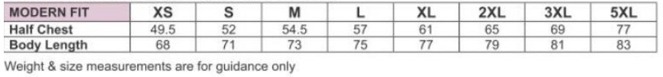

T-SHIRTS (LADIES FIT): $23:50

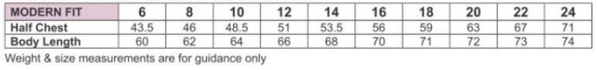

LONG SLEEVE SHIRTS: $29.50

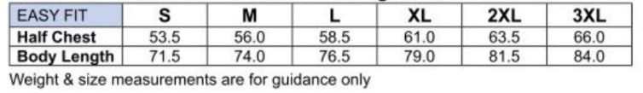

HOODIES: $50
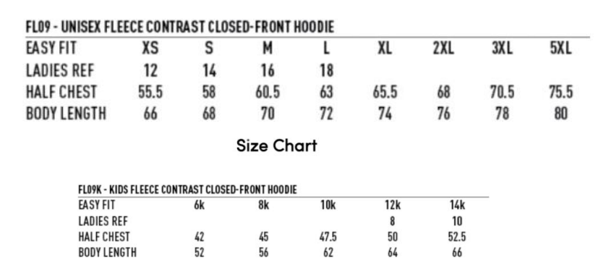

Design
The items will be a dark navy colour with a small MGC logo on the front and the word ‘DANCE’ printed on the back in white writing.

HOODIE:
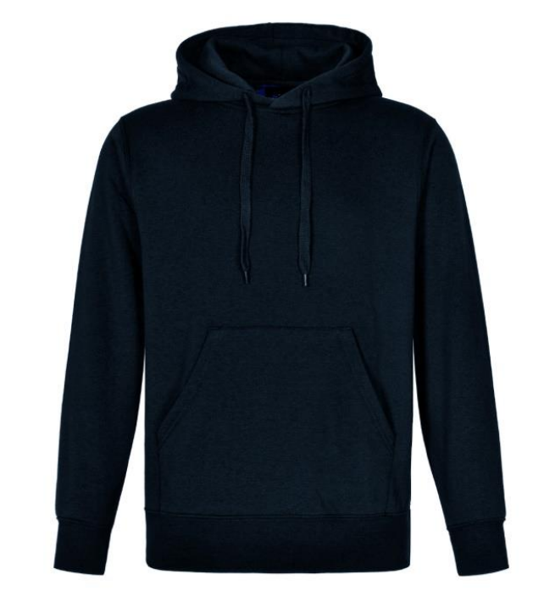
LONG SLEEVE SHIRT:
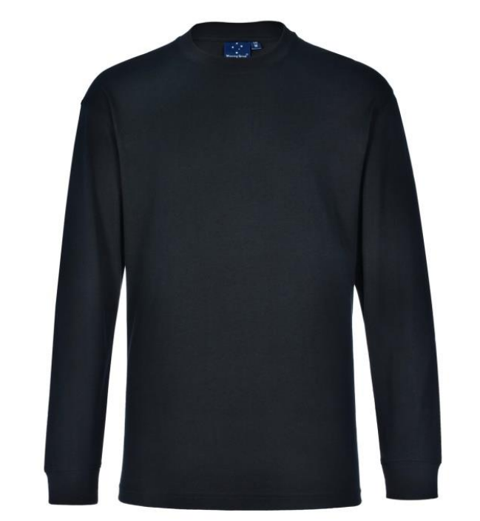

T-SHIRTS (UNISEX FIT:
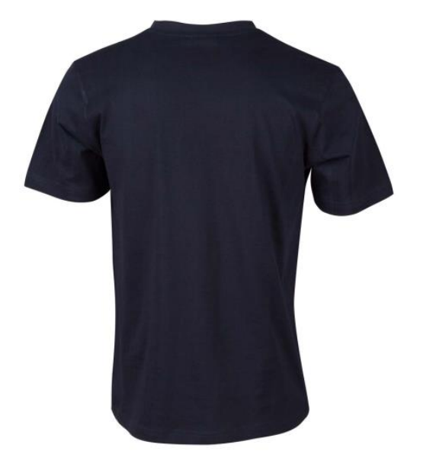
T-SHIRT (LADIES FIT):

