# **Korumburra Secondary Performing Arts Information Pack**

**About…**

Welcome to Korumburra Secondary College, we pride ourselves on our strong Performing Arts program. For Instrumental Music, Korumburra is a part of the South Gippsland Schools Music Program which shares its resources across five schools. Under this arrangement we can offer a wide range of instruments for tuition at a competitive price. The instruments we offer as part of SGSMP are;

|  |  |  |  |
| --- | --- | --- | --- |
| Voice | Alto Saxophone | Trombone | French horn |
| Guitar | Flute | Tenor Saxophone |  |
| Bass Guitar | Clarinet | Tuba |  |
| Drums/ Percussion | Trumpet | Euphonium |  |

Not sure what instrument? We run a try out day early in Term 1 for students to learn about the instruments and to meet our Instrumental Staff.

**After enrolment…**

Once you sign up to Instrumental Music you will become a part of SGSMP taking part in performances, excursions and workshops across the 5 different schools. Being a part of SGSMP means taking part in a **30 minute lesson** and a **60 minute band practice**. SGSMP believes in the importance of working as an ensemble to build musical skills and success so it is **compulsory** that if you are doing instrumental lessons, you will also be attending band practice. The first year of Band Practice will be focused on learning developmental skills and beginner pieces on your chosen instrument.

**In school opportunities…**

Korumburra offers many extra-curricular opportunities for Performing Arts. We hold a major performance event every year and we will be in our “School Production” year for 2021. 2022 will see “A Night to Remember” showcase as our major event. We also offer other ensembles such as; Dance Troupe and Drama Club. Ensembles are subject to student interest.

For more information contact:

[rosie.handley@education.vic.gov.au](mailto:rosie.handley@education.vic.gov.au)

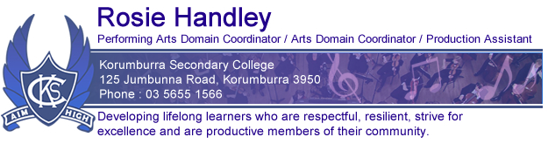

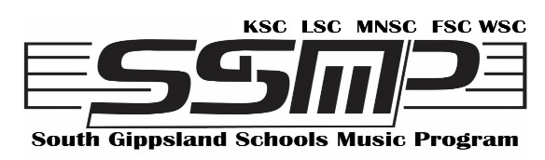

The following C**oncert Band instruments** are offered for tuition in the SGSMP program. If a student chooses one of these they will be required to attend weekly Concert Band rehearsals. A consistent practice schedule will be paramount to ensuring steady progress and an understanding of the concert band material.

**BRASS –** Trumpet, French Horn, Trombone, Euphonium, Tuba

**WOODWIND –** Flute, Clarinet, Saxophone

**PERCUSSION –** Drum kit, tuned percussion and auxiliary percussion instruments.

**BASS GUITAR**.

**GUITAR**

To be a part of the program, Guitar students must attend weekly Guitar Ensemble rehearsals which may be held before or after school. They also commit to undertaking any performances, as a member of the Guitar Ensemble, which may arise throughout the year. Guitar lessons shall support the material that is being taught in Guitar Ensemble. Students who elect to learn guitar must commit to a daily practice schedule of at least 20 minutes as a beginner.

SGSMP Guitar lessons provide an opportunity for students to develop their guitar playing skills with a focus on correct technique and notation reading. Students will learn how to sight read music and play in a variety of styles with a specialist guitar teacher. Lessons at junior and intermediate levels will be taken in groups. Students who elect to choose Guitar as a VCE subject will have individual Guitar lessons.

**VOICE**

To be a part of the program, Voice students must attend weekly Vocal Group rehearsals which may be held before or after school, or at lunch time. Students will learn how to sight read music notation and sing in a variety of styles with an emphasis on correct vocal production. Songs will be chosen according to their pedagogical value and student ability.

Voice lessons will be tailored as a pathway towards VCE Music Performance. In a graded approach students will be taught the aural skills and technical work required for VCE music. They will be given opportunities to perform in solo and group contexts throughout the year and will be encouraged to undertake AMEB (Australian Music Examinations Board) examinations.

Lessons at junior and intermediate levels will be taken in groups. Students who elect to choose Voice as a VCE subject will have individual Voice lessons.

**NOTE: Students who do not attend Concert Band/Ensemble/Vocal Group rehearsals regularly may be removed from the program.**