Senior School | Name | Position
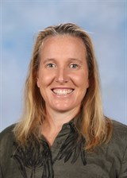 | Renea Betts | Head of House (Hydra & Ignis)
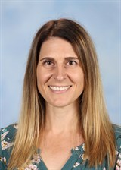 | Amy Hooper | Head of House (Stella & Terra)
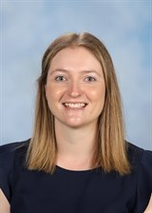 | Casey Lawson | House Leader of Hydra
 | Jess Chong | House Leader of Stella
 | Patrick Delany | House Leader of Ignis
 | Jacob Callahan | House Leader of Terra
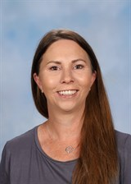 | Fleur Lidyard | Senior School Assistant

